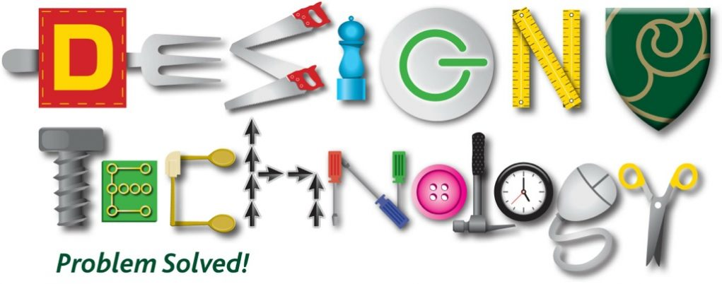 April- May 2020 Activities
May 2020
1.  .  What happens to an egg when placed in vinegar.  Use clear vinegar and record for next 15 days what happens  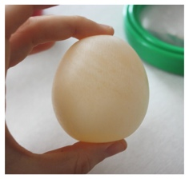 | 2.  In your kitchen draw, in pencil a small electrical appliance. Label what each part does.  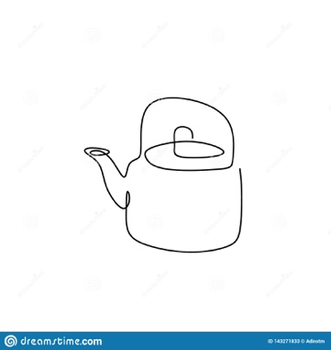 | 3.  Download PIC Collage (FOC App). Send your friends a collage of your activities. | 4.  Visit https://designmuseum.org/design and rate your favourite designs. | 5.  Without lifting your pencil from a page draw a family member!!!! Tricky!!!  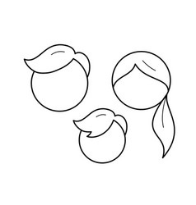 | 6.  Coding without computers. Write down step by step how to make a sandwich or photograph it- send using PIC Collage.  1.  2.  3.  4.  5..6..7..8..9..10..11…….
7.  Upcycle an old piece of furniture or T-shirt into something YOU can use. | 8.  Design a new clock for your bedroom.  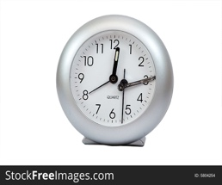 | 9.  Make and decorate a sign for your room. | 10.  Socks never stay together after washing- THINK of an idea or a device that will keep them together after washing. | 11.  How best can you organise your bedroom. Make inserts for your drawers, CD/ Games etc. | 12  Write down or draw all the tool you have used so for in technology.  What does each do?  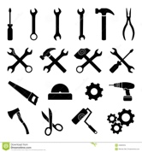
13.  A joiner uses wood  A painter uses brushes.  Name 5 more careers in technology e.g. Electrician uses …..  Mechanic uses ……… | 14.  Design a family board game. Use an empty cereal box, a dice and different coloured counters | 15.  Remove your egg and drop it! What has happened?. | 16.  Draw a map of your house, room by room. Add things that you would like. | 17.  Have a technology free day! No TV, kettle, toaster, microwave- can you do it!!!! | 18.  Google ‘ how does a washing machine work.’
19.  Using a ruler, measure each of your fingers and compare these with your left and right hands. Same? | 20.  List 10 of the coolest gadgets you enjoy.  Google 10 Coolest New Gadgets of 2020 | 21.  AI  technology  Discuss what you think of them? Good, bad, not sure? | 22.  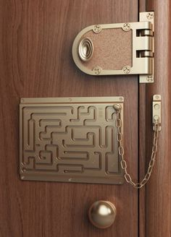 Useful? | 23.  Mobile phones are always being upgraded- how best can you reuse them? | 24.  Why are nails and screws different lengths?  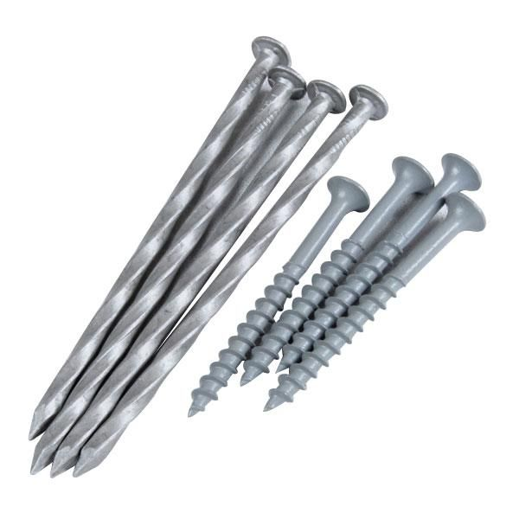
25.  Make an acronym for TECHNOLOGY.  T is for TOOLS  E is for  C is for  H  N  O  L  O  G  Y……………. | 26.  What’s the difference is hard and soft wood?  Names 10 tree types- which is hard and soft. | 27.  Why are there different GRADES of sand paper? | 28.  Make paper aeroplanes, make each different, colour them in, use different sizes of paper. How far does each go, why?  Draw a table of your results. | 29.  Ultimate Egg Drop Challenge  Google it and try!!!  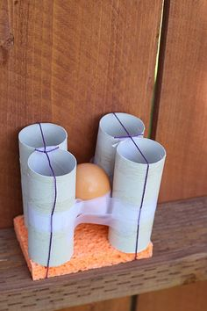 | 30.  Measure the LENGTH, WIDTH and HEIGHT of a cereal box- compare it to other cereal boxes.

