PE Ideas
Hello everyone, here are some ideas to help you keep active.
At the minute we are all allowed out for some exercise with our families every day. Please do this. A walk is perfect, just stay with your family members.
If you have access to the internet there are loads of different exercise ideas. I’m just going to mention one, Joe Wicks.
Joe is on youtube every morning at 9am for 30 minutes. His workouts are fun, easy to follow, and everyone in the family can participate. If something that Joe does is too difficult just adapt it to suit yourself. That’s what I’m doing!
You might like to try this ‘Alphabet Challenge’. If there is an exercise you’re not sure about just google it.
Spell a word everyday and then do the exercises e.g. spell your name.
- 20 Burpees
- 20 Lunges
- Run up/down stairs 10 times
- 20 Sit ups
- 20 Press ups
- Hold plank for 30 seconds
- Shuttle runs 10 x 10m
- Jog on the spot 1 minute
- Run on the spot 30 seconds
- 20 Squats
- 20 Mountain climbers
- 50 Step ups
- Tricep dips 20(chair)
- 20 Star Jumps
- High knees 60 seconds
- 20 Leg lifts
- 10 Knee to elbow plank
- Russian Twists 20
- 10 Arm circles
- 20 Heel flicks ( jog on spot with heel touching bum)
- 50 Ball bounces
- Skipping 60 seconds
- 20 Straddle Jumps (over school bag)
- 1 leg balance 15 seconds
- Tuck Jump 30 seconds
- Side Plank 30 seconds

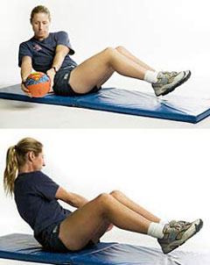Russian Twists
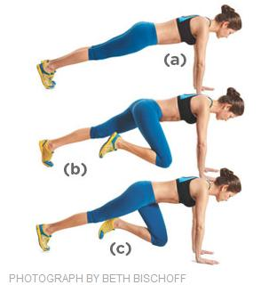Mountain Climbers

Have a competition with a brother or sister to see who can do the most of any exercise in 20 seconds.

I’m also including a scavenger hunt that you might enjoy outside. Its from the Twinkl web site which has plenty of other ideas.

Mr. Starrs.

