[https://encrypted-tbn1.gstatic.com/images?q=tbn:ANd9GcTJ9tqxeGI21DlLf8WYJ-nfu3kHi_4TDbpyE31zr9apd6nB6kGUUK3jV2g](http://www.google.co.uk/url?sa=i&rct=j&q=&esrc=s&source=images&cd=&cad=rja&uact=8&ved=0CAMQjRxqFQoTCNaw1rf_38cCFYMU2wodizEDIg&url=http://www.rewardinglearning.org.uk/&psig=AFQjCNGpFfNpBAsETNiBNiy1n5XlUIt_fA&ust=1441545992372912)

Final Level:

I certify that the evidence submitted for this unit is my own work:

Learner Signature: ………………………………………………………………………

I certify that the evidence submitted for this unit is the work of: ………………………………….

Teacher Signature: ……………………………………. Date: ………………………

***CCEA Occupational Studies***

***Entry Level***

|  |  |
| --- | --- |
| **Candidate Name** |  |
| **Candidate Number** |  |
| **Teaching Centre Name** | **Longstone Special School** |
| **Teaching Centre Number** | **71551** |
| **Administration Centre Name** |  |
| **Administration Centre Number** |  |
| **Pathway** | **Digital Imaging** |

**Digital Imaging**

**Unit 16: Using a Camera**

A01 Knowledge Check

Job Opportunities, Health and Safety and the Three Rs

In this section you will:

1 *Identify a job opportunity in Digital Imaging, identify one place of work, two roles and responsibilities in Digital Imaging.*

2 *Recognise one potential health hazard, identify two health and safety rules in Digital Imaging and the*

*potential consequences of non compliance.*

3 *Recognise what is meant by the three Rs, identify what is meant by the Three Rs and state why recycling is*

*important in Digital Imaging.*

18

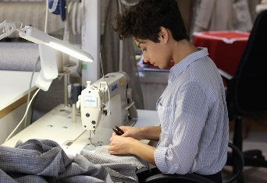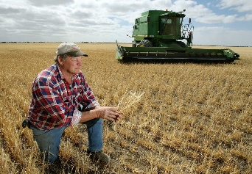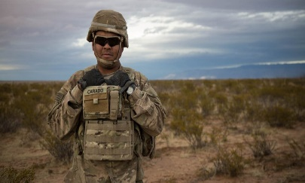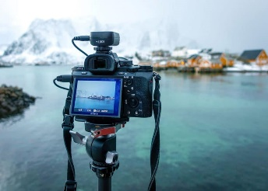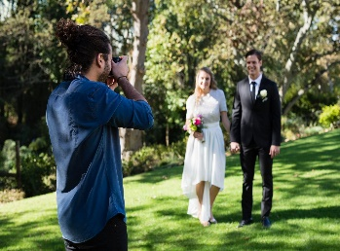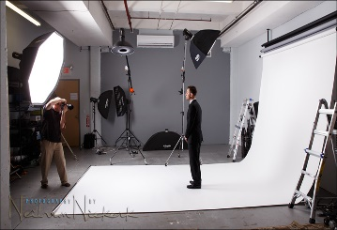

Unit 16 Using a Camera

19

Wedding Photographer Studio Photographer

Travel Photographer Graphic Designer

EL2 –Draw a line from the words listed in the green box to the correct place of work.

EL1 –Recognise by **placing an x below** a job opportunity which is related to the **digital imaging industry.**

**Job Opportunities**

**A01**

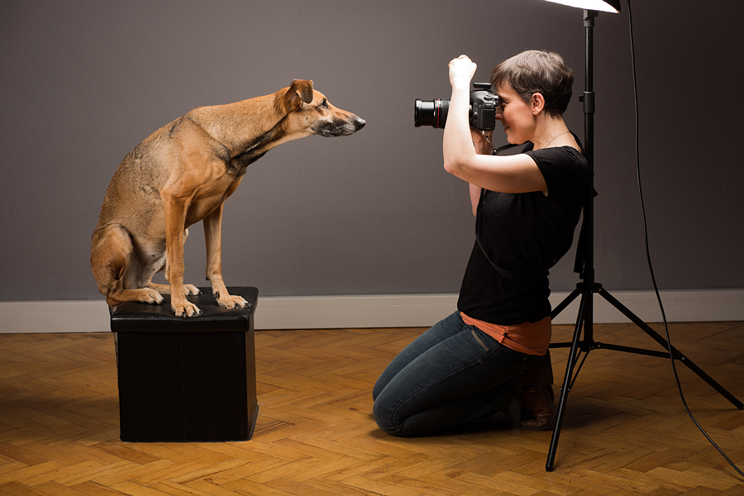

Unit 16 Using a Camera

***Bank Manager***

***Pet Photographer***

**Writer**

***Fire Fighter***

Vet

Nurse

I am a______________________________________________ (Choose from the list in the pink box)

**EL3 State at least two roles and responsibilities of a position**

20

EL1 EL2 EL3 Teacher /Lecturer signature

EL3 Identify two roles and responsibilities for someone working in this area of the Digital Imaging Industry.

1. Role__________________________

Responsibility _________________________________________________

____________________________________________________________

2. Role__________________________

Responsibility__________________________________________________

_____________________________________________________________

The student has achieved

Careers at …..

7

**Job Opportunites**

**A01**

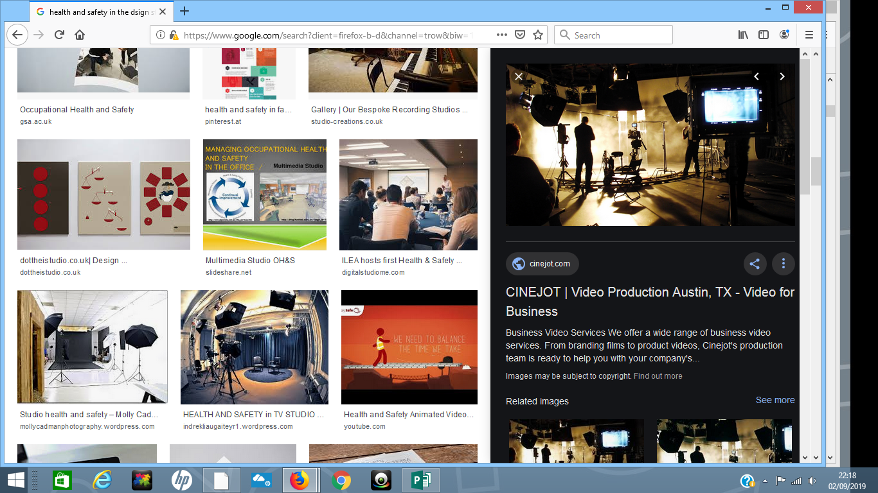

Unit 16 Using a Camera

Ensure there are no tripping hazards

When working in a dark room with chemicals, eat your lunch

Do not touch hot photography lights

Drink lots of caffeinated drinks whilst you edit photos on the computer

Have your chair at the correct height for you when using the computer

Do not run in the photography studio

EL2 --Identify, by ticking the boxes below, the Health and Safety rules that must be observed in the Digital Imaging industry.

21

EL1 –Recognise by **circling** at least one potential health and safety hazard in the image of a studio below.

hazard in the images below.

**Health and Safety**

**A01**

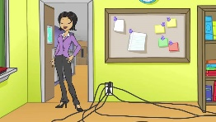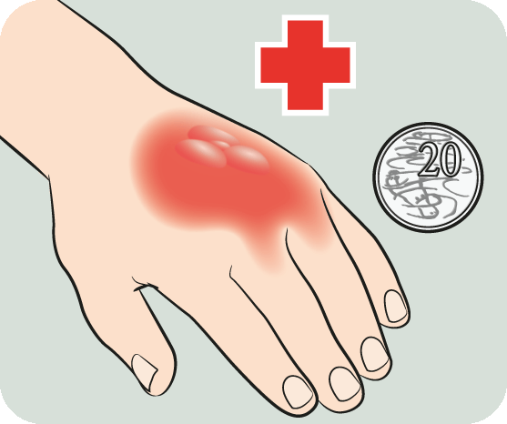

Unit 16 Using a Camera

You could trip and fall

You could knock over the lights and smash them

It could give you a sore back if you don’t!!

POSSIBLE CONSEQUENCES

You could get a burn!!

RULES

Do not run in the studio when the studio lights are up

Ensure there are no

hazards such as badly placed studio wires

Do not touch hot

photography lights

Have your chair at the

correct height for you when using the computer

22

EL1 EL2 EL3 Teacher /Lecturer signature

EL1 EL2 EL3 Teacher /Lecturer signature

The student has achieved

Health & Safety at …..

7

EL3 —Explain what might happen if the rules are broken. Join the sentence to the correct image.

**Health and Safety**

**A01**

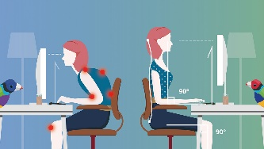

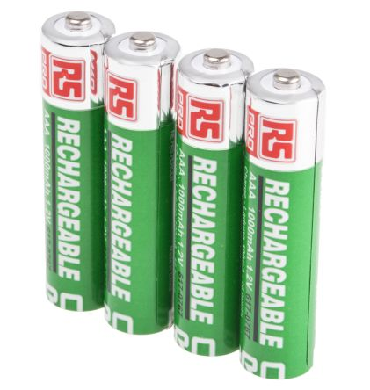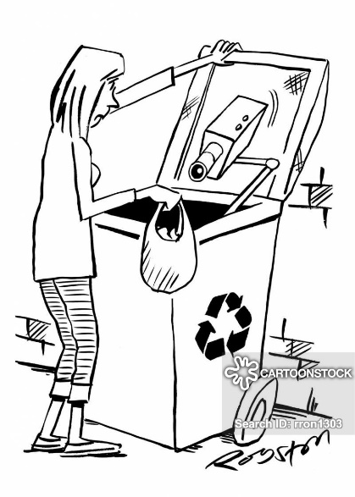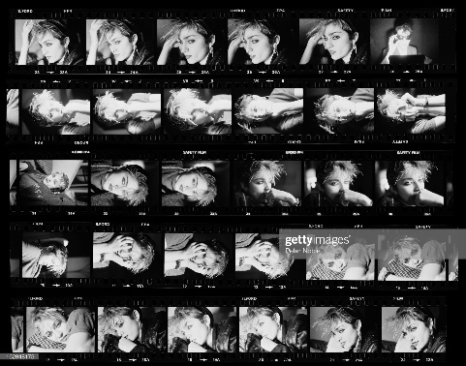

Unit 16 Using a Camera

Circle

Contact Sheet

EL2 What do the three Rs mean? the three images that represent the three Rs and good practice.

R___________________

R___________________

R___________________

EL1 What is meant by the 3Rs? (Complete the words below)

23

Circle

Unit 16 Using a Camera

EL1 EL2 EL3 Teacher /Lecturer signature

The student has achieved

Recycling at …..

7

3

2

1

EL3 Why is recycling important in the Digital Imaging Industry?

24

Unit 16 Using a Camera

25

A01 Knowledge Check

Materials, Related Skills and Knowledge

In this section you will:

1 *Demonstrate basic (EL1), some (EL2) and/or good (EL3) knowledge and understanding of equipment and/or*

*software used in Digital Imaging.*

2 *Identify two different types of equipment used in*

*Photography, three different types of equipment used in Photography and identify their usage, and identify four different types of equipment in Photography and explain how and why each is used.*

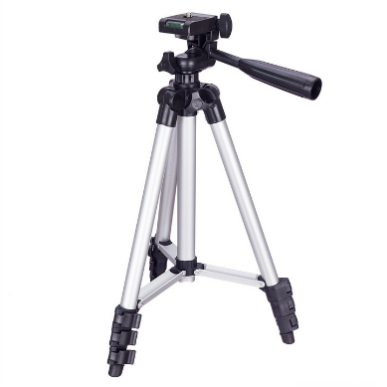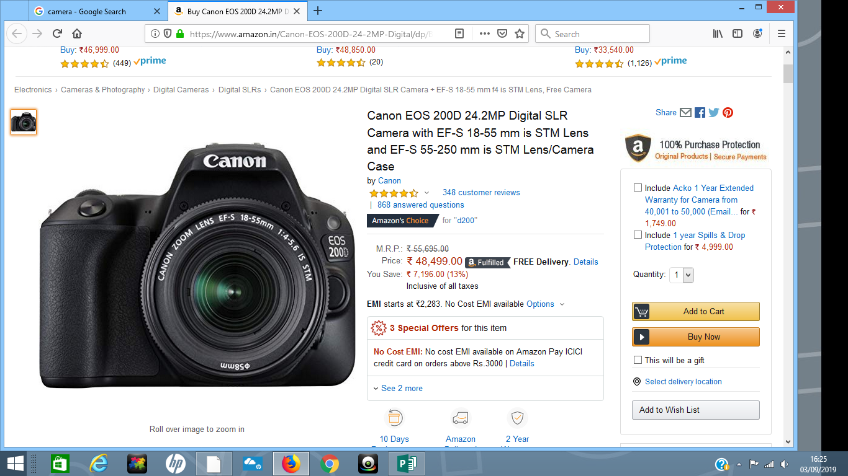

Unit 16 Using a Camera

1

**MATERIALS AND RELATED SKILLS AND KNOWLEDGE**

**EL1 Demonstrate a basic knowledge of equipment used in Digital**

**Imaging.**

Circle three types of equipment used by a Photographer.

27

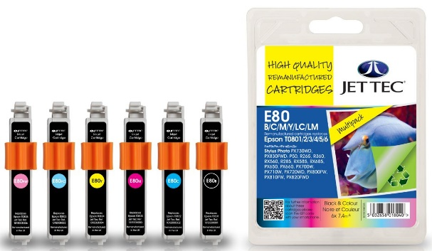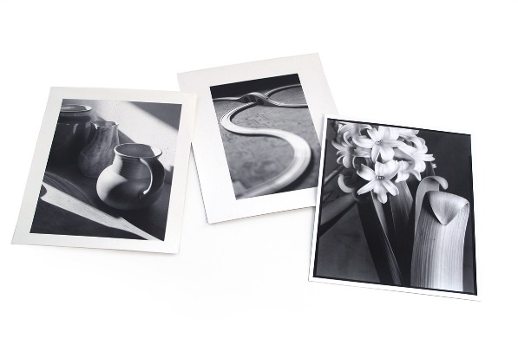

Unit 16 Using a Camera

1

**MATERIALS AND RELATED SKILLS AND KNOWLEDGE**

**EL1 Demonstrate a basic knowledge of materials used in Digital**

**Imaging.**

Circle three types of material used in Photography.

28

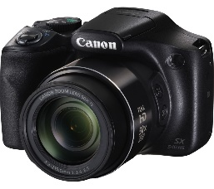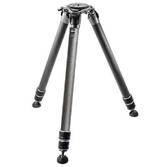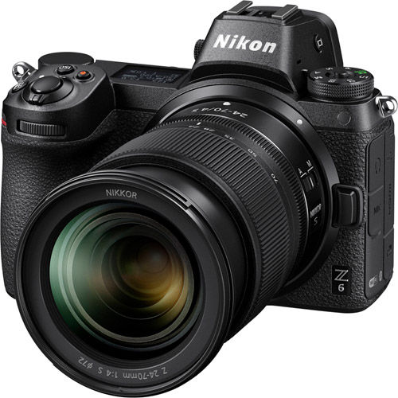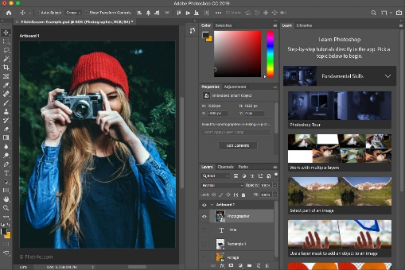

Unit 16 Using a Camera

29

A

B

C

**EL1 Understanding equipment.** Which of the above is required to:

(Insert the correct letter in the box)

1. EDIT A PHOTOGRAPH.

2. PRINT AN IMAGE ON PHOTOGRAPHIC PAPER.

3. TAKE A PHOTOGRAPH.

**EL2 Understanding equipment. Label the following items from the words listed below.**

Lens Camera Memory Card

TRIPOD



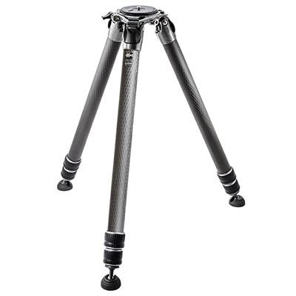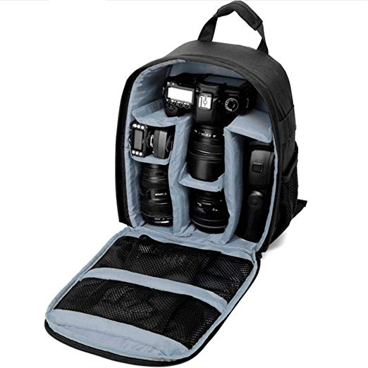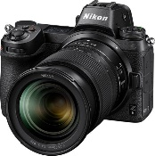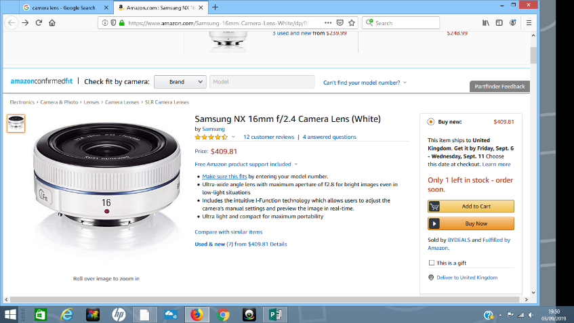

Unit 16 Using a Camera

30

EL2 Show an understanding of how different types of equipment are used in Photography.

*Label the equipment and then join the sentences to the correct images*

-I use this to take a photograph

-I use this to zoom in and out

-I use this is transfer images from a camera to computer

-I use this to keep the camera steady

-I use this to shine more light on a subject being photographed

-I use this to protect the camera

gear

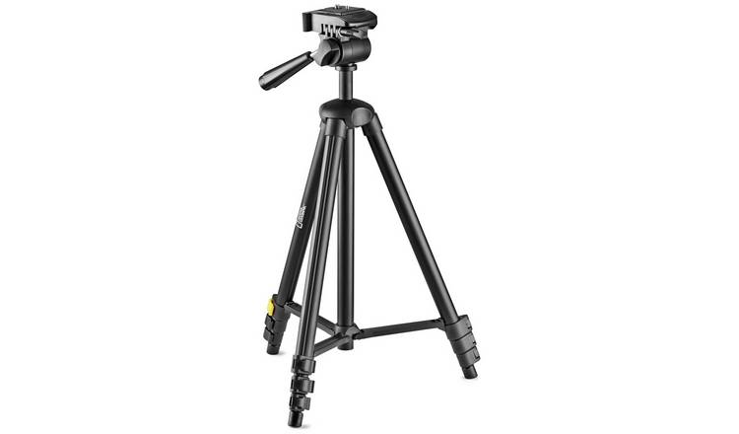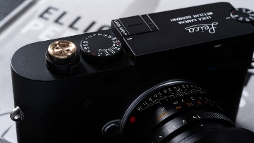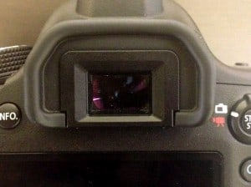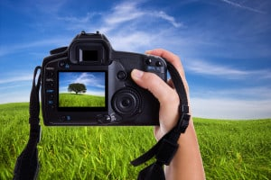

Unit 16 Using a Camera

These are——————————

This is a ————————

Name the silver button

These are called—————

WHAT IS THEY USED FOR?

NAME

Label the following in the white boxes and explain how a photographer would use them. Write your answers in the pink boxes.

**EL3 Demonstrate good knowledge and understanding of the types of**

**equipment used in digital imaging.**

31

Unit 16 Using a Camera

Underwater Casing

Printer

Computer

Backdrop

Studio Lights

**EL3 Demonstrate good knowledge and understanding of equipment used in Photography.**

*When would a Photographer use the following?*

32



Unit 16 Using a Camera

33

**EL1- Identify two different types of equipment used in photography.**

**Tick the following types of equipment that *might* be used by a school photographer in the box below.**

**MATERIALS** **EQUIPMENT**

**Photographic Paper Knitting Needles**

**Wool Saucepan**

**Dark Room Chemicals Studio/Umbrella Lights**

**Beads Camera**

**Printing Ink Back Drop Support**

**Canvas Easel**

**Paint Tripod**

**Salt Dough Rolling Pin**

**Felt Steadicam**

**Clay Kiln**

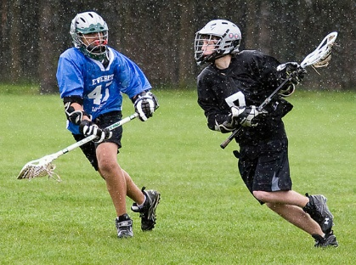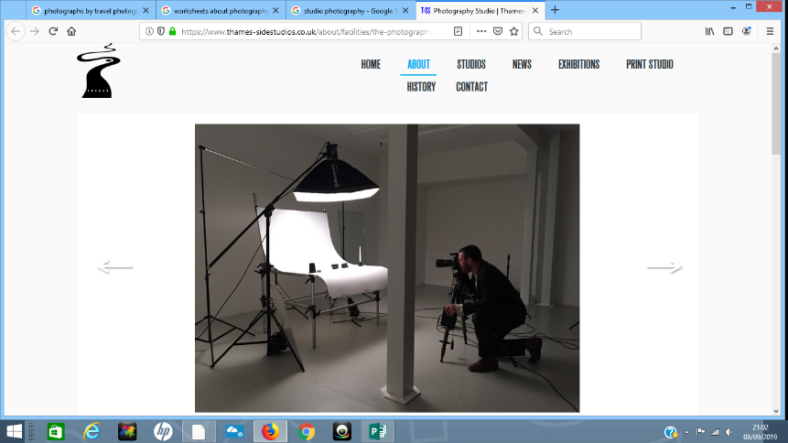

Unit 16 Using a Camera

Night Time Photography

Sports Photography

Studio Photography

Rain Cover Camera Strap Camera Bag DSLR Camera

Tripod Zoom Lens Flash Backdrop Studio Lights

Zoom Lens Remote Shutter

*Look at the images below and list the equipment a photographer would require for each. Choose words from the list below.*

**EL2– Identify three different types of equipment used in photography and show an understanding of their usage.**

34

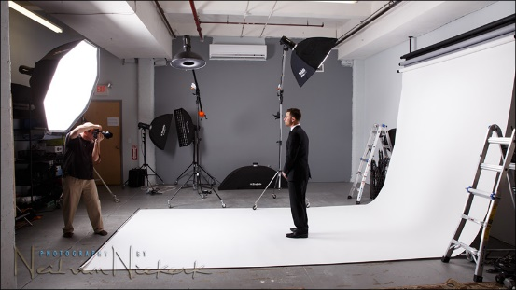

Unit 16 Using a Camera

EL1 EL2 EL3 Teacher /Lecturer signature

The student has achieved

Materials, skills at …..

7

2nd Piece of Equipment:

.

Ist Piece of Equipment:

.

2nd Piece of Equipment:

.

Ist Piece of Equipment:

.

Look at the images below. Select two pieces of photography equipment from each and

explain how they are used.

**EL3– Identify more than four different types of equipment used in Photography,**

**explaining how and when each is used.**

35