**CCEA Occupational Studies**

**Entry Level**

Final Level:

[https://encrypted-tbn1.gstatic.com/images?q=tbn:ANd9GcTJ9tqxeGI21DlLf8WYJ-nfu3kHi_4TDbpyE31zr9apd6nB6kGUUK3jV2g](http://www.google.co.uk/url?sa=i&rct=j&q=&esrc=s&source=images&cd=&cad=rja&uact=8&ved=0CAMQjRxqFQoTCNaw1rf_38cCFYMU2wodizEDIg&url=http://www.rewardinglearning.org.uk/&psig=AFQjCNGpFfNpBAsETNiBNiy1n5XlUIt_fA&ust=1441545992372912)

**Creative Crafts**

**Unit 11: Making a Gift**

|  |  |
| --- | --- |
| **Candidate Name** |  |
| **Candidate Number** |  |
| **Teaching Centre Name** | **Longstone Special School** |
| **Teaching Centre Number** | **71551** |
| **Administration Centre Name** |  |
| **Administration Centre Number** |  |
| **Pathway** | **Creative Crafts** |

I certify that the evidence submitted for this unit is my own work:

Learner Signature: ………………………………………………………………………

I certify that the evidence submitted for this unit is the work of: ………………………………….

Teacher Signature: ……………………………………. Date: ………………………

**Photographs of End Products**

**Tracking Grid**

**Tracking Grid**

**Tracking Grid**

**Tracking Grid**

**Tracking Grid**

**Tracking Grid**

**Tracking Grid**

**Tracking Grid**

**Tracking Grid**

**Tracking Grid**



**Assessment Criteria**

**Assessment Criteria**

**Assessment Criteria**

**Assessment Criteria**

**A01Knowledge Check**

**Health and Safety, Environment and Related Careers**

**In this section you will:**

* **Identify a job opportunity in the crafts industry, identify one place of work in the crafts industry and state at least two roles and responsibilities of the position.**
* **Recognise a potential health and safety hazard in the crafts industry, two health and safety rules and the potential consequences of non-compliance.**
* **Recognise what is meant by the 3R’s, identify what is meant by the 3Rs and explain why recycling is important.**

**AO1 Health and Safety, Environment and Related Careers**

**EL1: Circle the job related to an opportunity in the Crafts industry.**

**EL2: Draw a line from each job to the correct place of work**

[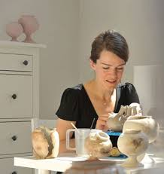](https://www.google.co.uk/url?sa=i&rct=j&q=&esrc=s&source=images&cd=&cad=rja&uact=8&ved=0ahUKEwjJs5HJkPLUAhWrK8AKHfCyBvUQjRwIBw&url=https://ru.pinterest.com/pin/354377064400141833/&psig=AFQjCNFjYkAlbDyhddWqvgWt3ITf4kYEMA&ust=1499343663249459)

Salon

[](http://www.google.co.uk/url?sa=i&rct=j&q=&esrc=s&source=images&cd=&cad=rja&uact=8&ved=0ahUKEwjDs4L2kPLUAhWiJMAKHdCDBRIQjRwIBw&url=http://blog.gamedevfort.com/igmc-a-judges-reflections/&psig=AFQjCNGMyMNfgVxbyaP0A3Iia3vusYWUlg&ust=1499343757473269)

Court House

[](http://www.google.co.uk/url?sa=i&rct=j&q=&esrc=s&source=images&cd=&cad=rja&uact=8&ved=0ahUKEwi6_MOQkfLUAhWILsAKHYVFBd4QjRwIBw&url=http://www.ukrobstep.com/hair-dresser/&psig=AFQjCNH1hpdBbirySjNR2W3atzhoVIQKWA&ust=1499343807280088)

Building Site

[](http://www.google.co.uk/url?sa=i&rct=j&q=&esrc=s&source=images&cd=&cad=rja&uact=8&ved=0ahUKEwi5iOy3kfLUAhVLJMAKHfETAeAQjRwIBw&url=http://www.opencolleges.edu.au/careers/blog/how-to-be-a-builder-construction-manager&psig=AFQjCNGmAKOaEMUvPPaPiV6lEACT0wvZTw&ust=1499343894553339)

Restaurant

[](http://www.google.co.uk/url?sa=i&rct=j&q=&esrc=s&source=images&cd=&cad=rja&uact=8&ved=0ahUKEwiyzvqjkfLUAhXlA8AKHaXRBxEQjRwIBw&url=http://www.gettyimages.com/photos/waiter&psig=AFQjCNEaOL9FiRXaQgYYQ-14VH3rQShnCw&ust=1499343852332170)

Studio

**El3 State at least two roles and responsibilities of a position**

**This is Joan she is a ___________________________**

[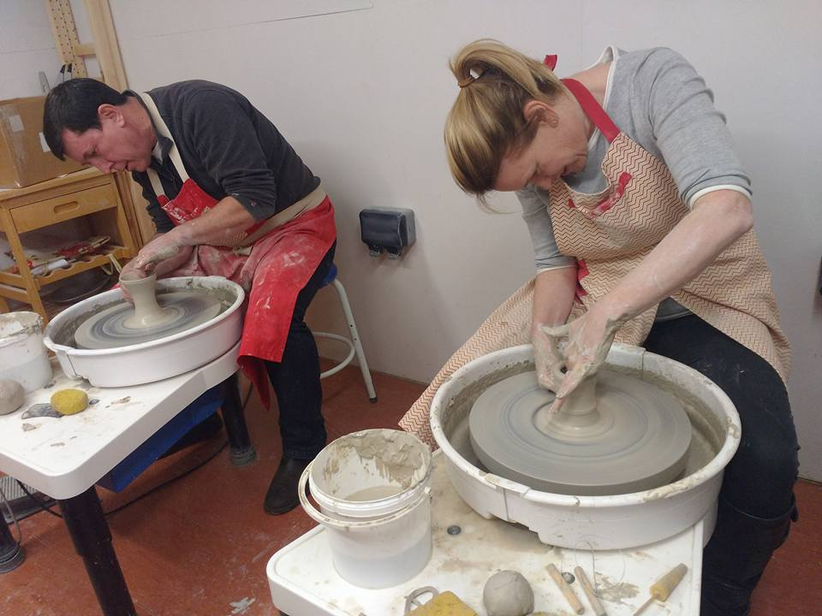](http://www.google.co.uk/url?sa=i&rct=j&q=&esrc=s&source=images&cd=&cad=rja&uact=8&ved=0ahUKEwiO1NiIkvLUAhVDBsAKHfo4AYUQjRwIBw&url=http://www.claywithcarole.co.uk/&psig=AFQjCNEPh9NdiSuzoiDCH-bcs-1bTOPu2g&ust=1499344056224887)

Chef

Plumber

Secretary

Pottery Maker

Farmer

Gardener

**Write down two responsibilities Joan has when working in her studio.**

|  |
| --- |
|  |
|  |

|  |
| --- |
|  |
|  |

|  |  |  |  |  |
| --- | --- | --- | --- | --- |
| **Job Opportunities Level achieved at:** | **EL1** | **EL2** | **EL3** | **Teacher Signature** |
|  |  |  |  |

**Health and Safety**

[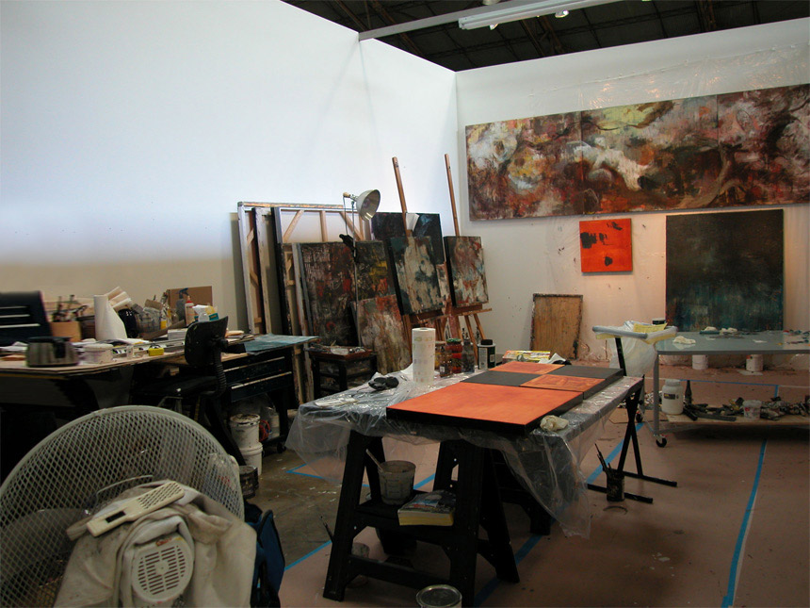](http://www.google.co.uk/url?sa=i&rct=j&q=&esrc=s&source=images&cd=&cad=rja&uact=8&ved=0ahUKEwjkyObllPLUAhWKC8AKHSQBAXIQjRwIBw&url=http://www.santamonicaartstudios.com/&psig=AFQjCNFPd9gEJtmOYJB5MhhU7cYgDDrviQ&ust=1499344795494084)

**EL1 Recognise a potential health and safety hazard in the above picture**

|  |
| --- |
|  |
|  |

**EL2 Identify by ticking in the box health and safety rules which must be observed in the Crafts industry**

|  |  |  |  |
| --- | --- | --- | --- |
|  | **Always wear PPE when needed** |  | **Make sure everyone in the studio is first aid trained** |
|  | **Take 2 hours for your lunch** |  | **Don’t eat while you work** |
|  | **Store chemicals carefully** |  | **Do not leave rubbish on the floor** |
|  | **Keep your phone charged all the time** |  | **Tell someone when you go to the bathroom** |

**EL3 Explain what might happen if these rules are broken:**

**Join the appropriate boxes together by drawing a line**

|  |
| --- |
| **Always wear PPE when needed** |

|  |
| --- |
| **Someone’s skin might be harmed** |

|  |
| --- |
| **Someone might slip or trip** |

|  |
| --- |
| **Store chemicals carefully** |

|  |
| --- |
| **Clean up spills quickly** |

|  |
| --- |
| **Someone might get poisoned** |

|  |
| --- |
| **Don’t eat while you are working** |

|  |
| --- |
| **Someone might get an eye injury** |

|  |  |  |  |  |
| --- | --- | --- | --- | --- |
| **Health and Safety Level achieved at:** | **EL1** | **EL2** | **EL3** | **Teacher Signature** |
|  |  |  |  |

**EL1 What do the 3 Rs stand for?**

**R________**

**R________**

**R________**

**EL2 what do the three Rs mean?**

**Circle the three pictures that represent the 3 Rs**

[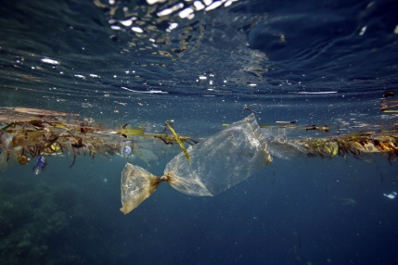](http://www.google.co.uk/url?sa=i&rct=j&q=&esrc=s&source=images&cd=&cad=rja&uact=8&ved=0ahUKEwian4XYmvLUAhWCB8AKHRxSA2IQjRwIBw&url=http://news.nationalgeographic.com/news/2014/04/140404-garbage-patch-indian-ocean-debris-malaysian-plane/&psig=AFQjCNHkzwLjS70XqZfIV-sfjhbBWRABAQ&ust=1499346336475316)[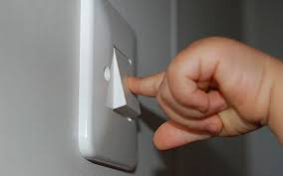](http://www.google.co.uk/url?sa=i&rct=j&q=&esrc=s&source=images&cd=&cad=rja&uact=8&ved=0ahUKEwjBsYnBnfLUAhUqKcAKHUknA8UQjRwIBw&url=http://www.jasonvalendy.net/blog/2014/6/4/light-switches-and-spirituality&psig=AFQjCNH_OcY5tGQsjr4TQbCpcLiOCpELrQ&ust=1499347105221707)

**[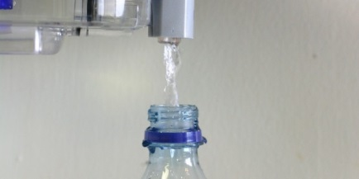](http://www.google.co.uk/url?sa=i&rct=j&q=&esrc=s&source=images&cd=&cad=rja&uact=8&ved=0ahUKEwiFkPCbnfLUAhVLL8AKHQFEATAQjRwIBw&url=http://www.huffingtonpost.com/2014/08/14/reuse-plastic-water-bottle_n_5671681.html&psig=AFQjCNG0sTiRB23z-i6JBRheDgR1uV0sUg&ust=1499347063201270)**

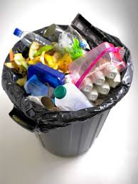

[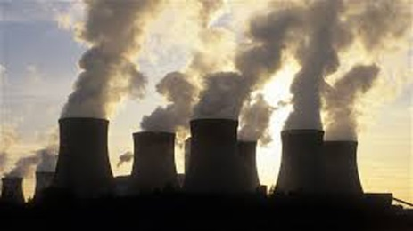](http://www.google.co.uk/url?sa=i&rct=j&q=&esrc=s&source=images&cd=&cad=rja&uact=8&ved=0ahUKEwjCiaPnnPLUAhWDL8AKHX_TDnUQjRwIBw&url=http://dailytimes.com.pk/sindh/06-Jun-16/pakistans-greenhouse-gas-emissions-likely-to-rise-survey&psig=AFQjCNGTJs0ZqW01T1ls-G4XIjCKh07CEA&ust=1499346952207580)[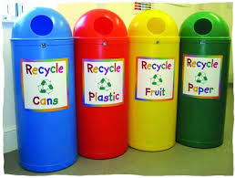](https://www.google.co.uk/url?sa=i&rct=j&q=&esrc=s&source=images&cd=&cad=rja&uact=8&ved=0ahUKEwjkguCMnfLUAhWMJMAKHQGZCboQjRwIBw&url=https://www.recyclingbins.co.uk/slimline-classic-recycling-bin.html&psig=AFQjCNGArra9aibTisjasezbmv1rPXRa1A&ust=1499347005317137)

**EL3 Why is it important to recycle as much as possible when making crafts?**

|  |
| --- |
|  |
|  |
|  |

|  |  |  |  |  |
| --- | --- | --- | --- | --- |
| **Recycling Level achieved at:** | **EL1** | **EL2** | **EL3** | **Teacher Signature** |
|  |  |  |  |

**AO1 Knowledge Check**

**Materials, Knowledge and Skills**

**In this section you will:**

* **Demonstrate basic, some, good knowledge and understanding of materials, equipment and skills required for creative crafts**
* **Identify suitable materials or equipment from a pre-selected range to help make a gift, select suitable materials or equipment from the range provided to make two different types of gift, select suitable materials or equipment from a wide range to make three different types of gifts for different occasions.**

**EL1 Demonstrate basic knowledge of materials required for creative crafts**

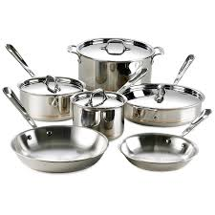**Circle the materials you would need to make a gift**

[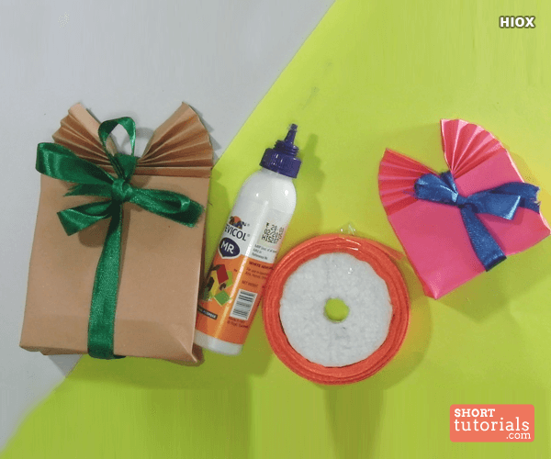](https://www.google.co.uk/url?sa=i&rct=j&q=&esrc=s&source=images&cd=&cad=rja&uact=8&ved=0ahUKEwifoMqmxvTUAhUFKcAKHarlBXcQjRwIBw&url=https://www.shorttutorials.com/how-to-make-paper-gift-bags/paper-gift-bags-page-1.html&psig=AFQjCNFDfNPx64yxpSw13rLc06pwX2OzWw&ust=1499426796374495)

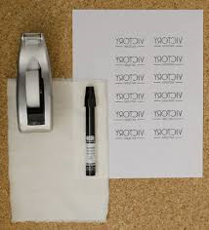[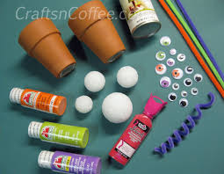](https://www.google.co.uk/url?sa=i&rct=j&q=&esrc=s&source=images&cd=&cad=rja&uact=8&ved=0ahUKEwjRyKWvxvTUAhUIOsAKHQkfCdoQjRwIBw&url=https://craftsncoffee.com/2012/10/01/halloween-gift-idea-make-a-halloween-eyeball-bouquet/&psig=AFQjCNFDfNPx64yxpSw13rLc06pwX2OzWw&ust=1499426796374495)

[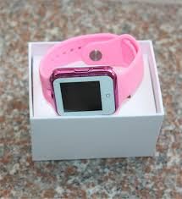](http://www.google.co.uk/url?sa=i&rct=j&q=&esrc=s&source=images&cd=&cad=rja&uact=8&ved=0ahUKEwi-m9uZx_TUAhVqBcAKHSthBCgQjRwIBw&url=http://www.dhgate.com/product/2016-hot-d3-bluetooth-smart-watch-for-kids/392034990.html&psig=AFQjCNEvt9oFAXM1Al1pTK1Epfm3GN47HQ&ust=1499427042949096)

[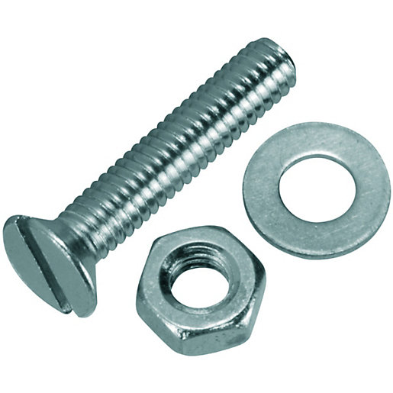](http://www.google.co.uk/url?sa=i&rct=j&q=&esrc=s&source=images&cd=&cad=rja&uact=8&ved=0ahUKEwjsq6G7x_TUAhVoCsAKHXSxBi0QjRwIBw&url=http://www.wickes.co.uk/Wickes-Machine-Screws-with-Slot-Head,-Nut+Washer-M4-x-20mm-Pack-10/p/510205&psig=AFQjCNFFh34w-EWYWF3OtFu07iQgbV-WtQ&ust=1499427122311910)

**EL1 Demonstrate basic understanding of the equipment required for creative crafts**

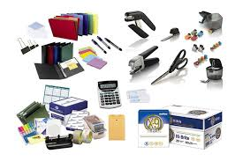**Circle the equipment you would use in creative crafts**

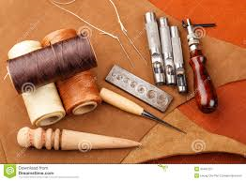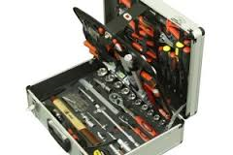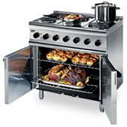

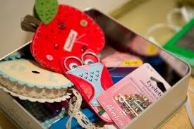

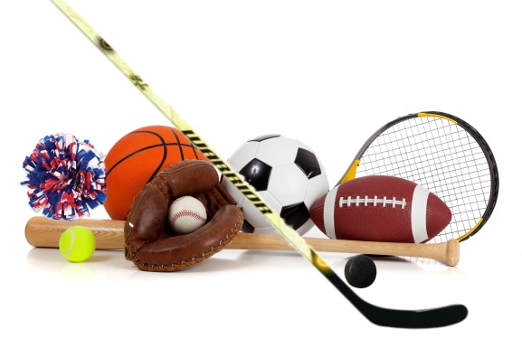

**Demonstrate basic knowledge of the skills required for creative crafts:**

**Circle the skills needed for the creative crafts industry**

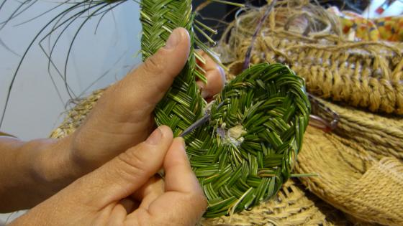

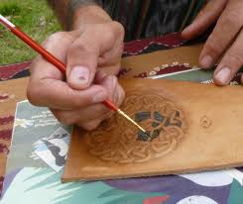

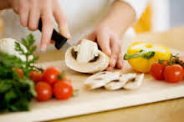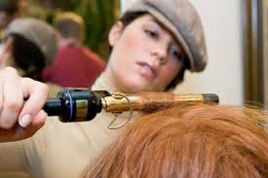

**EL2 Demonstrate some knowledge of the materials required for creative crafts**

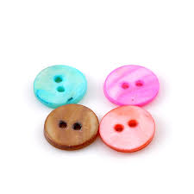**Label the following materials:**

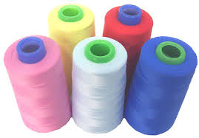

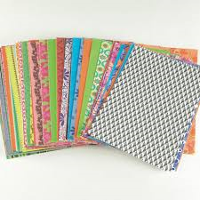



**EL2 Demonstrate some knowledge of the equipment required for creative crafts**

**Label the following pieces of equipment:**

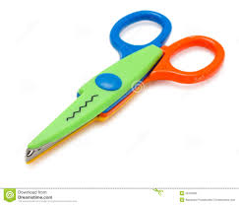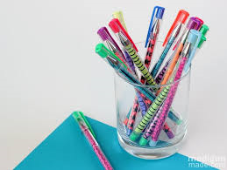

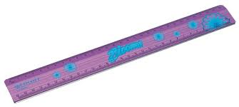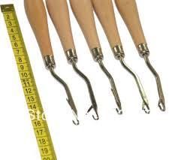

**EL2 Demonstrate some understanding of the skills required for creative crafts**

**Label the skills being used in the following pictures**

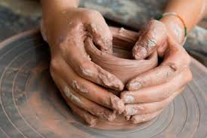

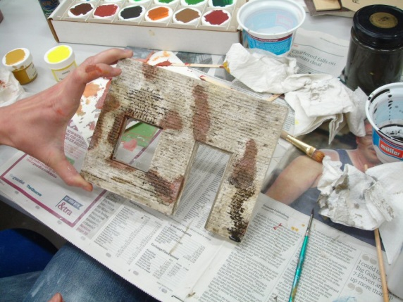

[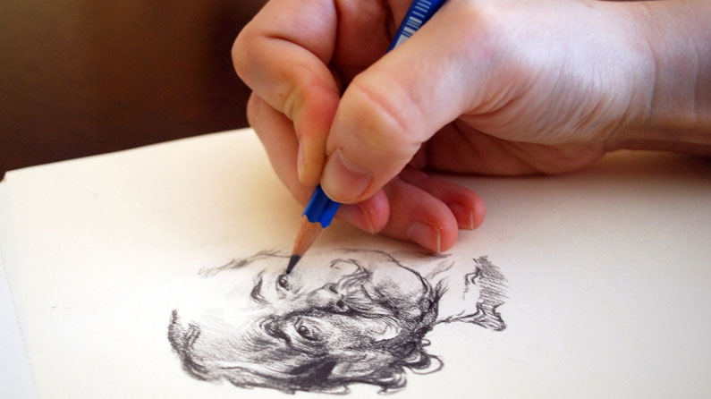](http://www.creativebloq.com/illustration/sketching-tips-beginners-81516497)

**EL3 Demonstrate good understanding of the materials required for creative crafts**

**List five materials required to make a gift**

|  |
| --- |
|  |
|  |
|  |
|  |
|  |

**List three tools required to make a gift and describe what they are used for:**

|  |  |
| --- | --- |
| **Tool One:** |  |

|  |  |
| --- | --- |
| **Use:** |  |
|  | |

|  |  |
| --- | --- |
| **Tool Two:** |  |

|  |  |
| --- | --- |
| **Use:** |  |
|  | |

|  |  |
| --- | --- |
| **Tool Three:** |  |

|  |  |
| --- | --- |
| **Use:** |  |
|  | |

**EL3 Demonstrate good understanding of the skills required for creative crafts**

**List three skills you might need to use when making a birthday card and describe how you might use them:**

|  |  |
| --- | --- |
| **Skill One:** |  |

|  |  |
| --- | --- |
| **Use:** |  |
|  | |

|  |  |
| --- | --- |
| **Skill Two:** |  |

|  |  |
| --- | --- |
| **Use:** |  |
|  | |

|  |  |
| --- | --- |
| **Skill Three:** |  |

|  |  |
| --- | --- |
| **Use:** |  |
|  | |

|  |  |  |  |  |
| --- | --- | --- | --- | --- |
| **Knowledge of materials, equipment and skills achieved at:** | **EL1** | **EL2** | **EL3** | **Teacher Signature** |
|  |  |  |  |

**EL1: Identify suitable materials or equipment from a pre-selected range to help make a gift**

[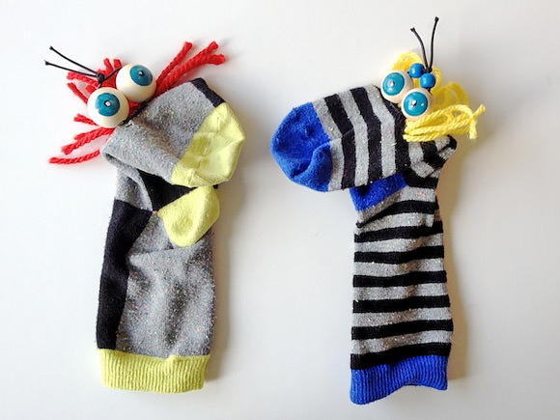](http://www.google.co.uk/url?sa=i&rct=j&q=&esrc=s&source=images&cd=&cad=rja&uact=8&ved=0ahUKEwjNzrSh2PTUAhVMJ8AKHZoSBnUQjRwIBw&url=http://www.handmadecharlotte.com/7-diy-sock-puppets/&psig=AFQjCNGqEAuOorwT9TfjONFT31l7_2QOIw&ust=1499431630980577)**Tick the following materials and equipment you will need to make the gift below:**

|  |  |
| --- | --- |
| **Materials** | **Equipment** |
| Ribbon | Scissors |
| Thread | Glue Gun |
| Beads | Marker |
| Jewels | Pencil |
| Paint | Needles |
| Socks | Bobbin |
| Wool | Ruler |
| Buttons | Crochet Hook |

**EL2: Select suitable materials or equipment from the range provided to make two different types of gift**

**Write the following materials and equipment you will need to make the gifts, using the list below to help you:**

|  |  |  |  |
| --- | --- | --- | --- |
| **Marshmallows** | **Toilet Roll Tube** | **Hot Chocolate** | **Tea Bags** |
| **Eye Decoration** | **Star Decoration** | **Glue** | **Pipe Cleaners** |
| **Coloured Paper** | **Piping Bag** | **Scissors** | **Glue Gun or Glue** |
| **Felt tips** | **Coloured card** | **Pom Pom** | **Ribbon** |

[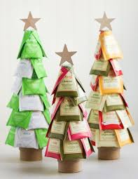](https://www.google.co.uk/url?sa=i&rct=j&q=&esrc=s&source=images&cd=&cad=rja&uact=8&ved=0ahUKEwjp1KnVhffUAhUJCMAKHZw4CjgQjRwIBw&url=https://www.pinterest.com/santalove/christmas-ornament-diy-exchange/&psig=AFQjCNHqrOWCGFqGN8LY20gVdW2IS0ZbYQ&ust=1499512528439977)**Gift One:**

[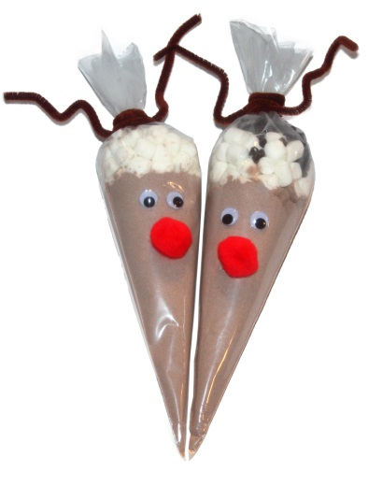](http://www.google.co.uk/url?sa=i&rct=j&q=&esrc=s&source=images&cd=&cad=rja&uact=8&ved=0ahUKEwjGuOKRhvfUAhVsDsAKHU9CAJcQjRwIBw&url=http://www.chicagoparent.com/magazines/chicago-parent/2014-december/reindeer-cones&psig=AFQjCNFMq_WXmZYJp495SsRY9hpmTJFHvA&ust=1499512666043897)

**Gift Two**

**Gift One:**

**List the equipment and materials required to create gift one:**

|  |  |
| --- | --- |
|  |  |
|  |  |
|  |  |
|  |  |
|  |  |
|  |  |

**Gift Two:**

**List the equipment and materials required to craft gift two:**

|  |  |
| --- | --- |
|  |  |
|  |  |
|  |  |
|  |  |
|  |  |
|  |  |

**EL3: Select suitable materials or equipment from a wide range to make three different types of cards for different occasions**

**Look at the three cards below, list on the next page the materials or equipment required to make them.**

[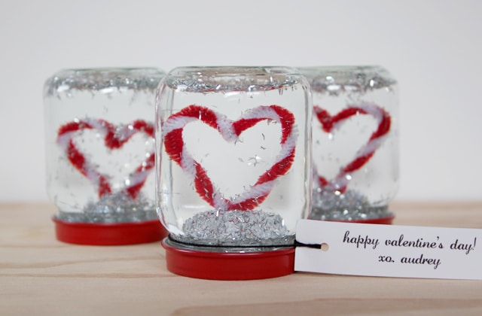](http://www.google.co.uk/url?sa=i&rct=j&q=&esrc=s&source=images&cd=&cad=rja&uact=8&ved=0ahUKEwjVoqiPi_fUAhUJAsAKHdSFDDQQjRwIBw&url=http://playtivities.com/homemade-valentine-gifts/&psig=AFQjCNEU_EkY1tXWeAjmC1n-mUHCbT5QkA&ust=1499513945859752)

Gift One

Gift Two

Gift Three

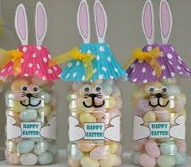

[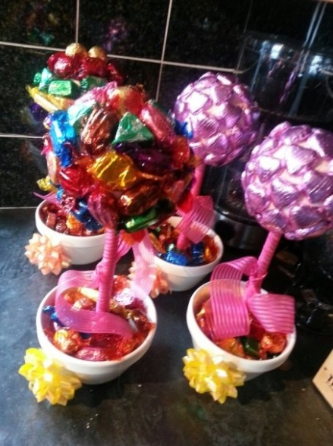](https://www.google.co.uk/url?sa=i&rct=j&q=&esrc=s&source=images&cd=&cad=rja&uact=8&ved=0ahUKEwiElbPYivfUAhWjAMAKHdxxAX8QjRwIBw&url=https://www.ukbride.co.uk/wedding-forum-discussion/do-it-yourself-sweet-tree-instructions-x_2?DiscussionID=45542&page=2&psig=AFQjCNEsYklgY6v-08p3DTTnoh-U6SvHeA&ust=1499513780042689)

**Gift One:**

|  |  |
| --- | --- |
|  |  |
|  |  |
|  |  |
|  |  |
|  |  |

**Gift Two**

|  |  |
| --- | --- |
|  |  |
|  |  |
|  |  |
|  |  |
|  |  |

**Gift Three**

|  |  |
| --- | --- |
|  |  |
|  |  |
|  |  |
|  |  |
|  |  |

**AO2 Practical Assessment**

You are a designer for Gifts R Us; they want to launch a new range of gifts for the following occasions:

* Christmas
* Easter Celebration
* Birthday

You have been asked to choose a design from a range of samples for gift.

Once you have chosen your favourite design you will create a plan of work and follow it to make the gift(s).

You will be assessed on the following areas:

* **Personal health and safety issues**
* **Safe use of tools and materials**
* **Choosing the gift item to make**
* **Materials and equipment**
* **Planning**
* **End Product**

**A02 Practical Assessment**

**Personal Health and Safety Issues**

**For this assessment you have to prepare for gift making by considering Personal Health and Safety Issues.**

**Pupils who will achieve Level One will:**

* Be able to identify suitable protective clothing that should be worn when gift making.

**Pupils who will achieve Level Two will:**

* Be able to select suitable protective clothing that should be worn when gift making.

**Pupils who will achieve Level Three will:**

* Be able to prepare for their craft work by wearing suitable protective clothing.

**AO2 Practical Assessment One: Personal Health and Safety**

|  |  |  |  |
| --- | --- | --- | --- |
|  | **Please indicate by placing one tick in the appropriate box the level the learner has achieved** | | |
| **Skill Demonstrated** | **EL1** | **EL2** | **EL3** |
| **Preparing for craft work by wearing suitable protective clothing** | **Skill demonstrated by learner who received significant help** | **Skill demonstrated by learner who received some help** | **Skill demonstrated by learner who received little or no help** |
| **Level Achieved** |  |  |  |
| **Evidence: Photograph** | | | |
| **Evidence Teacher Witness Statement:** | | | |

**A02 Practical Assessment**

**Safe use of tools and materials**

**For this assessment you have to prepare for card making using tools and materials safely.**

**Pupils who will achieve Level One will:**

* Be able to use scissors safely.

**Pupils who will achieve Level Two will:**

* Be able to use two tools safely and appropriately.

**Pupils who will achieve Level Three will:**

* Use at least three tools to work safely and appropriately.

**AO2 Practical Assessment Two: Safe use of tools and materials**

|  |  |  |  |
| --- | --- | --- | --- |
|  | **Please indicate by placing one tick in the appropriate box the level the learner has achieved** | | |
| **Skill Demonstrated** | **EL1** | **EL2** | **EL3** |
| **Safe use of tools and materials** | **Skill demonstrated by learner who received significant help** | **Skill demonstrated by learner who received some help** | **Skill demonstrated by learner who received little or no help** |
| **Level Achieved** |  |  |  |
| **Evidence: Photographs** | | | |
| **Evidence Teacher Witness Statement:** | | | |

**A02 Practical Assessment**

**Choosing the gift item to make**

**For this assessment you have to prepare select a gift to make from a range of samples.**

**Pupils who will achieve Level One will:**

* Select a gift to make from a small selection of samples provided.

**Pupils who will achieve Level Two will:**

* Select two different types of gifts to make from a selection of samples.

**Pupils who will achieve Level Three will:**

* Select at least three different types of gifts to make for different occasions.

**AO2 Practical Assessment Three: Choosing the gift item to make**

|  |  |  |  |
| --- | --- | --- | --- |
|  | **Please indicate by placing one tick in the appropriate box the level the learner has achieved** | | |
| **Skill Demonstrated** | **EL1** | **EL2** | **EL3** |
| **Correct basic materials** | **Skill demonstrated by learner who received significant help** | **Skill demonstrated by learner who received some help** | **Skill demonstrated by learner who received little or no help** |
| **Level Achieved** |  |  |  |
| **Evidence: Photographs** | | | |
| **Evidence Teacher Witness Statement:** | | | |

**A02 Practical Assessment**

**Materials and Equipment**

**For this assessment you have to select appropriate materials and equipment**

**Pupils who will achieve Level One will:**

* Select appropriate materials or equipment from a limited range provided, for example, glue, scissors, pencils and felt tips.

**Pupils who will achieve Level Two will:**

* Select appropriate materials or equipment for two different types of gifts from a broad range provided.

**Pupils who will achieve Level Three will:**

* Select a variety of appropriate materials and equipment to make at least three different types of gifts for three different occasions demonstrating flair and creativity.

**AO2 Practical Assessment Four: Materials and Equipment**

|  |  |  |  |
| --- | --- | --- | --- |
|  | **Please indicate by placing one tick in the appropriate box the level the learner has achieved** | | |
| **Skill Demonstrated** | **EL1** | **EL2** | **EL3** |
| **Materials and Equipment** | **Skill demonstrated by learner who received significant help** | **Skill demonstrated by learner who received some help** | **Skill demonstrated by learner who received little or no help** |
| **Level Achieved** |  |  |  |
| **Evidence: Photographs** | | | |
| **Evidence Teacher Witness Statement:** | | | |

**A02 Practical Assessment**

**Planning**

**For this assessment you have to (help) make a plan of work**

**Pupils who will achieve Level One will:**

* Set out the chosen materials and equipment to help make a plan of work.

**Pupils who will achieve Level Two will:**

* Make a plan of work using the materials as a guide.

**Pupils who will achieve Level Three will:**

* Make a plan of work.

**My Plan of Work**

**Gift One**

|  |
| --- |
| **Step One** |
| **Step Two** |
| **Step Three** |
| **Step Four** |
| **Step Five** |
| **Step Six** |
| **Step Seven** |

**My Plan of Work**

**Gift Two**

|  |
| --- |
| **Step One** |
| **Step Two** |
| **Step Three** |
| **Step Four** |
| **Step Five** |
| **Step Six** |
| **Step Seven** |

**My Plan of Work**

**Gift Three**

|  |
| --- |
| **Step One** |
| **Step Two** |
| **Step Three** |
| **Step Four** |
| **Step Five** |
| **Step Six** |
| **Step Seven** |

**AO2 Practical Assessment Five: Planning**

|  |  |  |  |
| --- | --- | --- | --- |
|  | **Please indicate by placing one tick in the appropriate box the level the learner has achieved** | | |
| **Skill Demonstrated** | **EL1** | **EL2** | **EL3** |
| **Planning** | **Skill demonstrated by learner who received significant help** | **Skill demonstrated by learner who received some help** | **Skill demonstrated by learner who received little or no help** |
| **Level Achieved** |  |  |  |
| **Evidence: Photographs** | | | |
| **Evidence Teacher Witness Statement:** | | | |

**A02 Practical Assessment**

**End Product**

**For this assessment you have to make gift(s) of a particular quality.**

**Pupils who will achieve Level One will:**

* Follow the plan to make the gift.

**Pupils who will achieve Level Two will:**

* Follow the plan to make two different types of gifts and answer questions about what they are doing. These gifts should be of a reasonable quality.

**Pupils who will achieve Level Three will:**

* Follow the plan to make at least three different types of gifts for three different occasions, explaining the processes involved. These gifts should be of a high quality finish, pleasing to look at and demonstrate flair and creativity.

**AO2 Practical Assessment Six: End Product**

|  |  |  |  |
| --- | --- | --- | --- |
|  | **Please indicate by placing one tick in the appropriate box the level the learner has achieved** | | |
| **Skill Demonstrated** | **EL1** | **EL2** | **EL3** |
| **End product**  **Making the gift(s)** | **Skill demonstrated by learner who received significant help** | **Skill demonstrated by learner who received some help** | **Skill demonstrated by learner who received little or no help** |
| **Level Achieved** |  |  |  |
| **Evidence: Photographs** | | | |
| **Evidence Teacher Witness Statement:** | | | |

**EL1 Gift One**

**Picture of end product**

**EL2 Gift Two**

**Photo of gift two**

**EL2 Verbal Questions and responses about making the gifts**

***Classroom assistant can scribe responses***

**What Personal Protective Equipment are you using?**

|  |
| --- |
|  |
|  |
|  |

**What tools are you using?**

|  |
| --- |
|  |
|  |
|  |

**What materials are you using?**

|  |
| --- |
|  |
|  |
|  |

**What skills are you using?**

|  |
| --- |
|  |
|  |
|  |

**What planning did you have to do get to this stage?**

|  |
| --- |
|  |
|  |
|  |

**EL2 Verbal Questions and responses about making the gifts**

***Classroom assistant can scribe responses***

**What Personal Protective Equipment are you using?**

|  |
| --- |
|  |
|  |
|  |

**What tools are you using?**

|  |
| --- |
|  |
|  |
|  |

**What materials are you using?**

|  |
| --- |
|  |
|  |
|  |

**What skills are you using?**

|  |
| --- |
|  |
|  |
|  |

**What planning did you have to do get to this stage?**

|  |
| --- |
|  |
|  |
|  |

**Gift Three**

**Photo of gift**

**EL3 Explaining the Processes involved**

**As the learner is making their gifts they will be explaining and demonstrating to a Teacher or Classroom Assistant the processes involved. The Teacher or Classroom Assistant will scribe what the pupil says below:**

**Gift One: Processes involved**

|  |
| --- |
|  |
|  |
|  |
|  |
|  |
|  |
|  |
|  |

**Gift Two: Processes involved**

|  |
| --- |
|  |
|  |
|  |
|  |
|  |
|  |
|  |
|  |

**Gift Three: Processes involved**

|  |
| --- |
|  |
|  |
|  |
|  |
|  |
|  |
|  |
|  |

**AO3**

**Task Reviews**

In this section you need to indicate how you have performed in each task and show evidence of a basic review.

**Review of Task One: Personal Health and Safety Issues**

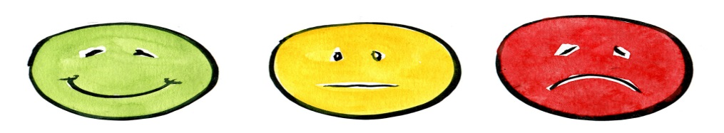**EL1 In this task I did:**

**EL2 Something I did well was:**

|  |
| --- |
|  |
|  |

**EL2 Something I could improve on is:**

|  |
| --- |
|  |
|  |

**EL3 A skill I learnt was:**

|  |
| --- |
|  |

**EL3: How will this skill help me in the future?**

|  |
| --- |
|  |
|  |

**EL3: What would I do differently next time?**

|  |
| --- |
|  |
|  |

**Review of Task Two: Safe use of tools and materials**

**EL1 In this task I did:**

**EL2 Something I did well was:**

|  |
| --- |
|  |
|  |

**EL2 Something I could improve on is:**

|  |
| --- |
|  |
|  |

**EL3 A skill I learnt was:**

|  |
| --- |
|  |

**EL3: How will this skill help me in the future?**

|  |
| --- |
|  |
|  |

**EL3: What would I do differently next time?**

|  |
| --- |
|  |
|  |

**Review of Task Three: Choosing the gift item to make**

**EL1 In this task I did:**

**EL2 Something I did well was:**

|  |
| --- |
|  |
|  |

**EL2 Something I could improve on is:**

|  |
| --- |
|  |
|  |

**EL3 A skill I learnt was:**

|  |
| --- |
|  |

**EL3: How will this skill help me in the future?**

|  |
| --- |
|  |
|  |

**EL3: What would I do differently next time?**

|  |
| --- |
|  |
|  |

**Review of Task Four: Materials and Equipment**

**EL1 In this task I did:**

**EL2 Something I did well was:**

|  |
| --- |
|  |
|  |

**EL2 Something I could improve on is:**

|  |
| --- |
|  |
|  |

**EL3 A skill I learnt was:**

|  |
| --- |
|  |

**EL3: How will this skill help me in the future?**

|  |
| --- |
|  |
|  |

**EL3: What would I do differently next time?**

|  |
| --- |
|  |
|  |

**Review of Task Five: Planning**

**EL1 In this task I did:**

**EL2 Something I did well was:**

|  |
| --- |
|  |
|  |

**EL2 Something I could improve on is:**

|  |
| --- |
|  |
|  |

**EL3 A skill I learnt was:**

|  |
| --- |
|  |

**EL3: How will this skill help me in the future?**

|  |
| --- |
|  |
|  |

**EL3: What would I do differently next time?**

|  |
| --- |
|  |
|  |

**Review of Task Six: End Product**

**EL1 In this task I did:**

**EL2 Something I did well was:**

|  |
| --- |
|  |
|  |

**EL2 Something I could improve on is:**

|  |
| --- |
|  |
|  |

**EL3 A skill I learnt was:**

|  |
| --- |
|  |

**EL3: How will this skill help me in the future?**

|  |
| --- |
|  |
|  |

**EL3: What would I do differently next time?**

|  |
| --- |
|  |
|  |

**AO3**

**Final Review**

In this section you need to indicate how you have performed in the unit and suggest how you might improve.

**Final Review**

**EL1 In this unit I learnt how to:**

|  |
| --- |
|  |
|  |
|  |
|  |
|  |

**EL1 I did well when:**

|  |
| --- |
|  |
|  |
|  |

**EL2 If I had to do this unit again I would:**

|  |
| --- |
|  |
|  |
|  |

**EL2 Would you like to work with crafts when you leave school?**

|  |  |
| --- | --- |
| Yes | No |

**EL2: What job would you like to do or where would you like to work?**

|  |
| --- |
|  |
|  |
|  |

**EL3 Explain a reason for your answer:**

|  |
| --- |
|  |
|  |
|  |

**EL3 What did you do well in A01?**

|  |
| --- |
|  |
|  |

**EL3 What did you do not so well in A01?**

|  |
| --- |
|  |
|  |

**EL3 What did you do well in A02?**

|  |
| --- |
|  |
|  |

**EL3 What did you do not so well in A02?**

|  |
| --- |
|  |
|  |