Please find a range of recipes that we use in Home Economics lesson below. They can be used to continue learning at home as well as a means of ensuring your child keeps their skill level refreshed until we return to class.

Encourage your child to take photos of them cooking, I would love to these in the new term!

Have fun and enjoy your time in the kitchen!!

Mrs Strain

Calzone

**Ingredients**

* 500g self-raising flour
* 1 teaspoon dried oregano
* 180mls of milk
* 50g sliced salami, cut into strips
* 1 cup grated mozzarella cheese
* 2 tablespoons grated parmesan cheese
* Pinch of salt
* 40g butter, cubed
* 3 tablespoons tomato puree
* ½ green pepper, diced
* 1 egg, lightly beaten
* 1 tablespoon sliced olives
* Mushrooms, optional

**Method**

1. Combine flour, salt and oregano in a large mixing bowl. Rub in butter with fingertips until the mixture resembles breadcrumbs.
2. Make a well in the centre, add the milk and mix to a soft dough. Care is needed at this stage as you may not need all of your milk. The dough should be soft but not sticky.
3. Knead dough lightly on a floured surface and roll out into a circle about the size of a dinner plate.
4. Place on a floured oven tray. Spread half of the dough with tomato puree, and top with salami, mozzarella cheese, parmesan cheese, green pepper, mushroom and olives.
5. Fold remaining dough over on top of toppings and pinch together carefully. It is important to create a complete seal to prevent the filling from oozing out while it cooks.
6. Brush with egg and bake at 200°C for 15- 20 minutes until golden brown and cooked through.

Chilli Chicken Burritos

Ingredients

* 200g skinless chicken breast fillet, cut into strips
* 1 teaspoon mild chilli powder
* 1 teaspoon ground cumin
* ½ teaspoon ground coriander
* 1 teaspoon olive oil
* ½ onion, sliced
* ½ red pepper, cut into strips
* 1 courgette, cut into strips
* 4 tortilla wraps, warmed
* 60g reduced-fat Cheddar cheese, grated
* 2 tablespoons of low-fat natural yoghurt

Method

1. Combine spices in a sandwich bag or small bowl add chicken strips and toss until coated.
2. Heat oil in non-stick frying pan or wok and sauté the onion, pepper and courgette for 2 minutes, add chicken and cook for a further 4 minutes until golden. Pour in one tablespoon of water and cook for another 2 minutes.
3. Warm tortilla (10 seconds in microwave).
4. To assemble burrito, lay tortillas onto a plate, sprinkle evenly in the centre with chicken mixture and a dollop of yoghurt. Roll tortilla up from the bottom, and then fold in from each side to enclose.

Tip:

Wrap tortilla in a serviette for easy handling.

**Cottage Pie with Champ Topping**

**[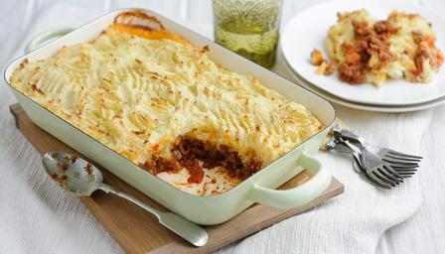](http://www.google.co.uk/url?sa=i&rct=j&q=&esrc=s&frm=1&source=images&cd=&cad=rja&uact=8&ved=0CAcQjRw&url=http://www.bbc.co.uk/food/recipes/comfortingcottagepie_14505&ei=uCC5VI7-H42O7Aa5kICQBA&bvm=bv.83829542,d.ZGU&psig=AFQjCNHitCyEhaD0OkBsSUZCZaJB6yMUTQ&ust=1421505076850311)**

**Ingredients:**

200g lean minced beef 300g potatoes diced

1 small onion chopped 2-3 spring onions diced

1 carrot finely diced 25g butter

1 parsnip finely diced Salt and pepper

1tablespoon gravy granules

**Method:**

1. Peel and chop potatoes into small cubes and boil for 20minutes until soft.
2. In a saucepan brown mince over a medium heat.
3. Finely chop the carrot, onion and parsnip
4. Add to the mince and cover with 100mls water, bring to boil then reduce heat and simmer for 15minutes. Then stir in the gravy granules.
5. Mash the potatoes and stir in the butter, milk and spring onions.
6. Transfer the mince to ovenproof dish and top with champ
7. Place in oven at 200ºC for 25minutes until the top goes golden brown.

Fifteens!!!

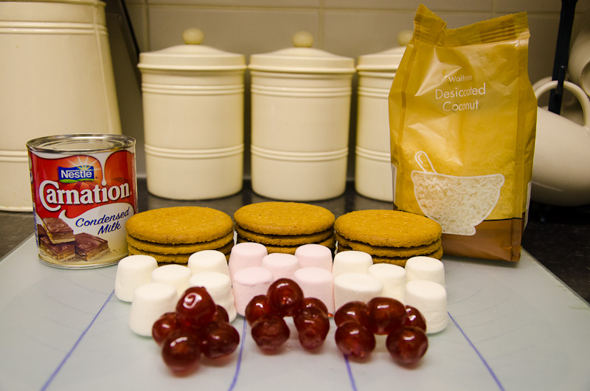



Crush the 15 digestive biscuits

Cut the 15 marshmallows in half

Cut the 15 cherries in half

Open the tin of condensed milk and mix all the ingredients together.

Roll out into a sausage shape.

Cover with coconut.

Wrap tightly and put into fridge for 20 minutes.

Cut into 15 biscuits.

**APPLE AND CINNAMON BUNS**

INGREDIENTS

150g self raising flour

¼ level teaspoon salt

1 ½ teaspoons cinnamon

75g margarine

75g Demerara sugar

1 cooking apple

1 egg

METHOD

1. Set oven to 220ºC/gas 6.
2. Sieve flour, salt and cinnamon into mixing bowl.
3. Cut and rub margarine into flour using fingertips.
4. Add sugar and mix well.
5. Grate peeled and cored apple into bowl.
6. Add egg and a little milk and mix to a soft dropping consistency.
7. Spoon into a patty tin. Bake for 15 minutes until golden.

EQUIPMENT LIST

Sieve

Baking bowl

Tin plate

Knife

Plastic spatula

Grater

Wooden spoon

Bun tray

Bun cases

Teaspoon

Pot stand

**LENTIL SOUP**

**Ingredients** 600ml Boiling water

1 stock cube

75g lentils

1 Potato

1 Onion

1 Small carrot

pinch of salt and pepper (for flavour)

**Method**

1. Dissolve stock cube in boiling water. Pour stock into large pan.
2. Add lentils, seasoning and simmer gently.
3. Wash, peel, slice and dice potato. Add to pan.
4. Peel and chop onion finely. Add to pan.
5. Wash, peel and grate carrot. Add to pan.
6. Simmer for 20-25 minutes with lid on. Stir occasionally.
7. 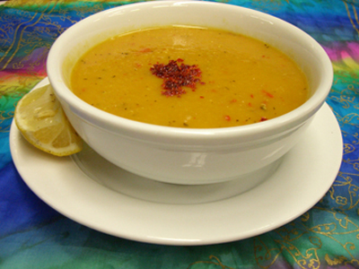Serve soup hot.

**MARS BAR KRISPIES**

**INGREDIENTS**

4 mars bars

100g margarine

100g Rice Krispies

1 bar cake chocolate

**METHOD**

1. Melt margarine in saucepan.
2. Add mars bars. Stir all the time.
3. When melted add Rice Krispies.
4. Put into swiss roll tin. Spread evenly.
5. Melt chocolate. Pour over and set.

**EQUIPMENT**

saucepan knife swiss roll tin

baking bowl wooden spoon spatula

pot stand chopping board

**SAVOURY PINWHEELS**



**INGREDIENTS**

200g block puff pastry

125g cheddar cheese Between 2

2 slices cooked ham

Dried mixed herbs

**METHOD**

1. Pre-heat oven to 200˚C, 400˚F, Gas 7.
2. Roll out the pastry on a lightly floured table until very thin.
3. Grate the cheese and chop the cooked ham finely.
4. Arrange the grated cheese and chopped ham over the pastry to within 1cm of the edges. Sprinkle with a little dried mixed herbs. Brush the space at the edges with cold water.
5. Roll up lengthways and cut into “pinwheels” 3/4 – 1cm thick.
6. Place pinwheels on a baking tray (only 7 or 8 per tray) to allow them to spread.
7. Bake for approximately 10 minutes.
8. Serve hot as a savoury snack for supper.

***Raspberry Buns***

[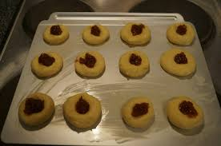](http://www.google.co.uk/imgres?imgurl=http://whattocookfordinnertonight.com/wp-content/uploads/2013/04/Raspberry-Jammy-Buns-ready-to-go-in-the-oven-1024x680.jpg&imgrefurl=http://whattocookfordinnertonight.com/raspberry-jam-biscuit/&h=680&w=1024&tbnid=8r8ziIfCXWIalM:&zoom=1&docid=RR8YD_yIsfMRaM&hl=en&ei=FS9rVIjjFI3PaNy3gsgM&tbm=isch&ved=0CEAQMygVMBU&iact=rc&uact=3&dur=585&page=2&start=13&ndsp=17)***Ingredients:***

100g self-raising flour

50g margarine

50g castor sugar

1 egg

Raspberry jam

***Method:***

Preheat oven to 200ºC.

Sieve flour into a baking bowl and rub in the margarine.

Add the sugar and stir using a wooden spoon.

Beat the egg in a measuring jug then add to the flour mixture. Mix well.

Place dough onto a floured desk and knead into a long strip.

Cut into smaller pieces and shape into round.

Place on a baking tray and make a well in each bun.

Fill with raspberry jam, and then bake for 20mins.

Leave to cool on a wire rack.

**Sausage Rolls**

[](http://www.google.co.uk/imgres?imgurl=http://www.tnpride.com/sites/default/files/styles/recipe-profile/public/recipes/SWIRLS%20HERO.jpg?itok=gFvcHSZ5&imgrefurl=http://www.tnpride.com/recipe/sausage-pinwheels&h=233&w=280&tbnid=ZX3sw6IdR-ltSM:&zoom=1&docid=PLxBxiUo-BChQM&hl=en&ei=ZO5_VfmWMtGI7Aa1moHYBw&tbm=isch&ved=0CGgQMyg7MDtqFQoTCPnY55r1k8YCFVEE2wodNU0Aew)***Ingredients:***

100g frozen puff pastry

100g pork sausage meant

1 egg, beaten

***Method:***

1. Pre-heat oven to 200°C
2. Onto a lightly floured surface roll out the pastry into a rectangle shape and approx., 1/2cm thick
3. [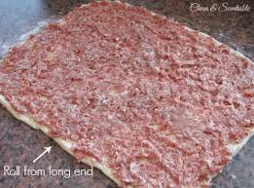](http://www.google.co.uk/imgres?imgurl=http://cf.cleanandscentsible.com/wp-content/uploads/2014/01/Sausage-Roll-Pinwheels.jpg&imgrefurl=http://www.cleanandscentsible.com/2014/01/sausage-pinwheels-big-game-day-giveaway.html&h=370&w=500&tbnid=STi4QtXpUUl02M:&zoom=1&docid=JG9noxtW5GG9-M&hl=en&ei=p-x_VcOYAuWY7ga5yoOIDQ&tbm=isch&ved=0CE4QMygkMCRqFQoTCIOIn8bzk8YCFWWM2wodOeUA0Q)Using a dinner knife spread the sausage meat over the surface in a thin even layer.
4. Dampen the edge closest to you and roll the pastry up
5. Glaze the top with beaten egg and cut into mini sausage roll sized pieces.
6. [](http://www.google.co.uk/imgres?imgurl=http://cf.cleanandscentsible.com/wp-content/uploads/2014/01/Sausage-Roll-Pinwheels-11.jpg&imgrefurl=http://www.cleanandscentsible.com/2014/01/sausage-pinwheels-big-game-day-giveaway.html&h=376&w=500&tbnid=Ek_Uf7NABcVxtM:&zoom=1&docid=JG9noxtW5GG9-M&hl=en&ei=p-x_VcOYAuWY7ga5yoOIDQ&tbm=isch&ved=0CE8QMyglMCVqFQoTCIOIn8bzk8YCFWWM2wodOeUA0Q)Place on baking tray, allowing room for the pastry to grow during cooking and bake for 12-15minutes until golden brown in colour.

**Oat Cookies**

***Ingredients***

[](http://www.google.co.uk/url?sa=i&rct=j&q=&esrc=s&frm=1&source=images&cd=&cad=rja&uact=8&ved=0CAcQjRw&url=http://pixelatedcrumb.com/2011/12/04/blueberry-walnut-oatmeal-cookies-and-a-giveaway/&ei=i5jUVLy0Isn-7AaqhYGQAQ&bvm=bv.85464276,d.ZGU&psig=AFQjCNHHLx7UadYy-PZmtHI07IMAcqiZUQ&ust=1423305207290115)

100g soft margarine

75g Demerara sugar

100g plain wholemeal flour

100g porridge oats

***Method***

1. Use a paper towel to grease the baking tray with a little soft margarine. Put the margarine and sugar into a bowl and mix them together with a wooden spoon.
2. Add the flour and the oats to the bowl. Mix everything together, using a spoon and then your hands, to make a soft dough.
3. Put the dough onto a floured surface and gently press it out.
4. Cut the circles of dough and put them onto the baking tray.
5. Bake the cookies in the oven for 12-15 at 180ºC, until they are golden brown. Place the cookies onto a wire rack to cool.