CCEA Occupational Studies
Entry Level
Final Level:

Horticulture
Unit 22: Planning: Growing Food from Seed
Candidate Name
Candidate Number
Teaching Centre Name | Longstone Special School
Teaching Centre Number | 71551
Administration Centre Name
Administration Centre Number
Pathway | Horticulture
I certify that the evidence submitted for this unit is my own work:

Learner Signature: ………………………………………………………………………
I certify that the evidence submitted for this unit is the work of: ………………………………….
Teacher Signature: ……………………………………. Date: ………………………

Photograph of End Product

Horticulture
Unit 22: Planning: Growing food from seeds

This unit is designed to provide vocational skills in horticulture at Entry Level 1, Entry Level 2 and Entry Level 3. It gives learners the opportunity to experience and become familiar with the skills they need to grow food from seeds. Learners will follow appropriate health and safety procedures throughout the planning, preparation and growing process. They will also consider environmental issues and job opportunities. Learners will develop their fine motor skills by completing and presenting the finished item(s) and will review their work.

This unit includes:

• Health and safety issues in horticulture activities;
• Job opportunities relating to horticulture;
• Environmental issues relating to horticulture;
• Using basic tools and equipment appropriately;
• Parts and functions of a plant;
• Life cycle of a plant;
• Planting a variety of seeds;
• Potting out seedlings;
• Care for plants in a container;
• A review of performance.

A01Knowledge Check

Health and Safety, Environment and Related Careers

In this section you will:

- Identify a job opportunity in the horticulture industry, identify one place of work in the horticulture industry and state at least two roles and responsibilities of the position.
- Recognise a potential health and safety hazard in the horticulture industry, two health and safety rules and the potential consequences of non-compliance.
- Recognise what is meant by the 3R’s, and explain why recycling is important.

AO1 Health and Safety, Environment and Related Careers
EL1: Circle the job related to an opportunity in the Horticulture industry.
EL2: Draw a line from each job to the correct place of work
Hospital
Restaurant
Factory
Garage

Park

El3 State at least two roles and responsibilities of a position
This is Derek he is a ___________________________
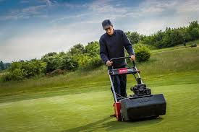
Chef

Plumber

Secretary
Jewellery designer

Farmer

Green Keeper

Write down two responsibilities Derek has when working on the golf course.

Health and Safety
EL1 Recognise (by circling) a potential health and safety hazard in the horticulture industry
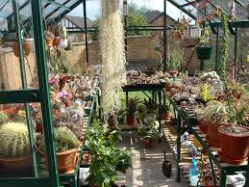

EL2 Identify two health and safety rules for the above Green House

EL3 Explain what might happen if these rules are broken:
What do the 3 Rs stand for?
R________
R________
R________
EL2: What does it mean to use the 3rs?

EL3 Why is it important to recycle as much as possible when undertaking horticultural work?

AO1 Knowledge Check

Materials, Knowledge and Skills

In this section you will:

- Demonstrate basic, some, good knowledge and understanding of materials, equipment and skills required for horticulture
- Identify one, two pots suitable for small herbs and a container suitable for larger plants.
- Identify one, two or three tools needed to work in horticulture.
- Identify one seed and one flower, two seeds and two flowers or three seeds and three flowers.
- Identify one root, stem, leaf and flower or two roots, stems, leaves and flowers or three roots, stems, leaves and flowers and explain their purpose.
- Help make a poster or leaflet explaining how to care for plants, or help make a poster or leaflet explaining how to care for indoor plants or help make a poster or leaflet explaining how to care for indoor and outdoor plants.

EL1 Identify one pot or container to plant out a small herb

Which pot or container is suitable to plant out a small herb?

Number:_____
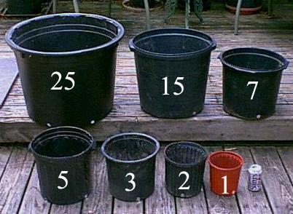

EL2: identify two suitable pots or containers to plant out some small herbs

Circle two suitable pots or containers which would be suitable to plant out some small herbs
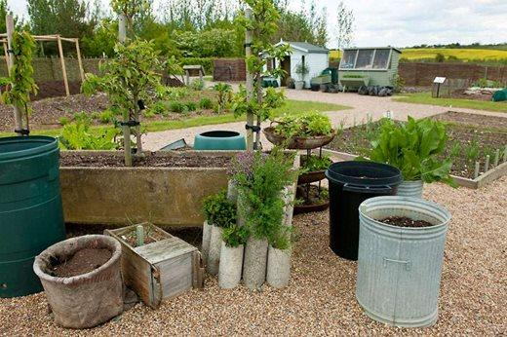
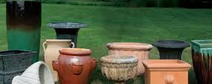
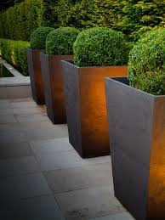
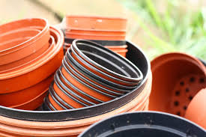
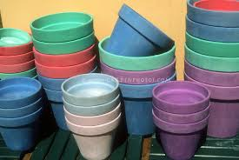

EL3: identify a pot or container to plant out a small herb plant and a container suitable for larger plants
Sort the below containers and pots into either suitable for a small herb plant or suitable for larger plants.

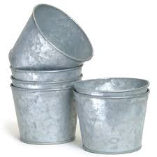
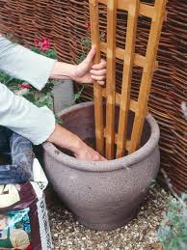

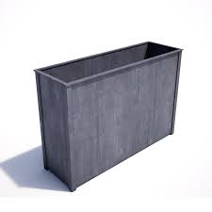

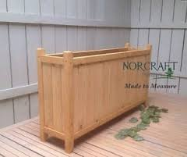
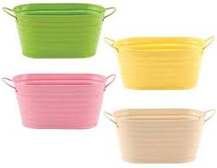

EL1 Identify one tool
EL2 Identify two tools
EL3 Identify three tools

Identify as many tools as you can
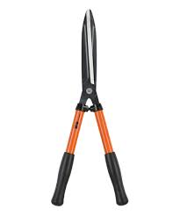
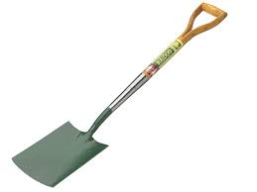
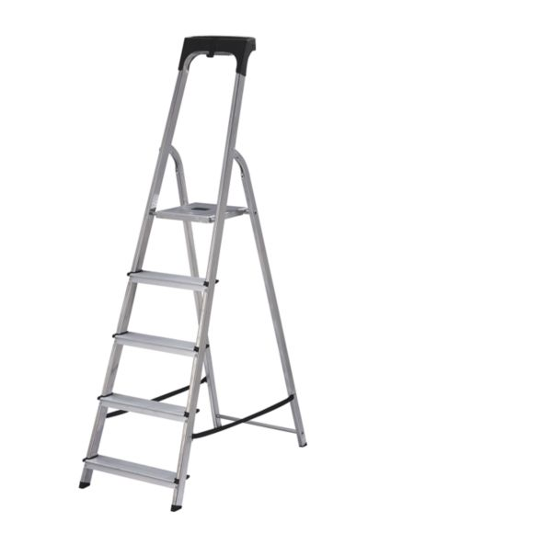
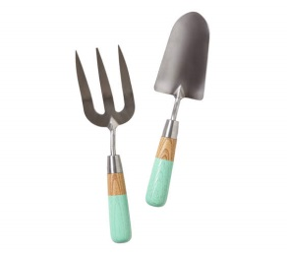
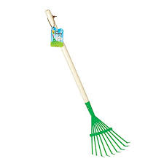
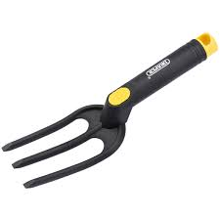
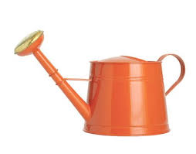
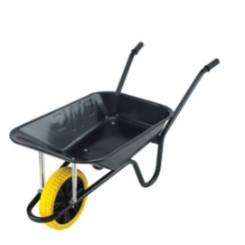
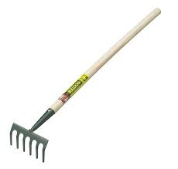

444444

EL1 Identify a seed and a flower
Label the below photographs either seed or flower
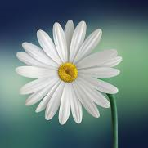

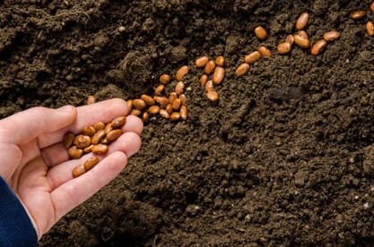

EL2: Identify two seeds and two flowers
Label the type of seed or flower below
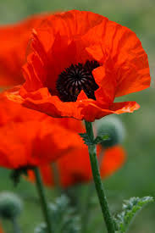
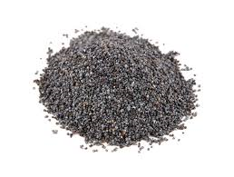
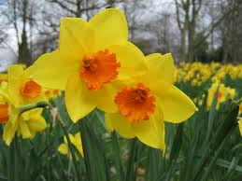
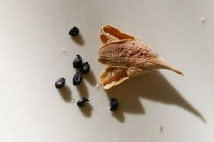

Poppy Seed Daffodil
Daffodil Seed Poppy

EL3 Identify three seeds and three flowers
Identify the three types of flowers below:

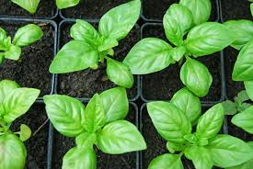
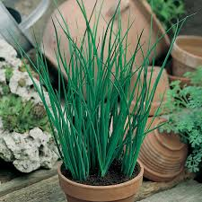
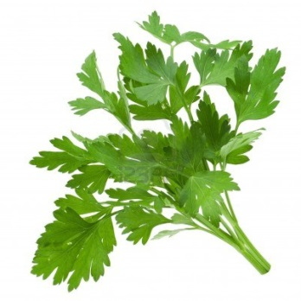

EL3 Identify the three seeds below;
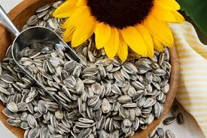
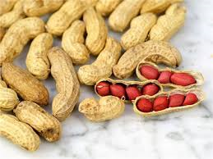
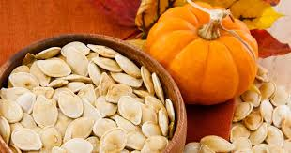

EL1 identify one root, stem, leaf or flower
Label the below diagram

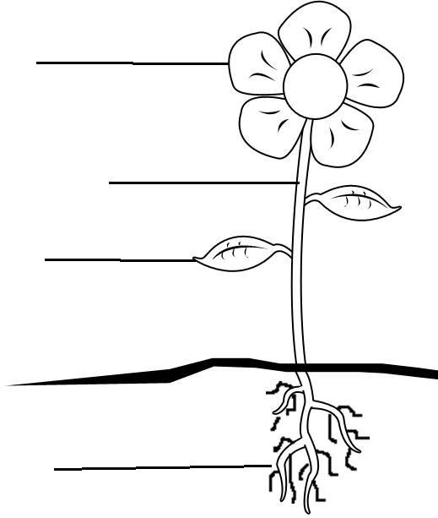

ROOT STEM LEAF FLOWER

EL2: identify two root, stem, leaf and flower
MAKE SURE YOU ANSWER PREVIOUS EL1 QUESTION

Label the below photographs:
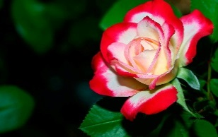
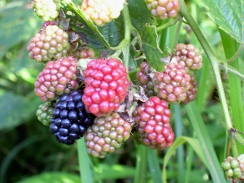
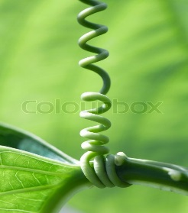
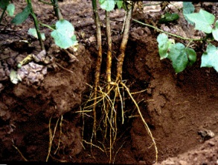
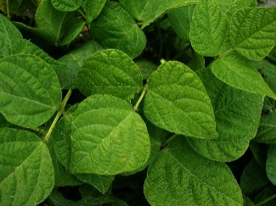

El3 identify three root, stem, leaf and flower and explain their purpose
MAKE SURE YOU ANSWER PREVIOUS EL1 AND EL2 QUESTIONS

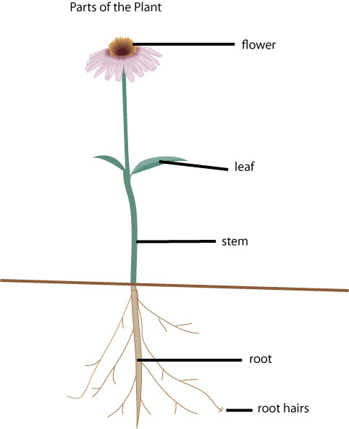

What do roots do?

What do stems do?

What do flowers do?

What do leaves do?

Task
Using a computer design a leaflet or poster for one of the following options
EL1 | EL2 | EL3
How to care for plants | How to care for plants indoors | How to care for plants indoors and outdoors

Make sure your leaflet or poster includes the following;

- Title
- Pictures
- Border
- Information on what a plant needs to survive
- How to plant a seed or plug
- Tips for daily care

Staple your print outs to this page

A02

In this section you will demonstrate the following skills and knowledge:

- Select and put on the correct PPE for every task
- Plant an ‘egg head’ with cress
- Plant a container with large seeds
- Plant out large seeds such as peas and beans in a large container or a vegetable patch
- Select container
- Pot out a container with herbs

A02 Task One
Practical Task: Select and put on the correct PPE for every task
Pupils will be asked to choose suitable PPE and tools from a range.
Teacher will tick the box which describes the pupil’s skill level
The pupil was able to:
EL1 | EL2 | EL3
Choose one item of PPE and choose one correct tool and clean it afterwards | Choose two items of PPE and choose two correct tools and help clean these afterwards | Choose three items of PPE and state their importance and choose three correct tools and clean these after use.
I can confirm the learner was able to choose the above number of PPE items / tools and clean them afterwards
Signed ____________ Date: _______________

Task One Photographic evidence of selecting correct tools & PPE

Task Two Photographic evidence of correct tools & PPE cress egg head

Task Three Photographic evidence of correct tools & PPE container with large seeds

Task four correct PPE & tools plant out large seeds in a large container or vegetable patch

Task Five correct PPE & tools when selecting a container

Task Six Photographic evidence correct PPE & tools when potting out a container with herbs:

4

Teacher witness statement

Signed ____________ Dated _______________

A02 Task Two
Practical Task: Plant an ‘Egg Head’ with cress
Pupils will be asked to plant an egg head with cress
Teacher will tick the box which describes the pupil’s skill level
The pupil was able to:
EL1 | EL2 | EL3
Handle the egg and fill it with compost mixed with seeds. | Handle the egg, fill it with compost and seeds and water it. | Handle the egg and fill it with compost and seeds, tidying up afterwards
I can confirm the learner demonstrated the above skills when planting an egg head with cress
Signed ____________ Date: _______________

Task Two: Photographic evidence of pupil planting an egg head with cress:

4

Task Two: Photographic evidence of pupil planting an egg head with cress:

Teacher witness statement

Signed ____________ Dated _______________

A02 Task Three
Practical Task: Plant a container with large seeds

EL1 Handle a large seed and one seedling carefully | EL2 Handle two large seeds and one seedling carefully | EL3 Handle three large seeds and three seedlings carefully
I can confirm the learner demonstrated the above skills when planting a container with large seeds
Signed ____________ Date: _______________

Task Three: Planting a container with large seeds photographic evidence

4

Task Three: Planting a container with large seeds photographic evidence

Teacher witness statement

Signed ____________ Dated _______________

A02 Task Four
Practical Task: Plant out large seeds such as peas or beans in a large container or vegetable patch

EL1 Help to place the compost in the container and plant one seed and a small plant | EL2 Place the compost into the container and plant two seeds and two small plants | EL3 Place the compost into the container and water. Plant three seeds and a small plant at correct depths and cover with compost
I can confirm the learner demonstrated the above skills when planting out large seeds in a large container or vegetable patch
Signed ____________ Date: _______________

Task Four: Photographic evidence of planting out large seeds in a large container or vegetable patch

Task Four: Photographic evidence of planting out large seeds in a large container or vegetable patch

Teacher witness statement

Signed ____________ Dated _______________
A02 Task Five
Practical Task: Select a container for herbs

EL1 identify a suitable container and fill it with compost and water. | EL2 identify two suitable containers and fill with compost and water | EL3 identify three suitable containers and fill with compost and water
I can confirm the learner demonstrated the above skills when selecting a suitable container for herbs.
Signed ____________ Date: _______________

Task Five: Photographic evidence of learner selecting a suitable container for herbs

Task Five: Photographic evidence of learner selecting a suitable container for herbs

Teacher witness statement

Signed ____________ Dated _______________

A02 Task Six
Practical Task: Pot out a container with herbs

EL1 Plant the seedlings or small plants and cover with compost | EL2 Plant seeds and small plants and cover with compost | EL3 Plant the seeds and small plants and cover with compost and put in an incubator
I can confirm the learner demonstrated the above skills when potting out a container with herbs
Signed ____________ Date: _______________

Task Six Photographic evidence of the learner potting out a container with herbs

Task Six Photographic evidence of the learner potting out a container with herbs

Teacher witness statement

Signed ____________ Dated _______________

AO3
Task Reviews

In this section you need to indicate how you have performed in each task and show evidence of a basic review.

Review of Task One: Personal Protective Equipment

EL1 In this task I did:
Very Good | OK | Not Well

EL2 Something I did well was:

EL2 Something I could improve on is:

EL3 A skill I learnt was:

EL3: How will this skill help me in the future?
EL3: What would I do differently next time?

Review of Task Two: Plant an Egg Head with cress

EL1 In this task I did:
Very Good | OK | Not Well

EL2 Something I did well was:

EL2 Something I could improve on is:

EL3 A skill I learnt was:

EL3: How will this skill help me in the future?
EL3: What would I do differently next time?

Review of Task Three: Plant a container with large seeds

EL1 In this task I did:
Very Good | OK | Not Well

EL2 Something I did well was:

EL2 Something I could improve on is:

EL3 A skill I learnt was:

EL3: How will this skill help me in the future?
EL3: What would I do differently next time?

Review of Task Four : Plant out large seeds such as peas or beans

EL1 In this task I did:
Very Good | OK | Not Well

EL2 Something I did well was:

EL2 Something I could improve on is:

EL3 A skill I learnt was:

EL3: How will this skill help me in the future?
EL3: What would I do differently next time?

Review of Task Five: Select a container

EL1 In this task I did:
Very Good | OK | Not Well

EL2 Something I did well was:

EL2 Something I could improve on is:

EL3 A skill I learnt was:

EL3: How will this skill help me in the future?
EL3: What would I do differently next time?

Review of Task Six: Pot out a container with herbs

EL1 In this task I did:
Very Good | OK | Not Well

EL2 Something I did well was:

EL2 Something I could improve on is:

EL3 A skill I learnt was:

EL3: How will this skill help me in the future?
EL3: What would I do differently next time?

AO3
Final Review

In this section you need to indicate how you have performed in the unit and suggest how you might improve.

Final Review
EL1 In this unit I learnt how to:

EL1 I did well when:

EL2 If I had to do this unit again I would:

EL2 Would you like to work with plants when you leave school?
Yes | No

EL3 Explain a reason for your answer:

EL3 What did you do well in A01?

EL3 What did you do not so well in A01?

EL3 What did you do well in A02?

EL3 What did you do not so well in A02?

