YEAR 8 ART

I am missing you guys! I hope you are all staying at home and I will see you soon! Mrs Cromie

NAME:________________________ CLASS_______

Draw yourself in the circle

1

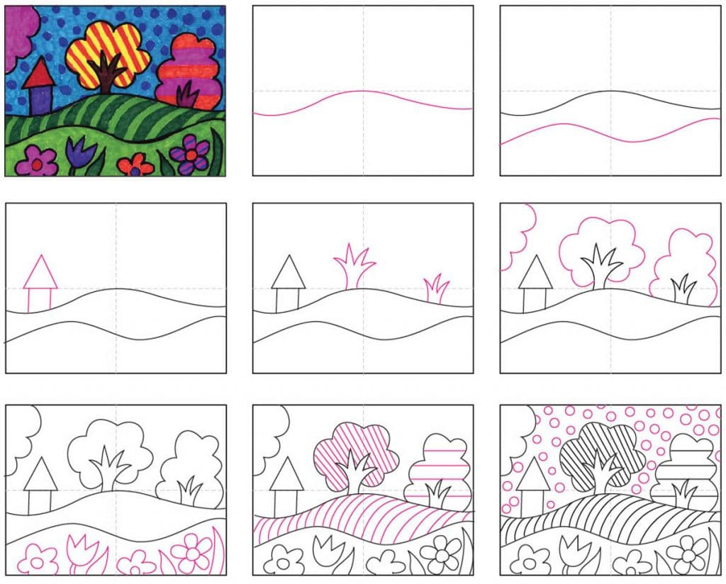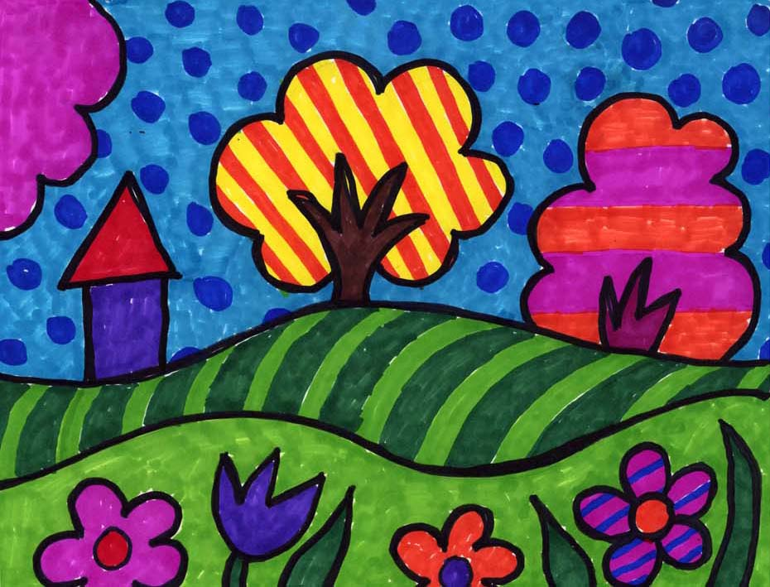

DRAW A POP ART LANDSCAPE

Follow these step by step instructions and draw your landscape on the next page. Turn the page on its side.

2

MY POP ART LANDSCAPE

3

Try to add some perspective. Fold the next page in half to guide you. Draw your design on the next page.

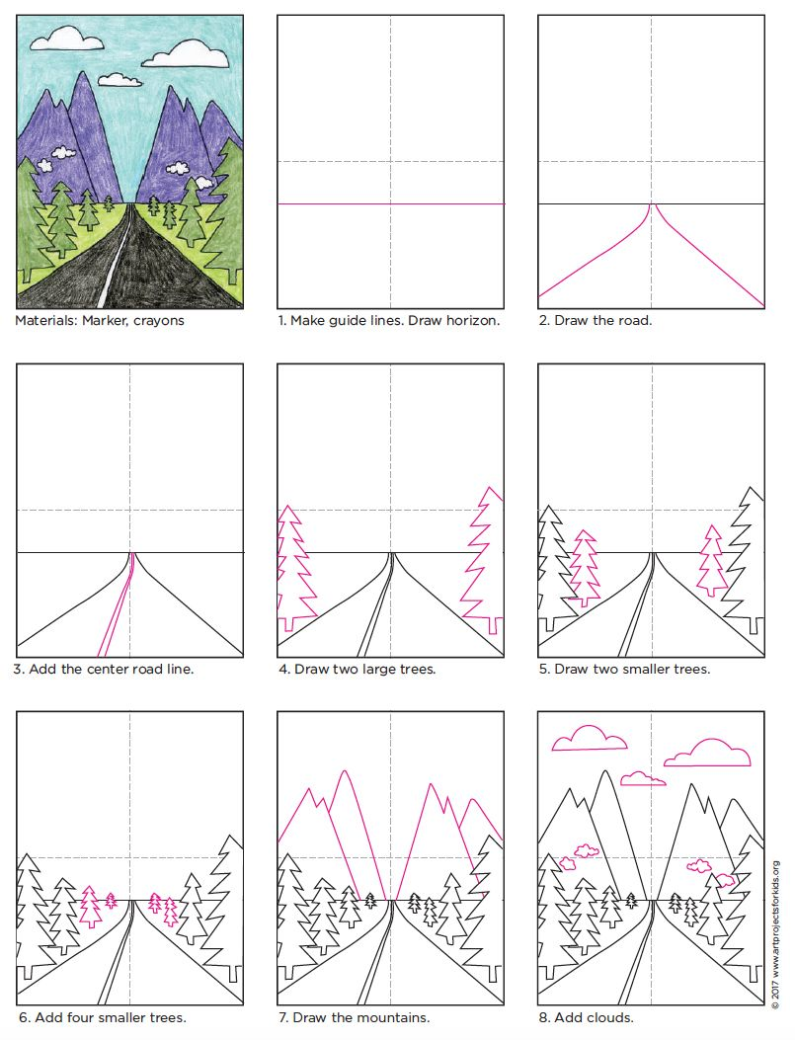

4

5

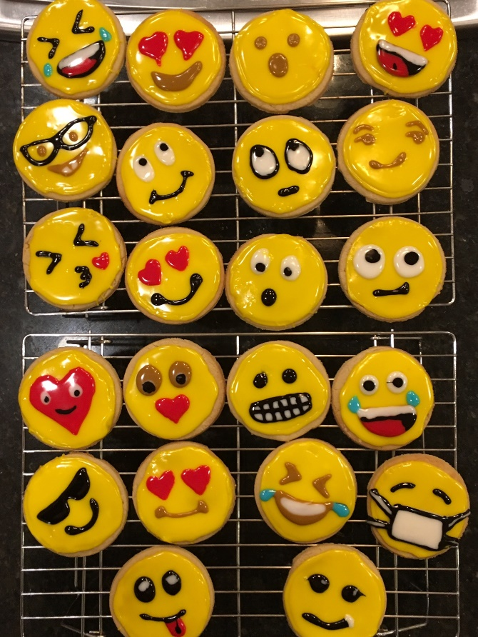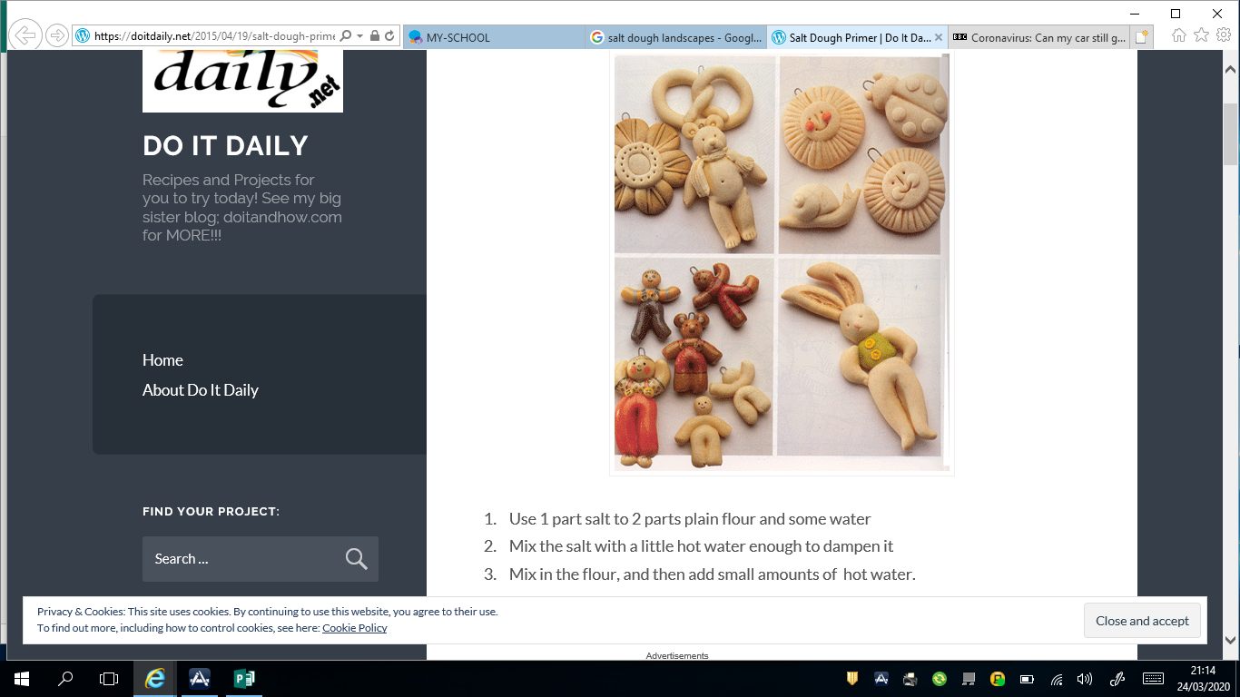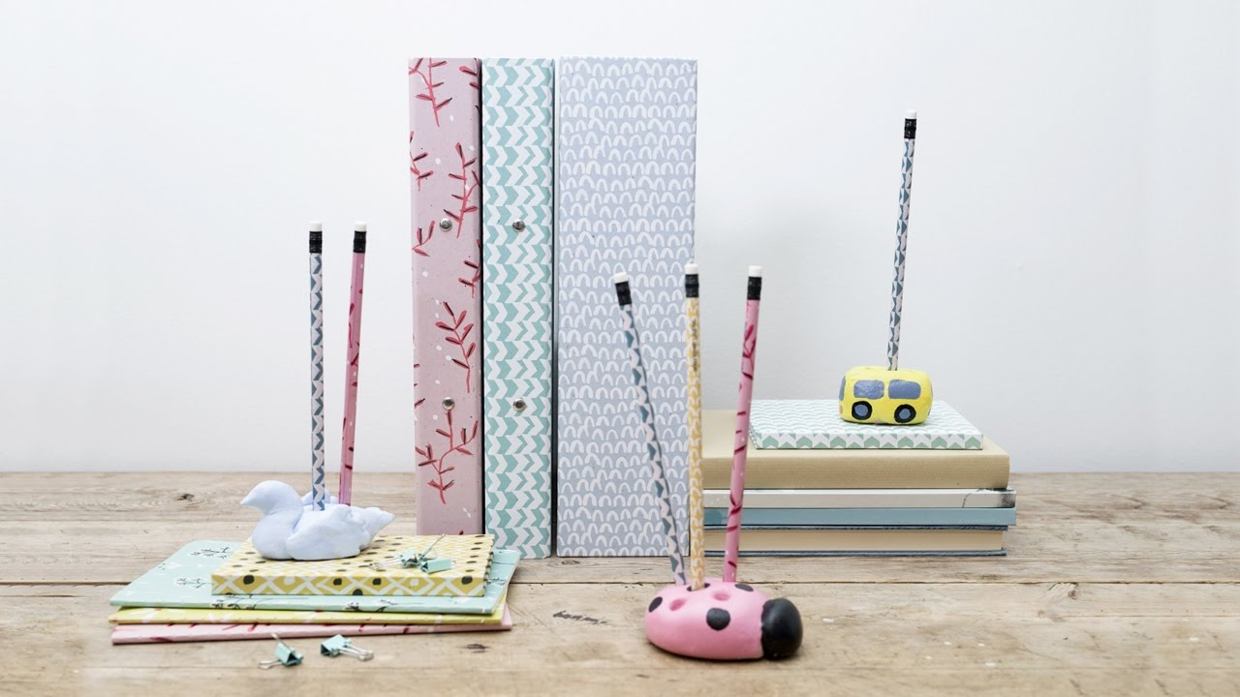

6

Make fun things with salt dough.

Salt Dough

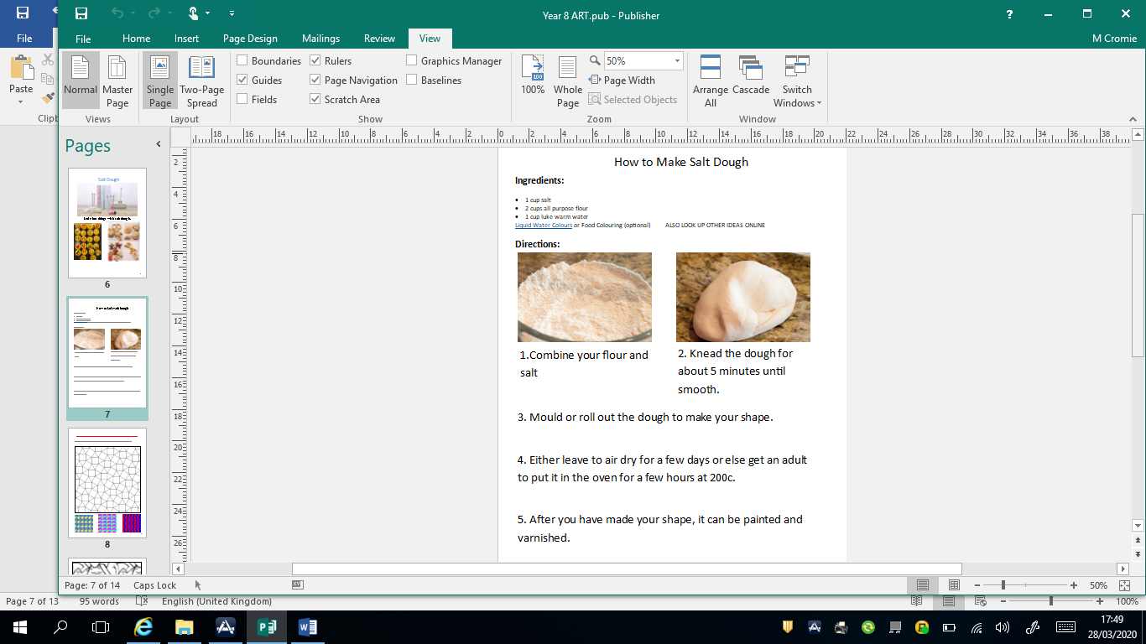

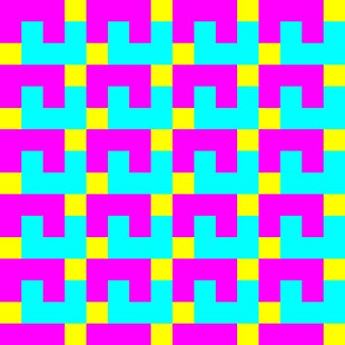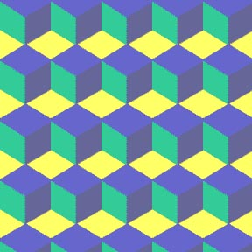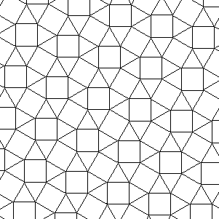

**TESSELLATIONS**

A pattern of shapes that fit perfectly together

8

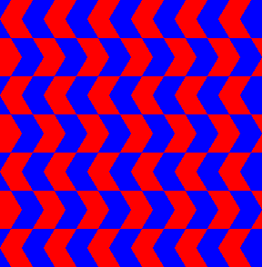

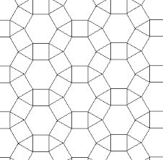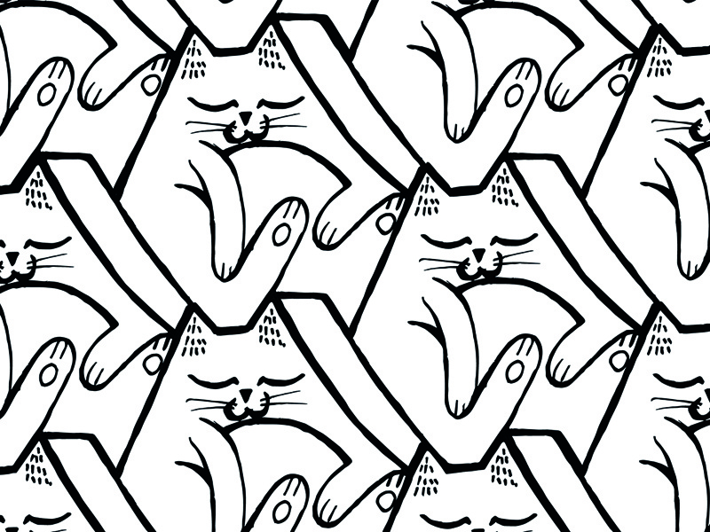

9

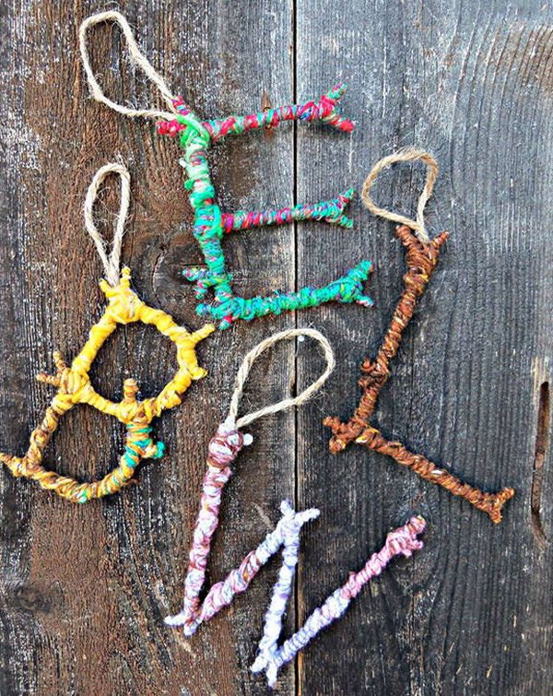

Twig Art

Try to make the letter of your first name from twigs and wool. A glue gun works best, but you can get an adult to help you use other glues and leave it to dried really well before wrapping wool around it.

You can look up ideas online!

10

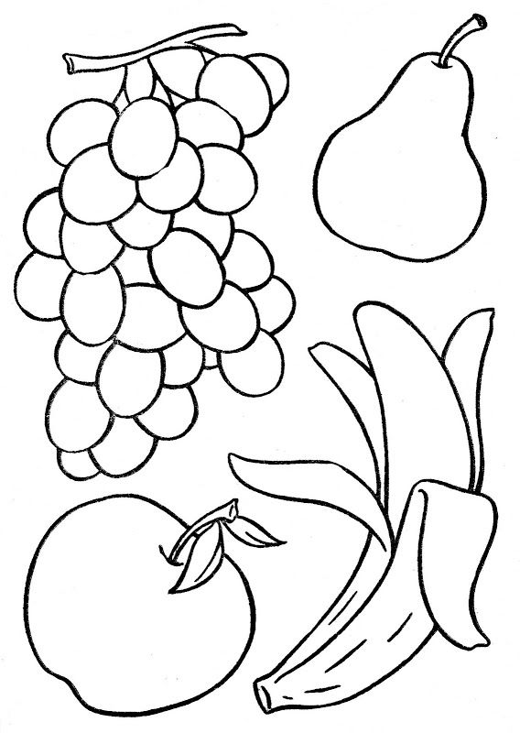

Collage. Use old magazines to cut or tear small pieces to inside these shapes. Use a glue stick or PVA and keep inside the lines.

11

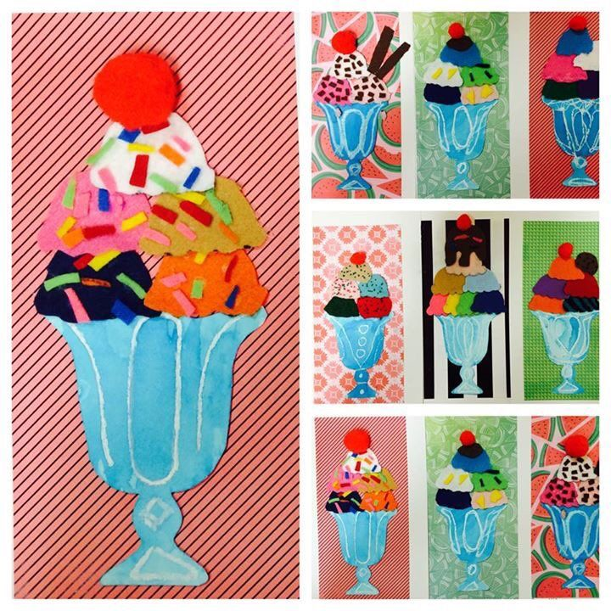

12

ICE CREAM SUNDAE COLLAGE

Colour or paint a glass and the background. Then cut out background colours from old pieces of paper or

magazines . Then add sprinkles.