CCEA Occupational Studies
Entry Level
Final Level:

Horticulture
Unit 23: Planning: Growing Bulbs for Gifts
Candidate Name
Candidate Number
Teaching Centre Name | Longstone Special School
Teaching Centre Number | 71551
Administration Centre Name
Administration Centre Number
Pathway | Horticulture
I certify that the evidence submitted for this unit is my own work:

Learner Signature: ………………………………………………………………………
I certify that the evidence submitted for this unit is the work of: ………………………………….
Teacher Signature: ……………………………………. Date: ………………………

Photograph of End Product

Horticulture
Unit 23: Planning: Growing bulbs for gifts
This unit is designed to provide vocational skills in horticulture at Entry Level 1, Entry Level 2 and Entry Level 3. It gives learners the opportunity to experience and become familiar with the skills they need to grow bulbs. They should also make the bulb container into a gift, choosing suitable wrapping, labels and packaging. Learners will follow appropriate health and safety procedures throughout the planning, preparation and growing process. They will also consider environmental issues and job opportunities. Learners will develop their motor skills by completing and presenting the finished item(s) and will review their work.
This unit includes:
• health and safety issues in horticulture activities;
• job opportunities relating to horticulture;
• environmental issues relating to horticulture;
• using basic tools and equipment appropriately;
• using suitable decorative materials for producing a seasonal gift;
• a review of performance.

A01 Knowledge Check

Health and Safety, Environment and Related Careers

In this section you will:

- Identify a job opportunity in the horticulture industry, identify one place of work in the horticulture industry and state at least two roles and responsibilities of the position.
- Recognise a potential health and safety hazard in the horticulture industry, two health and safety rules and the potential consequences of non-compliance.
- Recognise what is meant by the 3R’s, identify what is meant by the 3Rs and explain why recycling is important.

AO1 Health and Safety, Environment and Related Careers
EL1: Circle the job related to an opportunity in the Horticulture industry.
EL2: Draw a line from each job to the correct place of work
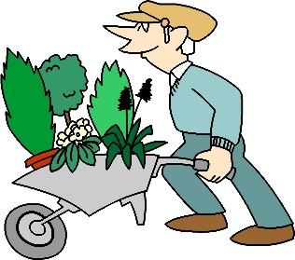
Homes and Businesses
Nursery
Office
Local Parks

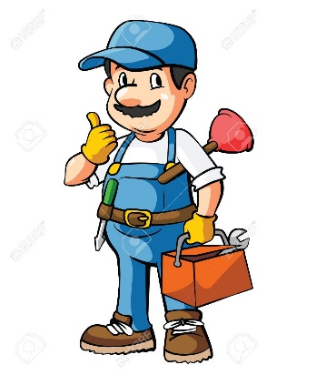

El3 State at least two roles and responsibilities of a position
This is John he is a ___________________________
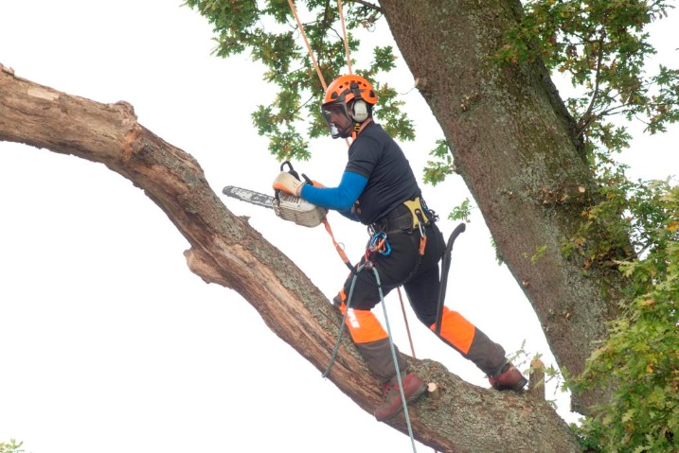
Chef

Plumber

Secretary
Jewellery designer

Farmer

Tree Surgeon

Write down two responsibilities Derek has when working with trees.

Careers level:
EL1 achieved | EL2 achieved | EL3 achieved

Health and Safety
EL1 Recognise (by circling) a potential health and safety hazard in the horticulture industry
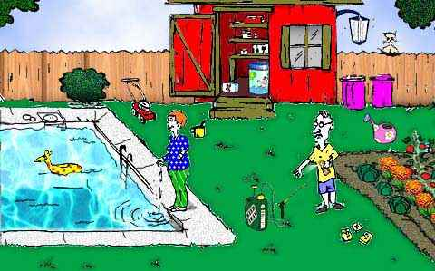
EL2 Identify two health and safety rules for the above garden:

EL3 Explain what might happen if these rules are broken:

H&S Level:
EL1 achieved | EL2 achieved | EL3 achieved

What do the 3 Rs stand for?
R________
R________
R________
EL2: What does it mean to use the 3rs?
In Horticulture you can re-use:

In Horticulture you can reduce;

In Horticulture you can recycle:

EL3 Why is it important to recycle as much as possible when undertaking horticultural work?

Environment level:
EL1 achieved | EL2 achieved | EL3 achieved

AO1 Knowledge Check

Materials, Knowledge and Skills

In this section you will:

- Demonstrate basic, some, good knowledge and understanding of materials, equipment and skills required for horticulture.
- Identify one, two bulbs and one corm,
- Identify the root and shoot ends of a bulb, which way to plant it and how to deep to plant it as well as when bulbs are planted for Christmas gifts and when they flower.
- Help make a poster with instructions on how to care for one named plant given as a gift, produce a poster with instructions on how to care for a gift of a plant, produce a poster with instructions on how to care for a gift of a plant for Christmas.

Demonstrate knowledge of materials, equipment and skills required for horticulture
EL1 Identify one material used in horticulture
EL2 Identify two materials used in horticulture
EL3 Identify three or more materials used in horticulture

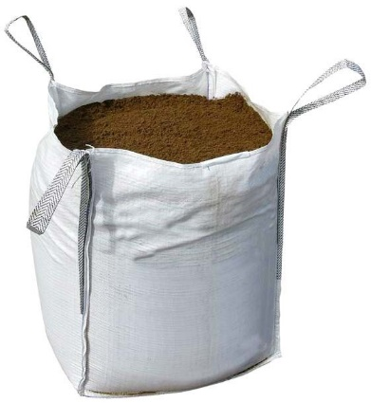
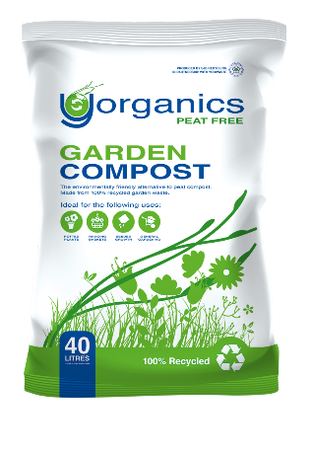
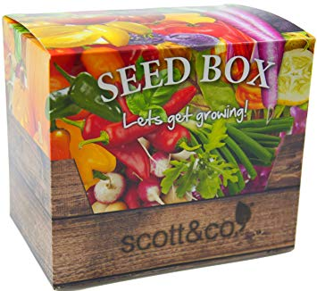
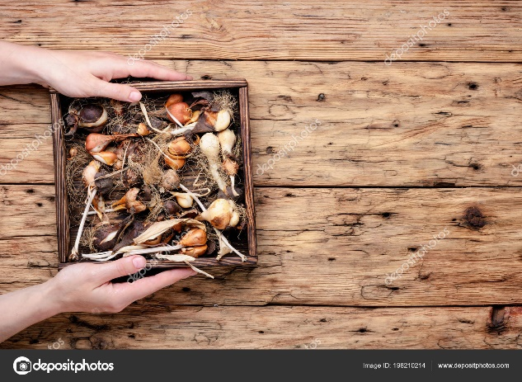
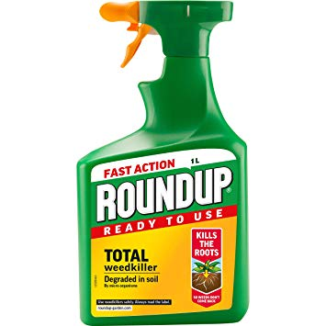
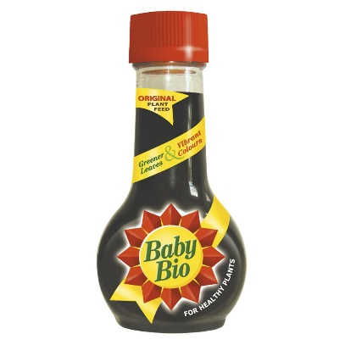

#

Demonstrate knowledge of materials, equipment and skills required for horticulture
EL1 Identify one piece of equipment used in Horticulture
EL2 Identify two pieces of equipment used in Horticulture
EL3 Identify three or more pieces of equipment used in Horticulture

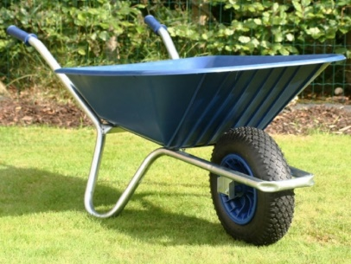
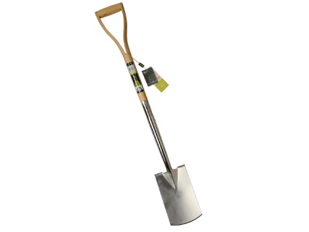
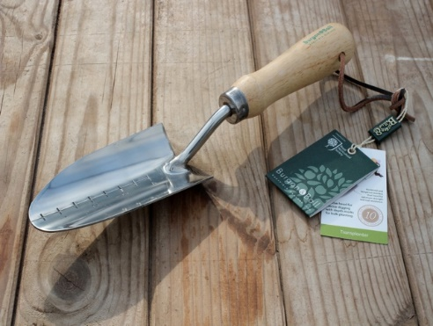
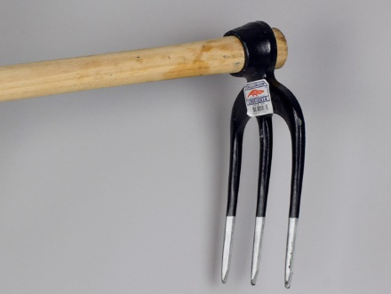
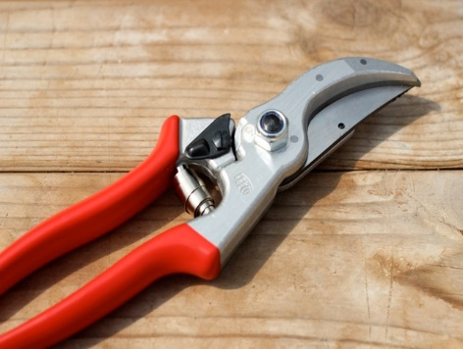
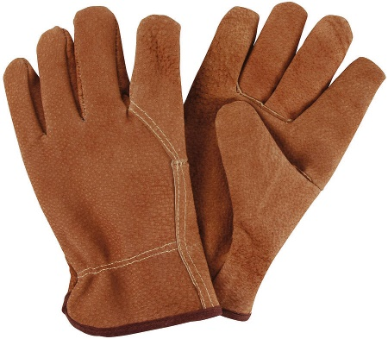

Demonstrate knowledge of materials, equipment and skills required for horticulture
EL1 Name one skill you need to work in Horticulture

EL2 Name another skill you need to work in Horticulture:

EL3 Name another skill you need to work in Horticulture
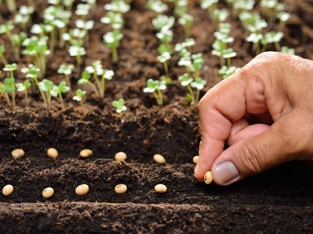
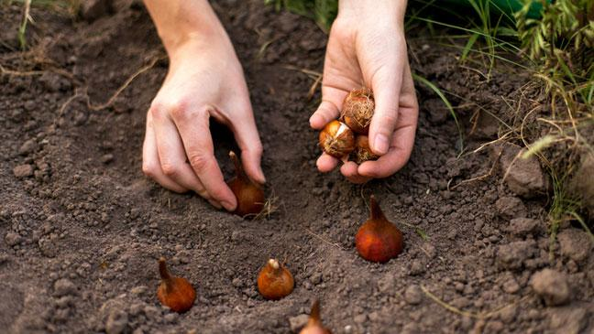
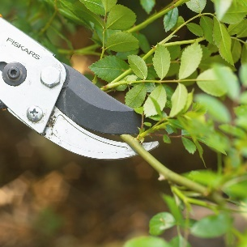
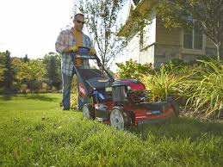
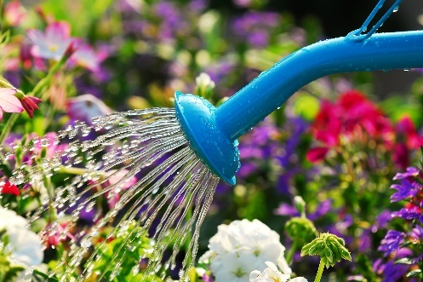
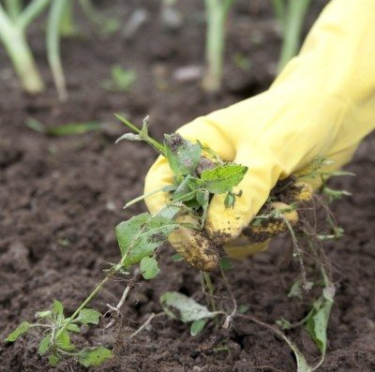
Materials, equipment and skills:
EL1 achieved | EL2 achieved | EL3 achieved

Identifying Bulbs and Corms
EL1 Identify one bulb
EL2 Identify two bulbs
EL3 Identify two bulbs and one corm
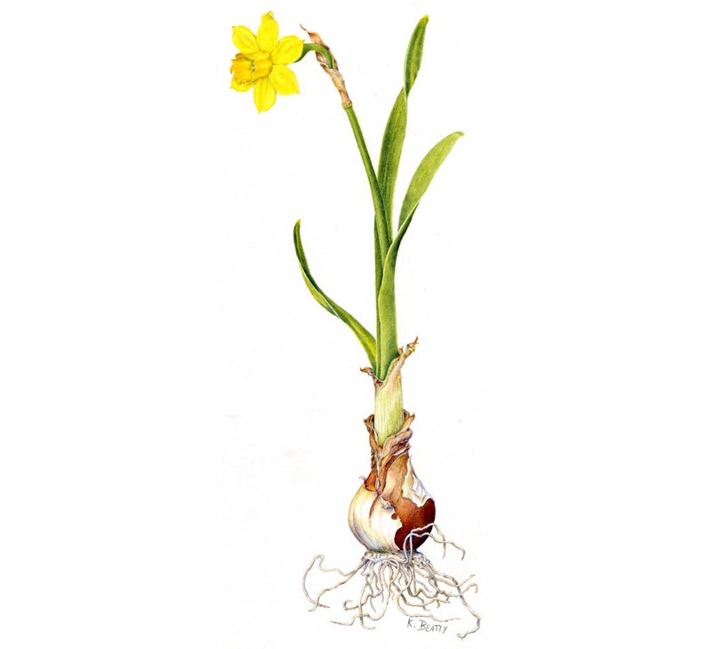
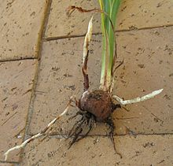
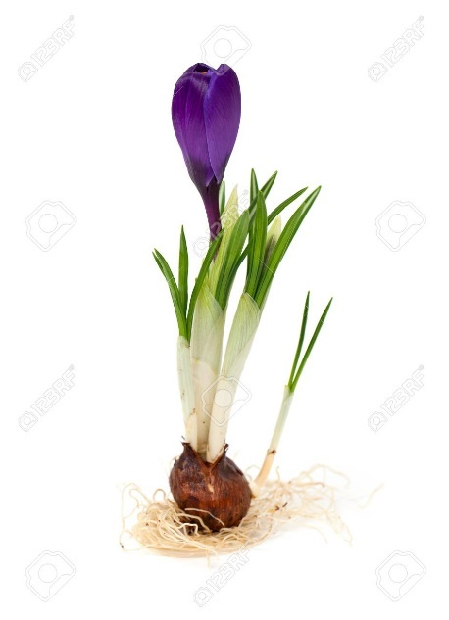
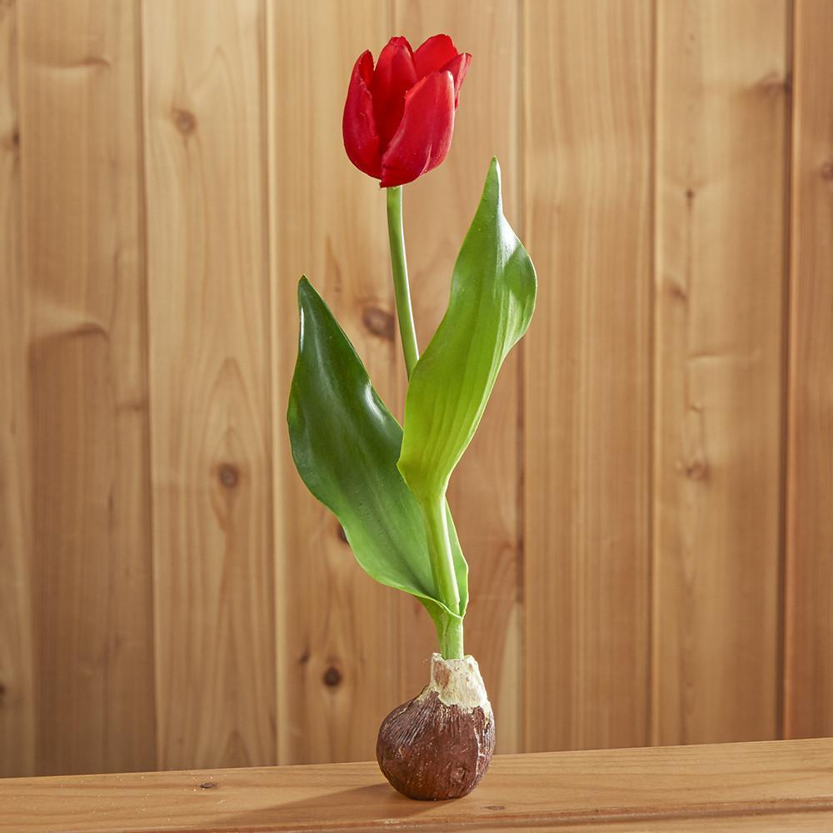

Identifying Roots and Shoots
EL1 Identify the root and shoot ends of a bulb
Draw a line to show where the root and shoot are on the bulb
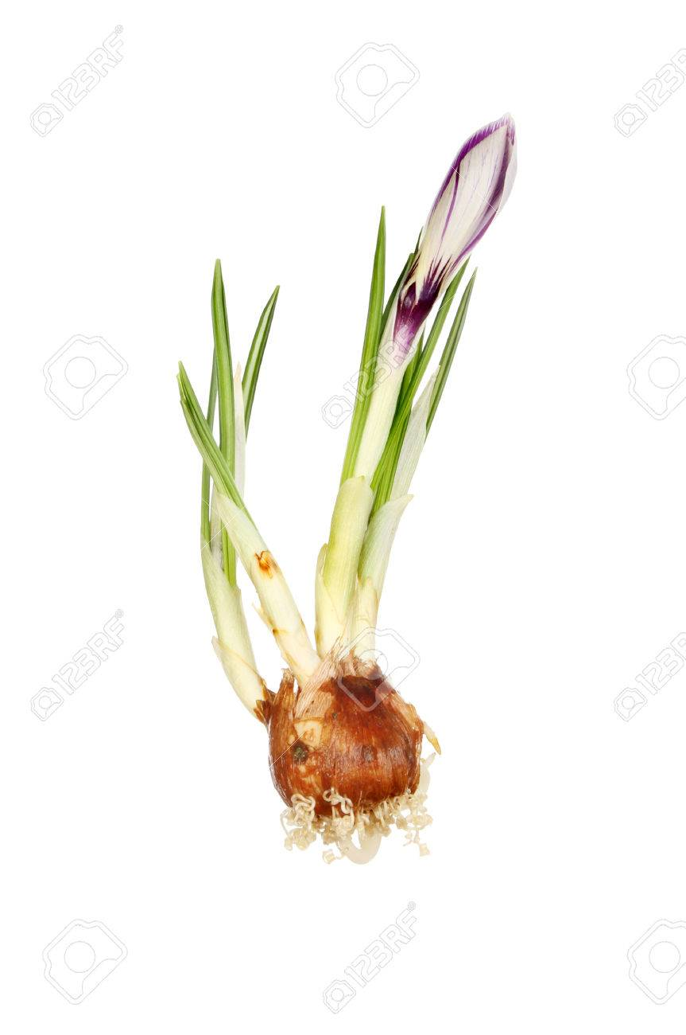
Shoot
Root

EL2 circle the right way to plant a bulb:
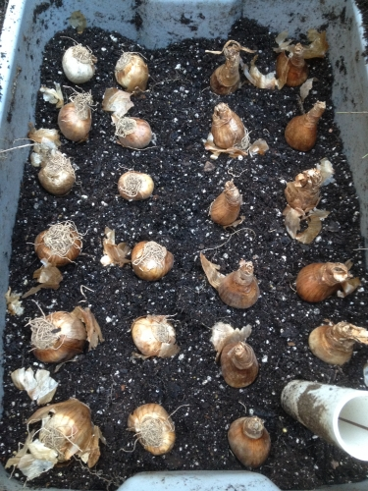
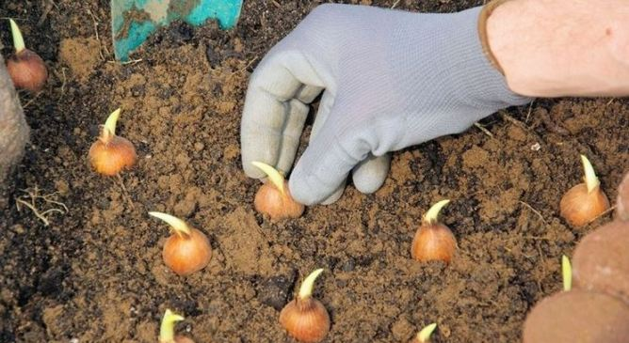

EL3 how deep should a tulip bulb be planted?

EL3 how deep should a crocus bulb be planted?

EL3 if you want to plant a bulb for a Christmas gift when should you plant it?

EL3 when will the bulb you planted for a Christmas gift flower?

AO1 Poster Task
Using a computer design a leaflet or poster for one of the following options
EL1 with significant help | EL2 with some help | EL3 with little help
Help to make a poster showing how to care for one named plant given as a gift | Produce a poster with instructions on how to care for a gift of a plant | Produce a poster with instructions on how to care for the gift of a plant for Christmas

Make sure your leaflet or poster includes the following;

- Title
- Pictures
- Border
- Tips for daily care

Staple your print outs to this page

A02

In this section you will demonstrate the following skills and knowledge:

- Select containers for gifts
- Decorate the container
- Plant containers with an amaryllis or hyacinth for a Christmas gift
- Make a suitable gift tag container
- Wrap the final gift
- Attach the gift tag

AO2 Task One
Select Containers for the Gift
For this task pupils need to select the containers for the gift.
EL1 | EL2 | EL3
EL1 pupils need to choose a suitable container for one bulb. | EL2 pupils need to choose two suitable containers for the bulbs | EL3 pupils need to choose three suitable containers for the bulbs
I can confirm the learner was able to choose the above number of containers for the gift:

Signed ____________ Date: _______________

EL1 / EL2 / EL3 Photograph of the pupil with their containers:

AO2 Task Two
Decorate the container
For this task the pupils need to decorate the container
EL1 | EL2 | EL3
Identify the colours or materials that can be used for the container | Decorate two containers to a reasonable standard as appropriate for the occasion | Decorate three containers to a good standard as appropriate for the occasion demonstrating flair and creativity
I can confirm the learner was able to decorate the container(s) as described in the ticked learning outcome above

Signed ____________ Date: _______________

EL1 Photograph of the pupil with their colours and materials chosen for their container

EL2 Photographs of the two containers decorated by the pupil

EL3 Photographs of the three containers decorated by the pupil, demonstrating flair and creativity

AO2 Task Three
Plant containers with an amaryllis or hyacinth for a Christmas gift
For this task the pupils need to plant containers with bulbs
EL1 | EL2 | EL3
Handle the compost and keep working area clean and tidy  Handle the bulb carefully | Handle the compost, taking care and tidy up after planting  Handle two bulbs carefully | Handle the compost, taking care not to spill it and tidy up after completing the task.  Handle three different bulbs carefully.  Know how deep to plant them in the compost
I can confirm the learner was able to plant the bulbs as described in the ticked level:

Signed ____________ Date: _______________

Teacher witness statement:

EL1 Photo of the pupil handling compost

EL1 photo of the working area being kept clean and tidy

EL1 Photograph of one bulb being handled carefully

EL2 Photograph of the pupil cleaning up after planting

EL2 Photograph of a second being handled carefully

EL3 photograph of a third bulb being handled carefully

EL3 photographs of the bulbs being planted at the right depth

AO2 Task Four
Make a suitable gift tag
For this task the pupils need to make a suitable gift tag
EL1 | EL2 | EL3
Make a suitable gift tag for one gift item from recycled materials | Make two suitable and different gift tags from a limited range of recycled materials | Make three suitable and different gift tags from a wide range of recycled materials demonstrating flair and creativity
I can confirm the learner was able to make the gift tag as described in the ticked level:

Signed ____________ Date: _______________

EL1 Photograph of gift tag

EL2 photograph of second gift tag

EL3 photograph of third gift tag

AO2 Task Five
Wrap the final gift(s)
For this task the pupils need to wrap the final gift(s)
EL1 | EL2 | EL3
Identify suitable wrapping material from a range  Wrap the container | Identify suitable wrapping material for two gifts  Wrap the container to a reasonable standard | Choose suitable wrapping material for three gifts and explain why they chose it  Wrap the container to a good standard
I can confirm the learner was able to wrap the gift as outlined in the ticked box above

Signed ____________ Date: _______________

EL1 photograph of pupil wrapping the container with suitable material

EL2 photograph of second gift wrapped

EL3 photograph of third gift wrapped

EL3 statement from pupil explaining why they chose the wrapping material they did

AO2 Task Six
Attach the gift tag
For this task the pupils need to attach the gift tag(s)
EL1 | EL2 | EL3
Attach the gift tag | Attach the two gift tags | Attach the three gift tags securely
I can confirm the learner was able to attach the gift tag as described in the ticked box above

Signed ____________ Date: _______________

EL1 Photograph of one gift tag attached

EL2 photograph of second gift tag attached

EL3 photograph of third gift tag attached securely

AO3
Task Reviews

In this section you need to indicate how you have performed in each task and show evidence of a basic review.

Review of Task One: Select containers for the gift

EL1 In this task I did:
Very Good | OK | Not Well

EL2 Something I did well was:

EL2 Something I could improve on is:

EL3 A skill I learnt was:

EL3: How will this skill help me in the future?
EL3: What would I do differently next time?

Review of Task Two: Decorate the container

EL1 In this task I did:
Very Good | OK | Not Well

EL2 Something I did well was:

EL2 Something I could improve on is:

EL3 A skill I learnt was:

EL3: How will this skill help me in the future?
EL3: What would I do differently next time?

Review of Task Three: Plant containers with an amaryllis or hyacinth

EL1 In this task I did:
Very Good | OK | Not Well

EL2 Something I did well was:

EL2 Something I could improve on is:

EL3 A skill I learnt was:

EL3: How will this skill help me in the future?
EL3: What would I do differently next time?

Review of Task Four : Make a suitable gift tag

EL1 In this task I did:
Very Good | OK | Not Well

EL2 Something I did well was:

EL2 Something I could improve on is:

EL3 A skill I learnt was:

EL3: How will this skill help me in the future?
EL3: What would I do differently next time?

Review of Task Five: Wrap the final gift (s)

EL1 In this task I did:
Very Good | OK | Not Well

EL2 Something I did well was:

EL2 Something I could improve on is:

EL3 A skill I learnt was:

EL3: How will this skill help me in the future?
EL3: What would I do differently next time?

Review of Task Six: Attach the gift tag(s)

EL1 In this task I did:
Very Good | OK | Not Well

EL2 Something I did well was:

EL2 Something I could improve on is:

EL3 A skill I learnt was:

EL3: How will this skill help me in the future?
EL3: What would I do differently next time?

AO3
Final Review

In this section you need to indicate how you have performed in the unit and suggest how you might improve.

Final Review
EL1 In this unit I learnt how to:

EL1 I did well when:

EL2 If I had to do this unit again I would:

EL2 Would you like to work with plants when you leave school?
Yes | No

EL3 Explain a reason for your answer:

EL3 What did you do well in A01?

EL3 What did you do not so well in A01?

EL3 What did you do well in A02?

EL3 What did you do not so well in A02?

