#mindhealthy@home

Looking after your family’s emotional wellbeing at home

Over the next few weeks we will all experience extra
pressures that will affect how we think and feel. It’s
important to recognise that all of us have mental health
and, just like our physical health, at this time it’s important to look after it.
Inside this book are a few tips, activities and useful
information to help you to keep yourself and your family emotionally healthy at home.
YEAR 8, 9, 10 (KS3)

It’s good to talk

We all get anxious and worried - especially during times of uncertainty. Anxiety is
a natural way of dealing with the dangers around us and can impact the way we
feel both emotionally and physically. For more information about this have a look
at www.mind.org.uk

Just like you, your child may be feeling anxious or worried at the moment about
all the changes and uncertainty that have arisen as a result of the coronavirus.
They may be worried about their loved ones, falling ill themselves, concerned
about what they are missing at school and generally missing their friends and
family. One way that we are communicating about how we feel in
schools is to ask how we are feeling on a scale from 1-10 (1 b
low, worried, angry etc, and 10 being happy, optimistic etc).
Primary schools call this the ROAR rainbow. Using this simple
tool can help us to see what is normally hidden - our feelings.

Some children may not want to talk about or may not be concerned about the
virus, whereas others will. Unicef has given some useful guidance for talking to children about Coronavirus:

1. Ask open questions and listen

Start by inviting your child to talk about the issue. Find out how much they already know and follow their lead.

Most importantly, don’t minimize or avoid their concerns. Be sure to acknowledge their feelings and assure them that it’s natural to feel scared about these things. Demonstrate that you’re listening by giving them your full attention, and make sure they understand that they can talk to you and their teachers whenever they like.

2. Be honest: explain the truth in a child-friendly way

Children have a right to truthful information about what’s going on in the world, but adults also have a responsibility to keep them safe from distress. Use age-appropriate language, watch their reactions, and be sensitive to their level of anxiety.

If you can’t answer their questions, don’t guess. Use it as an opportunity to explore the
answers together. Explain that some information online isn’t accurate, and that it’s best to trust the experts.

3. Show them how to protect themselves and their friends

One of the best ways to keep children safe from coronavirus and other diseases is to simply encourage regular handwashing. It doesn't need to be a scary conversation.

You can also show children how to cover a cough or a sneeze with their elbow, explain that it’s best not to get too close to people who have those symptoms, and ask them to tell you if they start to feel like they have a fever, cough or are having difficulty breathing.
4. Offer reassurance

When we’re seeing lots of troubling images on TV or online, it can sometimes feel like the
crisis is all around us. Children may not distinguish between images on screen and their own personal reality, and they may believe they’re in imminent danger. You can help your
children cope with the stress by making opportunities for them to play and relax, when
possible. Keep regular routines and schedules as much as possible, especially before they go to sleep, or help create new ones in a new environment.

If your child does feel unwell, explain that they have to stay at home/at the hospital because it is safer for them and their friends.

5. Check if they are experiencing or spreading stigma

The outbreak of coronavirus has brought with it numerous reports of racial discrimination around the world, so it’s important to check that your children are neither experiencing nor contributing to bullying.

Explain that coronavirus has nothing to do with what someone looks like, where they are
from or what language they speak. If they have been called names or bullied at school, they should feel comfortable telling an adult whom they trust.

6. Look for the helpers

It’s important for children to know that people are helping each other with acts of kindness and generosity.

Share stories of health workers, scientists and young people, among others, who are
working to stop the outbreak and keep the community safe. It can be a big comfort to know that compassionate people are taking action.
7. Look after yourself

You’ll be able to help your kids better if you’re coping, too. Children will pick up on your own response to the news, so it helps them to know you’re calm and in control.
8. Close conversations with care

It’s important to know that we’re not leaving children in a state of distress. As your
conversation wraps up, try to gauge their level of anxiety by watching their body
language, considering whether they’re using their usual tone of voice and watch
their breathing or
Remind your children that they can have other difficult conversations with you
at any time, although try to avoid bed-time as they may struggle to sleep.

#Resilient

Young children are going to remember how their family responded during difficult times. Our children are watching and learning about how to respond to stress and uncertainty. Let’s build up our children’s resilience rather than panic.
Stay APE

While you may be restricted in what you can do over the next few weeks you can still keep things in place to help you to look after your family’s wellbeing.
One piece of advice from the Youth Connect 5 training is to plan things into your week to stay APE! Try and plan something each week to allow you to:
1) Feel like you have Achieved something

You could use this time to have a good spring clean or create a vegetable
garden. We have also put together a few challenges for children and families to try and complete at home while schools are closed.
2) Connect with People

Even though we are being encouraged to keep social distance from people
during this time, it’s still important that we connect with friends and family. You
could plan in daily video chats with your child’s friends, grandparents or others.
3) njoy yourself

Try and use this time to play games as a family, do crafts and making sure that
you get a daily dose of laughter. Remember to get fresh air and exercise
regularly.
Take on a challenge
We have designed some resilience-building challenges for children to have a go at
home. Encourage your child to complete one a day. Once schools are open again
they can take their ticked off sheets back in and talk to their teachers about the
things that they did.

For more ideas of how to build resilience in children and young people you can
visit https://resilienceframework.co.uk

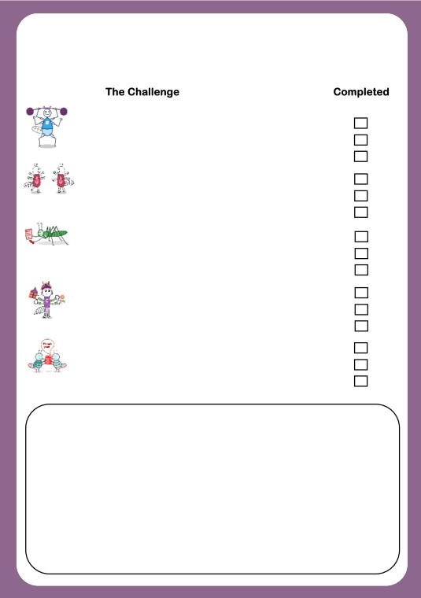
Resilience Challenges

1 Make up these challenges on your own
2 See next page for help!

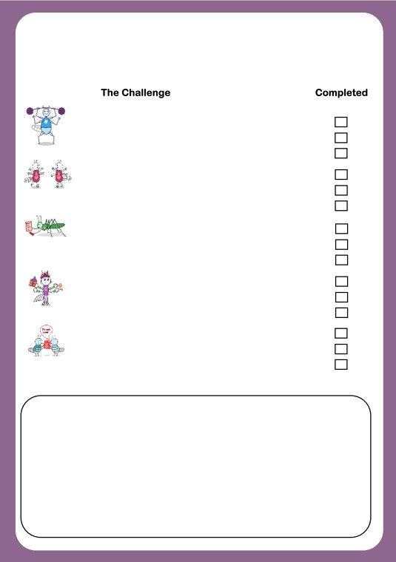
Resilience Challenges for 11-14 year olds

1 Do something kind for your neighbour
2 Make up a dance routine using moves from another
country
3 Make a healthy snack or meal
4 Phone/video call someone from your family that doesn’t
live in your house
5 Do a household job to help out the grown-ups
6 Play a game with someone older or younger than you
7 Try and learn a few phrases of another language
8 Complete the work sent home for you from school
9 Learn a new skill
10 Draw or write in a diary at least 3 times a week
11 Try a meditation exercise from youtube
12 Sing at least once a day for a week
13 Write a list of times when you have been resilient and
kept going even when things were hard.
14 Design a poster of yourself 10 years from now
15 Read a book and review it for your friends

Advice for parents/carers

It’s important to remember to take time to support yourself as well as your children during this time.
We will all be feeling a range of emotions at this time. Some of us are worried about our loved ones, anxious about paying bills or keeping our jobs, we may feel isolated and lonely and many of us are struggling with the uncertainty about what will
happen over the next few weeks.
Try to take time to focus on yourself and how you feel. Do something positive like
going for a walk, doing some exercise, reading a book or sorting out that cupboard that you’ve wanted to tackle for ages!

Focus on what’s in your control

If you are feeling overwhelmed try to focus on 5
things that you can control. Write them down. For
example you can’t predict what will happen in a
month’s time, but you can plan a simple routine
for you as a family to follow, plan your meals for
the week and stay in touch with loved ones.

If news updates are making you anxious, consider
limiting your checking of them to once or twice a
day.

