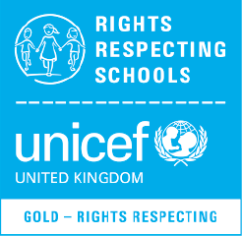
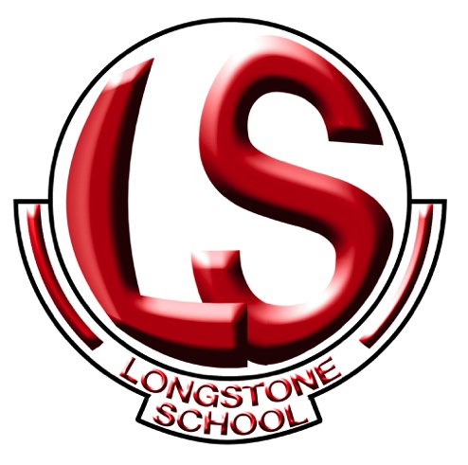
Rights Respecting School Policy
LONGSTONE SCHOOL
Rights Respecting School Policy
September 2019

Article 2 (Non-discrimination): The Convention applies to all children, whatever their race, religion or abilities; whatever they think or say, whatever type of family they come from. It doesn’t matter where children live, what language they speak, what their parents do, whether they are boys or girls, what their culture is, whether they have a disability or whether they are rich or poor. No child should be treated unfairly on any basis.

Longstone School achieved their Recognition of Commitment (ROC) in October 2015 and we achieved Level 1 in April 2017. We achieved Gold Award in April 2019. We are also involved in an Extended Schools Cluster Group Project and hope to be part of the first Rights Respecting Village in the future.
Introduction

By participating in the (UNICEF) Rights Respecting School Award we will strive to put the United Nations Convention on the Rights of the Child at the heart of our school’s planning, policies, practice and ethos. We will teach our children about children’s rights but also model rights and respect in all our relationships: between adults and adults, adults and pupils and pupils and pupils.(Article 42 Children have the Right to know their Rights).

UNCRC

All children have the same rights. All rights are interconnected and of equal importance. The Convention stresses these principles and refers to the responsibility of children to respect the rights of others. By the same token, children's understanding of the issues raised in the Convention will vary depending on the age of the child. Helping children to understand their rights does not mean adults should push them to make choices with consequences they are too young to handle.

The articles of the Convention may be grouped into four categories of rights and a set of guiding principles

- Survival rights
- Development rights
- Protection rights
- Participation rights

The guiding principles are

- Non-discrimination
- Best Interests of the child
- Right to life, survival and development
- Respect for the views of the child

The main responsibility for ensuring that all children (rights holders) enjoy their rights lies with adults, who are the duty bearers in our school.

Rights Respecting Ethos

- All members of the community model Rights Respecting language.
- The school environment should be safe physically and emotionally.
- Displays in school will identify Articles from the UNCRC
- All Assemblies will have a UNCRC Article as a theme/focus.
- Charters have replaced class rules and are drawn up after consultation between adults, children, BOG and Parents.
- Detention has been replaced by Thinking Time which is a reflective process. Conflicts will be resolved, where possible, by the children finding their own solutions and talking through issues to a conclusion, supported by staff.
- School Policies have been reviewed to make links with UNCRC explicit.

Pupils will learn about

- UNCRC
- Global Citizenship
- Working with others
- Mutual Understanding
- Keeping safe and healthy

Children are empowered to become active citizens and leaders through:

- School Council
- Eco-Schools
- Champions Club
- Prefect System
- Middle/Senior Reward System

We try to encompass the Rights of the Child throughout all our Pastoral and Curriculum areas. We seek to develop the whole child as an individual who can work with others, share and care with a good level of mutual understanding (Article 29 Respect other People).
We encourage a healthy and safe environment within the school setting and encourage older children to act as ‘helpers’ and mediators during their daily breaks. (Article 24 Right to a Clean and Safe Environment).

The Importance of the Classroom Charter
Each class is expected to have a charter which clarifies expectations for behaviour inside and outside the classroom so that children are aware of what is and is not acceptable and that there will be consequences for one’s actions. In the Junior School we have a simplified ‘charter’, including pictures that each child is able to understand.
The children must have ownership of this charter as it will have more impact and meaning to them if they have been involved in the decision-making process. The School Council will be responsible for drawing up the charter following a period of consultation with their class members. (Article 12 Right to an Opinion).
Our school charters were developed by the School Council in consultation with the whole school. They are displayed in all classrooms, using individual themes decided on by pupils, their teachers and non-teaching staff.
The charter is subject to annual review, meaning it continually evolves to meet the needs of everyone in the school.
Our School Charter summarises the schools vision and interprets this as the Rights and Responsibilities we all have in our school community.
The School Council also hope to draw up a Lunchtime and Playground charter and have also developed an Anti-Bullying Policy that will encompass a Rights Respecting ethos. (Article 19 Protection from Violence and being Mistreated).
Steering Group Members
Mr Skarmoutsos – Principal and Rights Respecting Coordinator
Mr McIlmoyle – Vice Principal and Rights Respecting Coordinator
Mr McCauley – Parent Rep and Board of Governor Representative
Mr Alan McTier & Mr Michael Douglas – PSNI Representatives
Mrs Plunkett – Key Stage Four Co-ordinator / Eco-Schools Coordinator
Mr Clulow - Technician
Mr Starrs – Middle Manager
Classroom Assistant Reps – Miss Frazer & Mrs Cummings

2018 -19 School Council Members

Taylor Pietersen 12B
Philip Barnes 12B
Katherine Hynes 12A
Victoria McKelvie 12A
Emily Stirling 12A
Corey McKeown 11B
Serine Charbib 11A
Megan Fisher 11A
Harvie Patterson 10B
Katie Brady 10B
Joshua Brown 10A
Bartek Wysokowski 9B
Beth Colhoun 9B
Amy Murray 9A
Ritchie Morton 8B
Ryan McCauley 8A
Rio Gorman Yr 7
Mason Coulter Yr 6
Josh Hamilton Yr 5

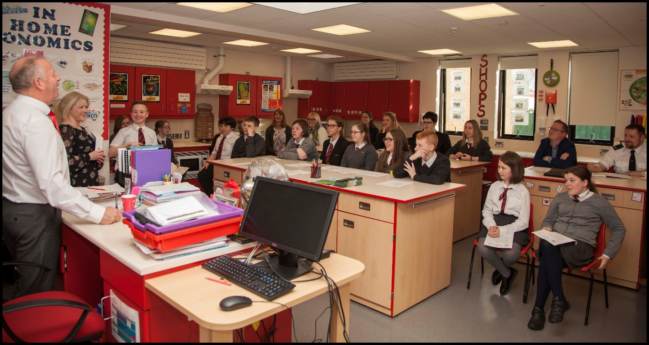
Policy Review
This policy will be a working document for the Board of Governors, Principal, Senior Management Team, staff and pupils. It will be reviewed in September 2020

