Global Citizens in the Making
Learning Intentions
- To think about the qualities needed to become a successful learner.
- To think about the qualities needed to become a confident individual.
- To think about the qualities needed to become a responsible citizen.
- To think about the qualities needed to become an effective contributor.
- To learn life lessons about my favourite fictional character or story.
- To learn life lessons about a famous person who inspires me.
- To research quotes which will inspire me to live a better life.
- To celebrate the achievement I am most proud of.
- To decide on the type of person I want to be in the future.
- To think about what I want to achieve in the future.
- To come up with a vision for a better world.
- To think of some actions I can take to make my vision become a reality.
- To make a poster based on what I have wrote in this booklet.

Name:
Class:

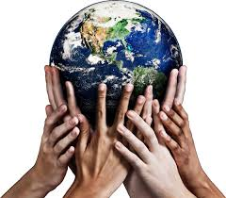
Mrs Plunkett

Successful Learners
- Open-minded I listen carefully to new ideas even if I disagree with them.
- Creative I have lots of new or unusual ideas that make a positive contribution to my life & others.
- Persistent I stick at a task until I know how to get it done.
- Independent I can complete tasks and solve problems on my own.
- Curious I like to find out about new things.
- Motivated I always want to complete tasks, even when they’re at their toughest.
- Humble I am always respectful and don’t show off when I have something that others may not

Order the above qualities from best describing you to least describing you in the table below:
1
2
3
4
5
6
7

Explain how you use your number one quality in every day life:

Select the quality that least describes you and give an example of how you are going to try and get better at this in every day life:

Confident Individuals
- Enthusiastic I feel positive and excited about working on this project.
- Trustworthy I can be relied upon by friends and family.
- Hard-working I always try my best.
- Determined I can complete any task when I put my mind to it.
- Resilient I can bounce back quickly when I fail at something the first-time round.
- Cheerful/Joyful I am happy and hopeful about the future.
- Self-Disciplined I do things that are needed, even though I may not want to do them.

Order the above qualities from best describing you to least describing you in the table below:
1
2
3
4
5
6
7

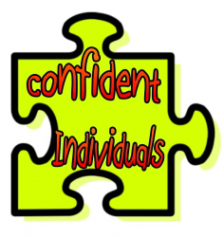

Explain how you use your number one quality in every day life:

Select the quality that least describes you and give an example of how you are going to try and get better at this in every day life:

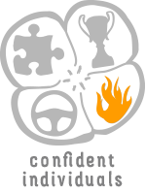

Responsible Citizens
- Thoughtful I am caring and understanding towards other people.
- Caring I am kind and show concern for others.
- Kind I am a good natured and loving person.
- Tolerant I can deal with people’s behaviour and opinions even when I don’t agree with them.
- Loving I am a friendly and approachable person.
- Selfless I put others needs and wishes before my own.
- Honest I will always give my true feelings and opinions on everything

Order the above qualities from best describing you to least describing you in the table below:
1
2
3
4
5
6
7

Explain how you use your number one quality in every day life:

Select the quality that least describes you and give an example of how you are going to try and get better at this in every day life:

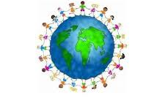

Effective Contributors
- Helpful I am willing to assist others with anything they need or have difficulty with.
- Respectful I am polite and courteous to others.
- Enterprising I am good at thinking and doing new and difficult things that haven’t been done.
- Generous I am willing to give more to the cause than is necessary.
- Principled I always behave in the correct way and know right from wrong.
- Purposeful I know what I want to do and how I am going to do it.
- Committed I am willing to give my time and energy to a task until I complete it.

Order the above qualities from best describing you to least describing you in the table below:

1
2
3
4
5
6
7

Explain how you use your number one quality in every day life:

Select the quality that least describes you and give an example of how you are going to try and get better at this in every day life:

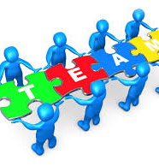

My Favourite Story or Fictional Character
Write or draw about your favourite story or fictional character. Explain why it is your favourite and the lessons you have learnt from it.
My Inspirational Character
My inspirational character is:

Their greatest achievement is:

I think they are inspiring because:

I am going to try and be like them by:

Inspiring Quotes
Use the iPads to research three inspiring quotes which you plan to live your life by. Try and find quotes said by famous people who inspire you.
Quote One:

Quote Two:

Quote Three:

My Inspiring Moment
The thing that I am most proud of is:

I want to be like my inspirational person because:

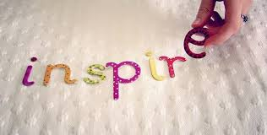
Me, My Future and My Commitment to a Better Future
What kind of person do you want to be?
The job I want to do when I am older is
Because:

What do you want to achieve?
In five years’, time I want to have achieved:

In ten years’, time I want to have achieved:

In fifteen years’, time I want to have achieved:

In twenty years’, time I want to have achieved:

What is your vision for a better world?
What changes do you want to see in the future?

Using the Global Goals what global issue are you most passionate about?

Actions to make a better world:
What can you start doing today to make a better world?
What can you start doing in the next few months to make a better world?

What steps do you need to take to make your vision a reality?

