Year 11

Personal, Social, Health Education

Coping With

Anxiety

Name:___________________

Class:___________

Mrs Cromie

Feeling Worried

It is natural for people to experience anxiety. When you watch the news, overhear conversations or communicate with your friends, your anxiety levels can increase if scary, distressing things are being discussed. Some people are able to talk about their concerns with people they trust. Others would rather write about these feelings and concerns. Some people even draw to make themselves feel better. There is no right or wrong approach.

Just remember, you cannot control everything in the World or your

environment. Instead try to focus on what you can control. Do this by being careful about what you watch on the internet, watch programmes that make you feel better, focus your mind by reading books or magazines that you like or even play board games with your family.

In this booklet, there are worksheets that will allow you to write or draw about your feelings. This includes mindfulness colouring-in sheets as I know many of you like these.

Take care and stay safe. See you soon!

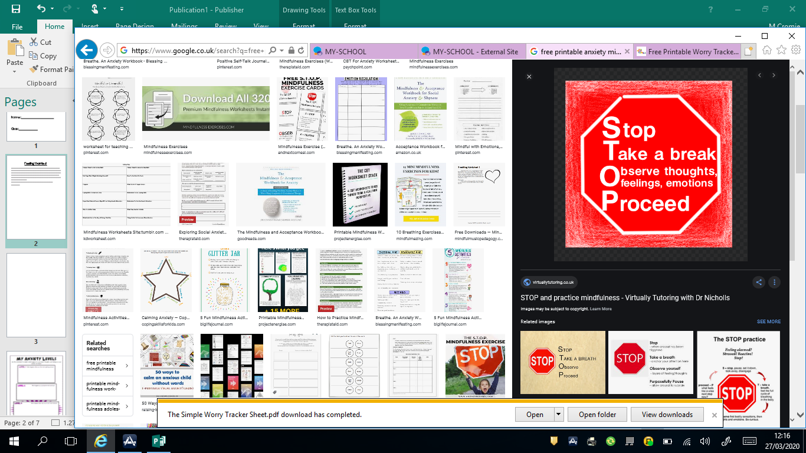

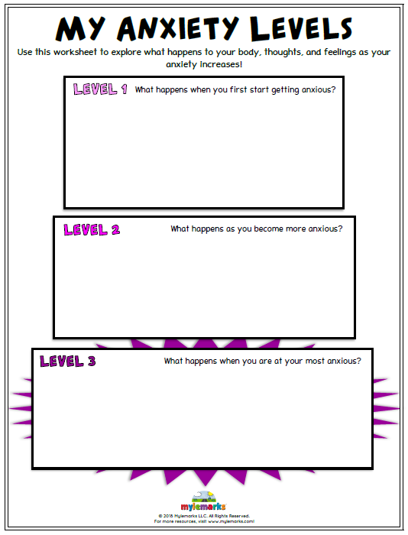

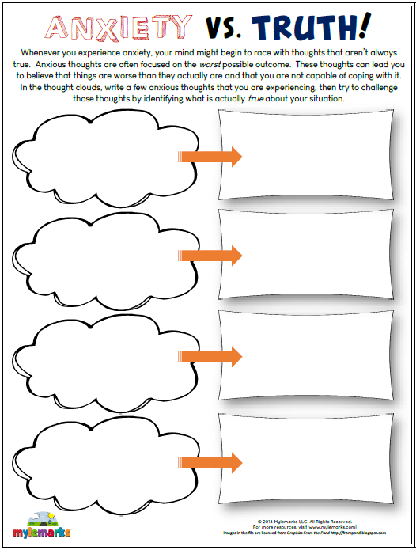

If you feel yourself getting anxious, breathing techniques can help.

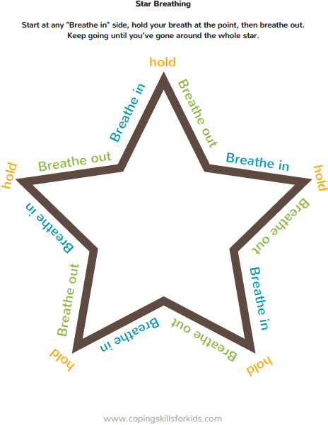

When people get stressed, the following strategies can often help them feel calm again.

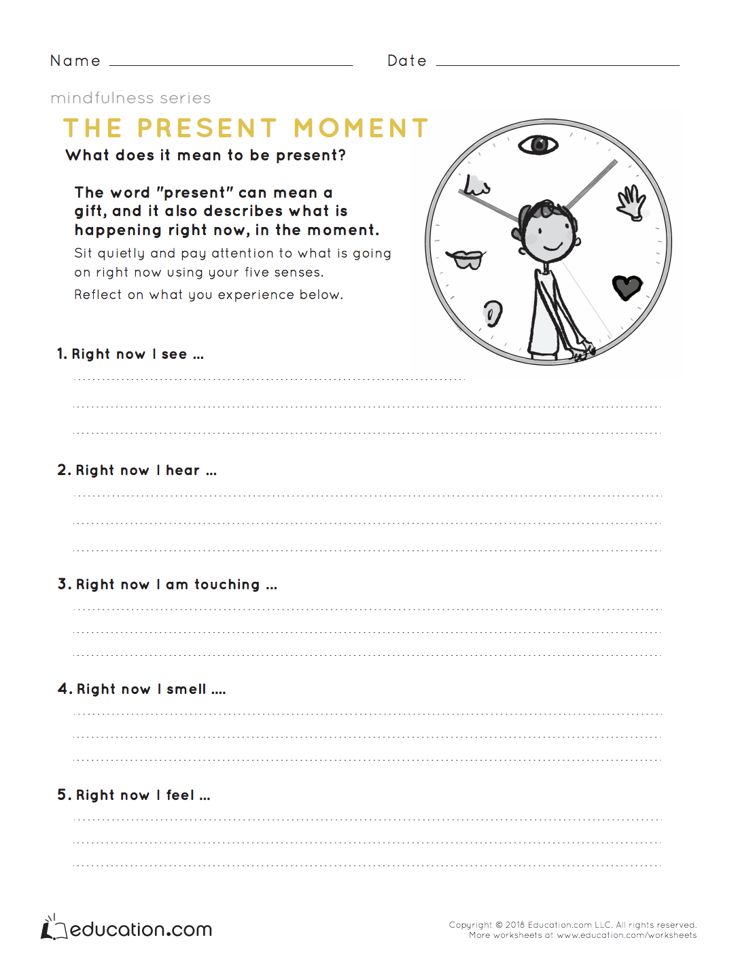

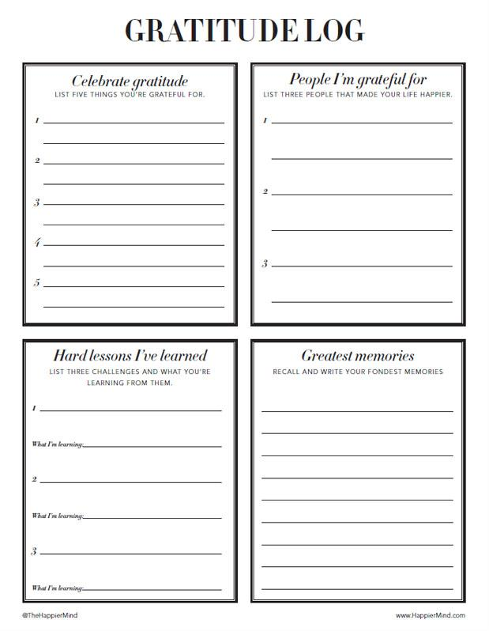

Think about positive things in our lives!

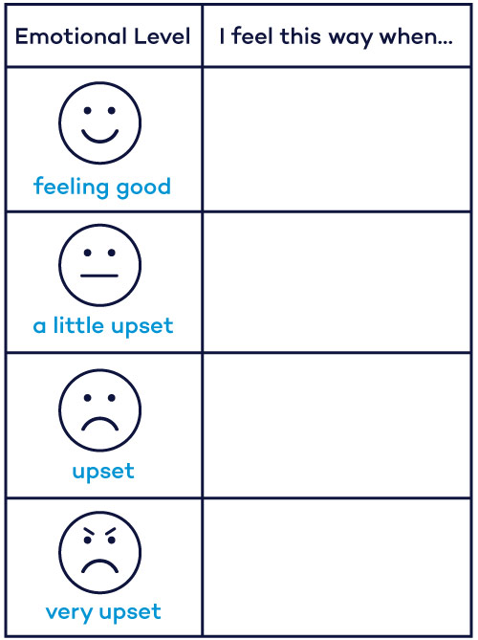

This might help you to evaluate your problems.

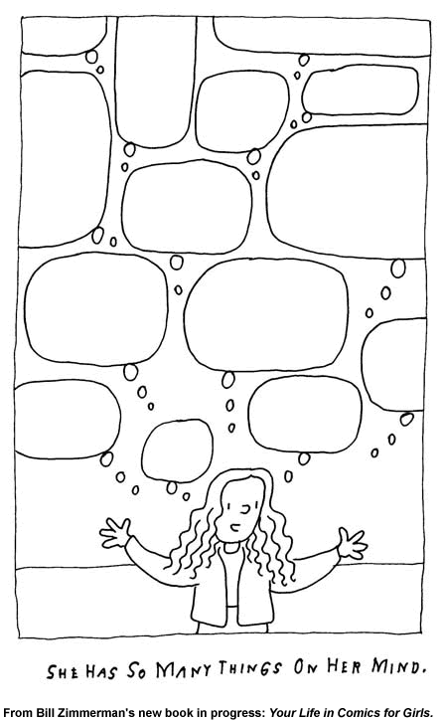

Draw or write about what is on your mind

