**CCEA Occupational Studies**

**Entry Level**

Final Level:

[https://encrypted-tbn1.gstatic.com/images?q=tbn:ANd9GcTJ9tqxeGI21DlLf8WYJ-nfu3kHi_4TDbpyE31zr9apd6nB6kGUUK3jV2g](http://www.google.co.uk/url?sa=i&rct=j&q=&esrc=s&source=images&cd=&cad=rja&uact=8&ved=0CAMQjRxqFQoTCNaw1rf_38cCFYMU2wodizEDIg&url=http://www.rewardinglearning.org.uk/&psig=AFQjCNGpFfNpBAsETNiBNiy1n5XlUIt_fA&ust=1441545992372912)

**Creative Crafts**

**Unit 10: Card Making**

|  |  |
| --- | --- |
| **Candidate Name** |  |
| **Candidate Number** |  |
| **Teaching Centre Name** | **Longstone Special School** |
| **Teaching Centre Number** | **71551** |
| **Administration Centre Name** |  |
| **Administration Centre Number** |  |
| **Pathway** | **Creative Crafts** |

I certify that the evidence submitted for this unit is my own work:

Learner Signature: ………………………………………………………………………

I certify that the evidence submitted for this unit is the work of: ………………………………….

Teacher Signature: ……………………………………. Date: ………………………

**Photographs of End Products**

**Creative Crafts**

**Unit 10: Card Making**

This unit is designed to provide vocational skills in creative crafts at Entry Level 1, Entry Level 2 and Entry Level 3. It gives learners the opportunity to experience and become familiar with the skills they need to follow a craft making process and produce a greetings card(s).

Learners will follow appropriate health and safety procedures throughout the

planning, preparation and making process. They will also consider environmental issues and job opportunities. Learners will develop their skills by completing and presenting the finished item(s) and will review their work.

This unit includes:

• Health and safety issues in card making activities;

• Job opportunities relating to creative crafts ;

• Environmental issues relating to card making;

• Using basic tools and equipment for making cards;

• Preparing, creating and completing a card(s);and

• A review of performance.

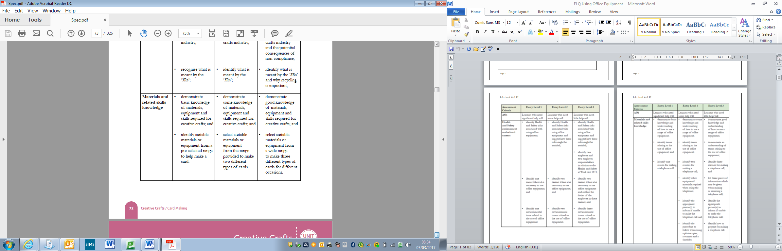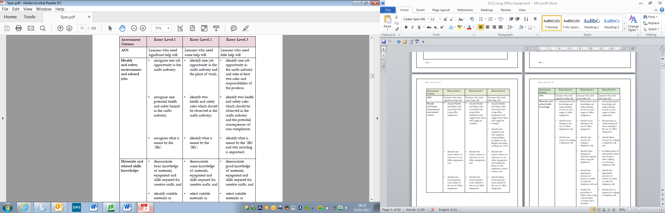

**A01Knowledge Check**

**Health and Safety, Environment and Related Careers**

**In this section you will:**

* **Identify a job opportunity in the crafts industry, identify one place of work in the crafts industry and state at least two roles and responsibilities of the position.**
* **Recognise a potential health and safety hazard in the crafts industry, two health and safety rules and the potential consequences of non-compliance.**
* **Recognise what is meant by the 3R’s, and explain why recycling is important.**

**AO1 Health and Safety, Environment and Related Careers**

**EL1: Circle the job related to an opportunity in the Crafts industry.**

**EL2: Draw a line from each job to the correct place of work**



Salon

Court House

Building Site

Restaurant

Studio

**El3 State at least two roles and responsibilities of a position**

**This is Derek he is a ___________________________**

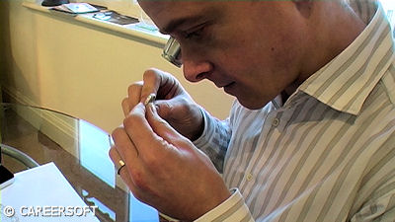

Chef

Plumber

Secretary

Jewellery designer

Farmer

Gardener

**Write down two responsibilities Derek has when working in his studio.**

|  |
| --- |
|  |
|  |

|  |
| --- |
|  |
|  |

**Health and Safety**

**EL1 Recognise a potential health and safety hazard in the crafts industry**

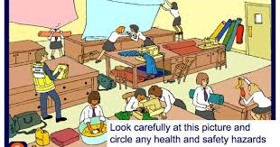

**EL2 Identify two health and safety rules for the above Craft Room**

|  |
| --- |
|  |

|  |
| --- |
|  |

**EL3 Explain what might happen if these rules are broken:**

|  |
| --- |
|  |
|  |
|  |
|  |

**EL1 What do the 3 Rs stand for?**

**R________**

**R________**

**R________**

**EL2 what do the three Rs mean?**

|  |
| --- |
|  |

**EL3 Why is it important to recycle as much as possible when making crafts?**

|  |
| --- |
|  |
|  |

**AO1 Knowledge Check**

**Materials, Knowledge and Skills**

**In this section you will:**

* **Demonstrate basic, some, good knowledge and understanding of materials, equipment and skills required for creative crafts**
* **Identify suitable materials or equipment from a pre-selected range to help make a card, select suitable materials or equipment from the range provided to make two different types of card, select suitable materials or equipment from a wide range to make three different types of cards for different occasions.**

**EL1 Demonstrate basic knowledge of materials required for creative crafts**

**Circle the materials you would need to make a card**

[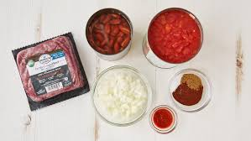](https://www.google.co.uk/url?sa=i&rct=j&q=&esrc=s&source=images&cd=&cad=rja&uact=8&ved=0ahUKEwiYoLWIibDSAhXlAMAKHZxtCNEQjRwIBw&url=https://www.pillsbury.com/everyday-eats/dinner-tonight/how-to-make-chili-3-foolproof-methods&bvm=bv.148073327,d.ZGg&psig=AFQjCNGUH7LT9eUwGI5GiNWxeTrfKxLF5A&ust=1488277811144009)[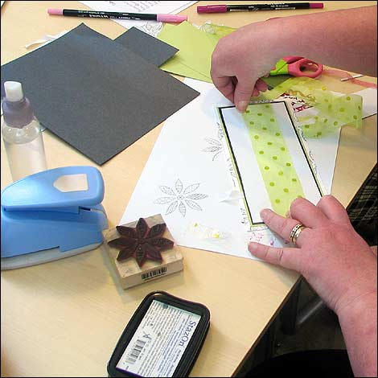](http://www.google.co.uk/url?sa=i&rct=j&q=&esrc=s&source=images&cd=&cad=rja&uact=8&ved=0ahUKEwjb1ebpiLDSAhVpB8AKHUx8AacQjRwIBw&url=http://www.bbc.co.uk/leicester/content/image_galleries/card_making_gallery.shtml&psig=AFQjCNGM1uY_wFccYisW-8URWQdRvhQN4Q&ust=1488277735147785)

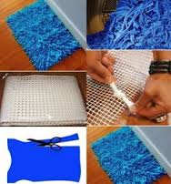

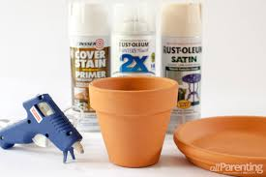

**EL1 Demonstrate basic understanding of the equipment required for creative crafts**

**Circle the equipment you would use in creative crafts**

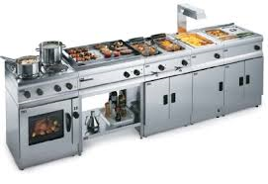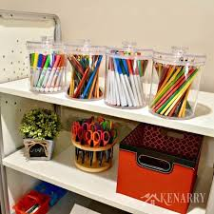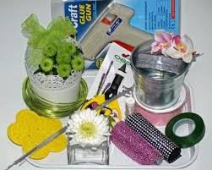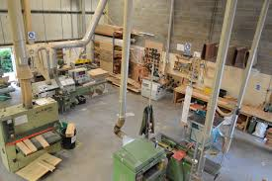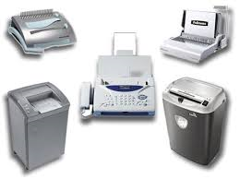

**Demonstrate basic knowledge of the skills required for creative crafts:**

**Circle the skills needed for the creative crafts industry**

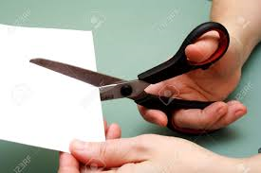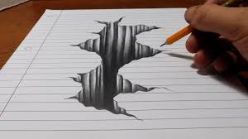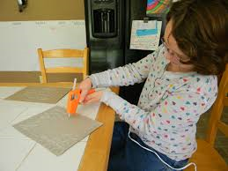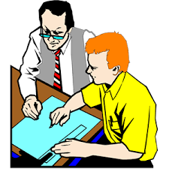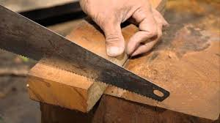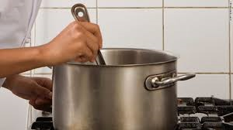

**EL2 Demonstrate some knowledge of the materials required for creative crafts**

**Label the following materials:**

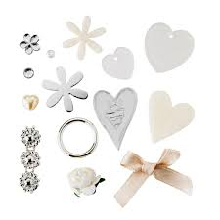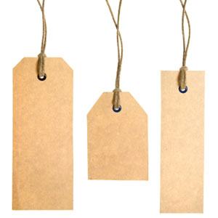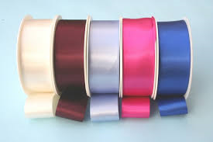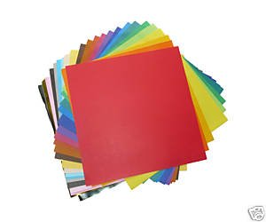

**EL2 Demonstrate some knowledge of the equipment required for creative crafts**

**Label the following pieces of equipment:**

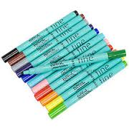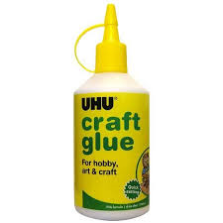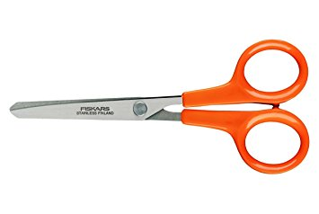

**EL2 Demonstrate some understanding of the skills required for creative crafts**

**Label the skills being used in the following pictures**

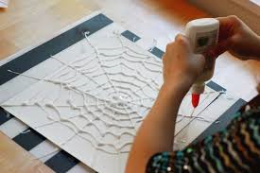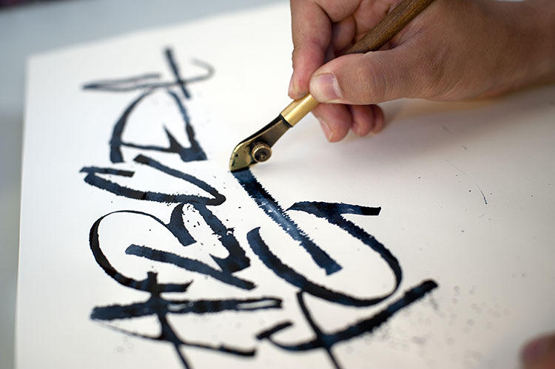

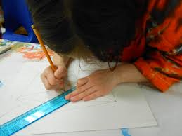

**EL3 Demonstrate good understanding of the materials required for creative crafts**

**List five materials required to make a birthday card:**

|  |
| --- |
|  |
|  |
|  |
|  |
|  |

**List three tools required to make a birthday card and describe what they are used for:**

|  |  |
| --- | --- |
| **Tool One:** |  |

|  |  |
| --- | --- |
| **Use:** |  |
|  | |

|  |  |
| --- | --- |
| **Tool Two:** |  |

|  |  |
| --- | --- |
| **Use:** |  |
|  | |

|  |  |
| --- | --- |
| **Tool Three:** |  |

|  |  |
| --- | --- |
| **Use:** |  |
|  | |

**EL3 Demonstrate good understanding of the skills required for creative crafts**

**List three skills you might need to use when making a birthday card and describe how you might use them:**

|  |  |
| --- | --- |
| **Skill One:** |  |

|  |  |
| --- | --- |
| **Use:** |  |
|  | |

|  |  |
| --- | --- |
| **Skill Two:** |  |

|  |  |
| --- | --- |
| **Use:** |  |
|  | |

|  |  |
| --- | --- |
| **Skill Three:** |  |

|  |  |
| --- | --- |
| **Use:** |  |
|  | |

**EL1: Identify suitable materials or equipment from a pre-selected range to help make a card**

**Tick the following materials and equipment you will need to make the card below:**

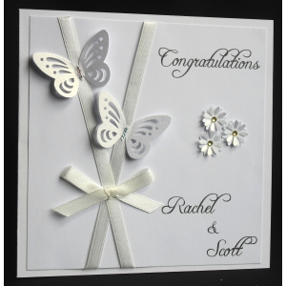

|  |  |
| --- | --- |
| **Materials** | **Equipment** |
| Ribbon | Paint brush |
| Decorative flowers | Pen |
| Stampers | Glue |
| Jewels | Scissors |
| Paint | Printer |
| Decorative butterflies | Trimmer |

**EL2: Select suitable materials or equipment from the range provided to make two different types of card**

**Write the following materials and equipment you will need to make the cards, using the list below to help you:**

|  |  |  |  |
| --- | --- | --- | --- |
| **Coloured card** | **White card** | **Glitter** | **Glue Gun or Glue** |
| **Computer** | **Paper** | **Ink** | **Scissors** |
| **Coloured paper** | **Candle** | **Ribbon** | **Straws** |
| **Felt tips** | **Stencil** | **Trimmer** | **Gems** |

**Card One:**

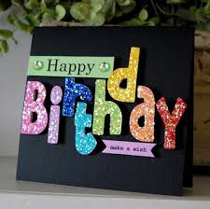

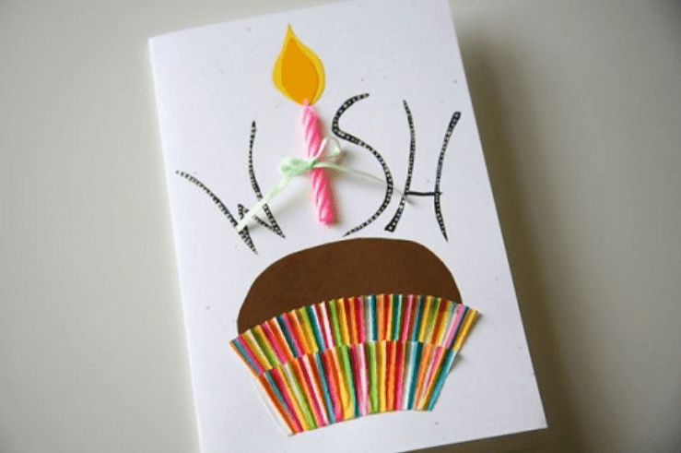

**Card Two**

**Card One:**

**List the equipment and materials required to craft card one:**

|  |  |
| --- | --- |
|  |  |
|  |  |
|  |  |
|  |  |
|  |  |
|  |  |

**Card Two:**

**List the equipment and materials required to craft card two:**

|  |  |
| --- | --- |
|  |  |
|  |  |
|  |  |
|  |  |
|  |  |
|  |  |

**EL3: Select suitable materials or equipment from a wide range to make three different types of cards for different occasions**

**Look at the three cards below, list on the next page the materials or equipment required to make them.**

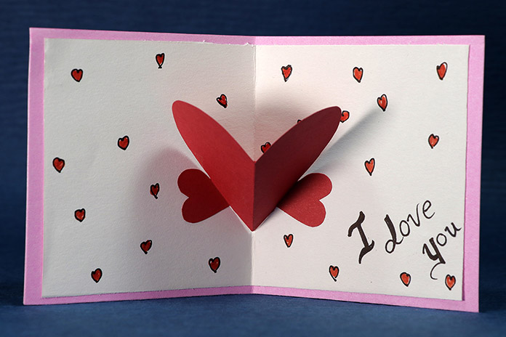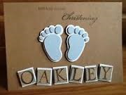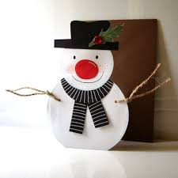

Card one

Card two

Card three

**Card One:**

|  |  |
| --- | --- |
|  |  |
|  |  |
|  |  |
|  |  |
|  |  |

**Card Two**

|  |  |
| --- | --- |
|  |  |
|  |  |
|  |  |
|  |  |
|  |  |

**Card Three**

|  |  |
| --- | --- |
|  |  |
|  |  |
|  |  |
|  |  |
|  |  |

**AO2 Practical Assessment**

You are a designer for Cards R Us; they want to launch a new range of cards for the following occasions:

* Mother’s Day
* Father’s Day
* Easter Celebration

You have been asked to choose a design from a range of samples for each card.

Once you have chosen your favourite design you will create a plan of work and follow it to make the card.

You will be assessed on the following areas:

* **Personal health and safety issues**
* **Safe use of tools and materials**
* **Correct basic materials**
* **Materials and equipment**
* **Planning**
* **End Product**

**A02 Practical Assessment**

**Personal Health and Safety Issues**

**For this assessment you have to prepare for card making by wearing suitable protective clothing.**

**Pupils who will achieve Level One will:**

* Be able to identify suitable protective clothing that should be worn when making cards.

**Pupils who will achieve Level Two will:**

* Be able to select suitable protective clothing that should be worn when making cards.

**Pupils who will achieve Level Three will:**

* Be able to prepare for their craft work by wearing suitable protective clothing.

**AO2 Practical Assessment One: Personal Health and Safety**

|  |  |  |  |
| --- | --- | --- | --- |
|  | **Please indicate by placing one tick in the appropriate box the level the learner has achieved** | | |
| **Skill Demonstrated** | **EL1** | **EL2** | **EL3** |
| **Preparing for craft work by wearing suitable protective clothing** | **Skill demonstrated by learner who received significant help** | **Skill demonstrated by learner who received some help** | **Skill demonstrated by learner who received little or no help** |
| **Level Achieved** |  |  |  |
| **Evidence: Photograph** | | | |
| **Evidence Teacher Witness Statement:** | | | |

**A02 Practical Assessment**

**Safe use of tools and materials**

**For this assessment you have to prepare for card making using tools and materials safely.**

**Pupils who will achieve Level One will:**

* Be able to use scissors safely.

**Pupils who will achieve Level Two will:**

* Be able to use two tools safely and appropriately.

**Pupils who will achieve Level Three will:**

* Use at least three tools to work safely and appropriately.

**AO2 Practical Assessment Two: Safe use of tools and materials**

|  |  |  |  |
| --- | --- | --- | --- |
|  | **Please indicate by placing one tick in the appropriate box the level the learner has achieved** | | |
| **Skill Demonstrated** | **EL1** | **EL2** | **EL3** |
| **Safe use of tools and materials** | **Skill demonstrated by learner who received significant help** | **Skill demonstrated by learner who received some help** | **Skill demonstrated by learner who received little or no help** |
| **Level Achieved** |  |  |  |
| **Evidence: Photographs** | | | |
| **Evidence Teacher Witness Statement:** | | | |

**A02 Practical Assessment**

**Correct basic materials**

**For this assessment you have to prepare select a card(s) to make from a range of samples.**

**Pupils who will achieve Level One will:**

* Select a card to make from a small selection of samples provided.

**Pupils who will achieve Level Two will:**

* Select two different types of cards to make from a selection of samples.

**Pupils who will achieve Level Three will:**

* Select at least three different types of cards to make for different occasions.

**AO2 Practical Assessment Three: Correct basic materials**

|  |  |  |  |
| --- | --- | --- | --- |
|  | **Please indicate by placing one tick in the appropriate box the level the learner has achieved** | | |
| **Skill Demonstrated** | **EL1** | **EL2** | **EL3** |
| **Correct basic materials** | **Skill demonstrated by learner who received significant help** | **Skill demonstrated by learner who received some help** | **Skill demonstrated by learner who received little or no help** |
| **Level Achieved** |  |  |  |
| **Evidence: Photographs** | | | |
| **Evidence Teacher Witness Statement:** | | | |

**A02 Practical Assessment**

**Materials and Equipment**

**For this assessment you have to select appropriate materials and equipment**

**Pupils who will achieve Level One will:**

* Select appropriate materials or equipment from a limited range provided, for example, glue, scissors, pencils and felt tips.

**Pupils who will achieve Level Two will:**

* Select appropriate materials or equipment for two different types of cards from a broad range provided.

**Pupils who will achieve Level Three will:**

* Select a variety of appropriate materials and equipment to make at least three different types of cards for three different occasions demonstrating flair and creativity.

**AO2 Practical Assessment Four: Materials and Equipment**

|  |  |  |  |
| --- | --- | --- | --- |
|  | **Please indicate by placing one tick in the appropriate box the level the learner has achieved** | | |
| **Skill Demonstrated** | **EL1** | **EL2** | **EL3** |
| **Materials and Equipment** | **Skill demonstrated by learner who received significant help** | **Skill demonstrated by learner who received some help** | **Skill demonstrated by learner who received little or no help** |
| **Level Achieved** |  |  |  |
| **Evidence: Photographs** | | | |
| **Evidence Teacher Witness Statement:** | | | |

**A02 Practical Assessment**

**Planning**

**For this assessment you have to (help) make a plan of work**

**Pupils who will achieve Level One will:**

* Set out the chosen materials and equipment to help make a plan of work.

**Pupils who will achieve Level Two will:**

* Make a plan of work using the materials as a guide.

**Pupils who will achieve Level Three will:**

* Make a plan of work.

**My Plan of Work**

**Card One**

|  |
| --- |
| **Step One** |
| **Step Two** |
| **Step Three** |
| **Step Four** |
| **Step Five** |
| **Step Six** |
| **Step Seven** |

**My Plan of Work**

**Card Two**

|  |
| --- |
| **Step One** |
| **Step Two** |
| **Step Three** |
| **Step Four** |
| **Step Five** |
| **Step Six** |
| **Step Seven** |

**My Plan of Work**

**Card Three**

|  |
| --- |
| **Step One** |
| **Step Two** |
| **Step Three** |
| **Step Four** |
| **Step Five** |
| **Step Six** |
| **Step Seven** |

**AO2 Practical Assessment Five: Planning**

|  |  |  |  |
| --- | --- | --- | --- |
|  | **Please indicate by placing one tick in the appropriate box the level the learner has achieved** | | |
| **Skill Demonstrated** | **EL1** | **EL2** | **EL3** |
| **Planning** | **Skill demonstrated by learner who received significant help** | **Skill demonstrated by learner who received some help** | **Skill demonstrated by learner who received little or no help** |
| **Level Achieved** |  |  |  |
| **Evidence: Photographs** | | | |
| **Evidence Teacher Witness Statement:** | | | |

**A02 Practical Assessment**

**End Product**

**For this assessment you have to make card(s) of a particular quality.**

**Pupils who will achieve Level One will:**

* Follow the plan to make the card.

**Pupils who will achieve Level Two will:**

* Follow the plan to make two different types of cards and answer questions about what they are doing. These cards should be of a reasonable quality.

**Pupils who will achieve Level Three will:**

* Follow the plan to make at least three different types of cards for three different occasions and present the cards in envelopes, explaining the processes involved. These cards should be of a high quality finish, pleasing to look at and demonstrate flair and creativity.

**AO2 Practical Assessment Five: End Prouct**

|  |  |  |  |
| --- | --- | --- | --- |
|  | **Please indicate by placing one tick in the appropriate box the level the learner has achieved** | | |
| **Skill Demonstrated** | **EL1** | **EL2** | **EL3** |
| **End product**  **Making the card** | **Skill demonstrated by learner who received significant help** | **Skill demonstrated by learner who received some help** | **Skill demonstrated by learner who received little or no help** |
| **Level Achieved** |  |  |  |
| **Evidence: Photographs** | | | |
| **Evidence Teacher Witness Statement:** | | | |

**EL1 Card One**

**Fix card to page**

**EL2 Card Two**

**Fix card to page**

**EL2 Verbal Questions and responses about making the card**

***Classroom assistant can scribe responses***

**What Personal Protective Equipment are you using?**

|  |
| --- |
|  |
|  |
|  |

**What tools are you using?**

|  |
| --- |
|  |
|  |
|  |

**What materials are you using?**

|  |
| --- |
|  |
|  |
|  |

**What skills are you using?**

|  |
| --- |
|  |
|  |
|  |

**What planning did you have to do get to this stage?**

|  |
| --- |
|  |
|  |
|  |

**Card Three**

**EL3 Fix card to page**

**EL3 Explaining the Processes involved**

**As the learner is making their cards they will be explaining and demonstrating to a Teacher or Classroom Assistant the processes involved. The Teacher or Classroom Assistant will scribe what the pupil says below:**

**Card One: Processes involved**

|  |
| --- |
|  |
|  |
|  |
|  |
|  |
|  |
|  |
|  |

**Card Two: Processes involved**

|  |
| --- |
|  |
|  |
|  |
|  |
|  |
|  |
|  |
|  |

**Card Three: Processes involved**

|  |
| --- |
|  |
|  |
|  |
|  |
|  |
|  |
|  |
|  |

**AO3**

**Task Reviews**

In this section you need to indicate how you have performed in each task and show evidence of a basic review.

**Review of Task One: Personal Health and Safety Issues**

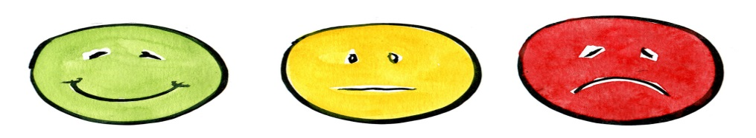**EL1 In this task I did:**

**EL2 Something I did well was:**

|  |
| --- |
|  |
|  |

**EL2 Something I could improve on is:**

|  |
| --- |
|  |
|  |

**EL3 A skill I learnt was:**

|  |
| --- |
|  |

**EL3: How will this skill help me in the future?**

|  |
| --- |
|  |
|  |

**EL3: What would I do differently next time?**

|  |
| --- |
|  |
|  |

**Review of Task Two: Safe use of tools and materials**

**EL1 In this task I did:**

**EL2 Something I did well was:**

|  |
| --- |
|  |
|  |

**EL2 Something I could improve on is:**

|  |
| --- |
|  |
|  |

**EL3 A skill I learnt was:**

|  |
| --- |
|  |

**EL3: How will this skill help me in the future?**

|  |
| --- |
|  |
|  |

**EL3: What would I do differently next time?**

|  |
| --- |
|  |
|  |

**Review of Task Three: Correct basic materials**

**EL1 In this task I did:**

**EL2 Something I did well was:**

|  |
| --- |
|  |
|  |

**EL2 Something I could improve on is:**

|  |
| --- |
|  |
|  |

**EL3 A skill I learnt was:**

|  |
| --- |
|  |

**EL3: How will this skill help me in the future?**

|  |
| --- |
|  |
|  |

**EL3: What would I do differently next time?**

|  |
| --- |
|  |
|  |

**Review of Task Four: Materials and Equipment**

**EL1 In this task I did:**

**EL2 Something I did well was:**

|  |
| --- |
|  |
|  |

**EL2 Something I could improve on is:**

|  |
| --- |
|  |
|  |

**EL3 A skill I learnt was:**

|  |
| --- |
|  |

**EL3: How will this skill help me in the future?**

|  |
| --- |
|  |
|  |

**EL3: What would I do differently next time?**

|  |
| --- |
|  |
|  |

**Review of Task Five: Planning**

**EL1 In this task I did:**

**EL2 Something I did well was:**

|  |
| --- |
|  |
|  |

**EL2 Something I could improve on is:**

|  |
| --- |
|  |
|  |

**EL3 A skill I learnt was:**

|  |
| --- |
|  |

**EL3: How will this skill help me in the future?**

|  |
| --- |
|  |
|  |

**EL3: What would I do differently next time?**

|  |
| --- |
|  |
|  |

**Review of Task Six: End Product**

**EL1 In this task I did:**

**EL2 Something I did well was:**

|  |
| --- |
|  |
|  |

**EL2 Something I could improve on is:**

|  |
| --- |
|  |
|  |

**EL3 A skill I learnt was:**

|  |
| --- |
|  |

**EL3: How will this skill help me in the future?**

|  |
| --- |
|  |
|  |

**EL3: What would I do differently next time?**

|  |
| --- |
|  |
|  |

**AO3**

**Final Review**

In this section you need to indicate how you have performed in the unit and suggest how you might improve.

**Final Review**

**EL1 In this unit I learnt how to:**

|  |
| --- |
|  |
|  |
|  |
|  |
|  |

**EL1 I did well when:**

|  |
| --- |
|  |
|  |
|  |

**EL2 If I had to do this unit again I would:**

|  |
| --- |
|  |
|  |
|  |

**EL2 Would you like to work with plants when you leave school?**

|  |  |
| --- | --- |
| Yes | No |

**EL2: What job would you like to do or where would you like to work?**

|  |
| --- |
|  |
|  |
|  |

**EL3 Explain a reason for your answer:**

|  |
| --- |
|  |
|  |
|  |

**EL3 What did you do well in A01?**

|  |
| --- |
|  |
|  |

**EL3 What did you do not so well in A01?**

|  |
| --- |
|  |
|  |

**EL3 What did you do well in A02?**

|  |
| --- |
|  |
|  |

**EL3 What did you do not so well in A02?**

|  |
| --- |
|  |
|  |