Personal Development
Health and Well-Being

Article 24: You have the right to best possible healthcare and to informaiton which will help keep you well

Year 12
WALT
- Evaluating their personal status in terms of health and well-being.
- Identifying, exploring and responding to opportunities and challenges that impact on the promotion of personal health and wellbeing
- Exploring the consequences to the individual, community and economy if potential health issues are not addressed.

Wellness Assessment

Organization
The ability to keep track of and make good use of possessions, money, and time.
Rate your answer from 1 – 10 with 1 being never, 5 being half the time and 10 being always
I feel good about with the way I get and spend, budget, and keep track of my money
I am always on time for school
I organize my time and plan ahead to make sure that I allow enough time to get everything done
I am happy with the way I organize my priorities, ensuring that I have enough time to dedicate to all the different aspects of my life
I have a good method of remembering all of my assignments and other obligations.
My backpack and bedroom are all organized, and I can get my hands on anything I might need rather quickly

I regularly take time to organize my possessions and myself so that I do not have to rush around at the last minute

I juggle school, friends, family, and other obligations in a healthy way.

I am becoming more responsible for myself. I do my own laundry, help with meals, make and keep appointments, and keep track of important papers.

Most days I accomplish all of the things I set out to do that day.
total

Stress Resilience

The ability to deal positively with the adversities of life. Rate your answer from 1 – 10 with 1 being never, 5 being half the time and 10 being always
I respond to changes in my life with a positive attitude
I am dealing well with any major changes that have happened recently
I feel good about the support I get from others when I have something big going on in my life
When I face a challenge, I feel confident that I handle stress
in a healthy way
When I have problems, I turn to other people for help
I set realistic goals for myself
When I have a problem, I take charge by creating a realistic
plan and working to solve it
I am satisfied with the way I handle stress, handling it in healthy ways rather than engaging in self-destructive ways to cope
I am addressing physical problems that may be related to stress in my life such as trouble sleeping, headaches, outbursts of anger or feelings of depression
I feel good that things going on in my personal life rarely interfere with my concentration at school or work
Total

Relationships
The ability to create and maintain healthy, life-giving connections with others.
Rate your answer from 1 – 10 with 1 being never, 5 being half the time and 10 being always
I am satisfied with the honest conversations I am able to have with my family and friends
I feel good about the relationships I have with my family members
I am happy with my friends and social group
My friends and those who know me well would says that am a good and trusted friend
My friends and I have the same values
I am satisfied with my use / non use of drugs and alcohol has on my relationships with family and friends
I feel good about the amount of trust, respect and honesty that exists in all of my relationships, including dating relationships
I am able to resolve conflict in a productive way with family and friends
I am able to talk through conflict so that it does not continue
I am able to identify and end an unhealthy relationship when I need to
Total

Rest and Play
The ability to balance work and play and to renew one’s self.
Rate your answer from 1 – 10 with 1 being never, 5 being half the time and 10 being always
I am satisfied with the amount of time I spent with the most important people in my life
On a regular basis I get enough rest to energise myself
I feel good about the amount of time I have set aside for healthy, fun activities
I have at least one hobby or interests that renews me and I take intentional time for it on a regular basis
I truly enjoy my recreational involvement in activities at school and in the community
I actively take advantage of opportunities to try new activities and ways to have fun
I am confident that the amount of time I spend connected to technology such as video games, TV, computer, Facebook and mobile phone is good for my well-being
I frequently have fun where alcohol and drugs are not present
I feel good about the people with whom I spend my free time
I use some of my free time to renew my relationship with myself
Total

Emotions
The ability to express and receive emotions in a healthy way.
Rate your answer from 1 – 10 with 1 being never, 5 being half the time and 10 being always
People who know me would say I handle my relationships in a healthy way
I avoid using alcohol and other drugs and addictive behaviours to deal with my emotions
The way I show emotions demonstrates respect towards myself and others
I am satisfied with the way I handle my emotions and how it affects my relationships
I have a solid and healthy sense of confidence in myself
I know the early warning signs of depression and anxiety and would feel comfortable seeking help from someone when needed
I am able to share all of my emotions (sadness, happiness, fear, worry).
I am able to communicate my emotions in a positive way without being irritable, critical or angry
When someone I care about is upset I am comfortable listening and really being present to them
When I am feeling emotionally overwhelmed I turn to others for help and support
Total

Spirituality

The development of a strong personal value system and a meaningful purpose in life.
Rate your answer from 1 – 10 with 1 being never, 5 being half the time and 10 being always
I have a clear sense of meaning and purpose in my life
I am pleased with what I give back to the world
I am involved in an activity that really matters to me
I forgive others and I forgive myself
I seek forgiveness from family and friends when I have hurt them
I have activities that I do regularly to renew my soul to centre myself and gain perspective
I am part of a community that enriches my spiritual life
The way I live my life is consistent with my spirituality and values
I am truly thankful for the good things in my life
My spirituality influences my behaviour in the rest of my life
Total

School and Work
The ability to get the most out of educational, volunteer, and employment opportunities.
Rate your answer from 1 – 10 with 1 being never, 5 being half the time and 10 being always
I am pleased with my overall involvement in school
I am personally happy with my grades
I feel good about the connections I have with the adults at school
I feel good about the relationships I have with other students and how those relationships impact my all-around success at school
I am confident that my use of social media, the internet and video games have no negative impact on my school work
I feel good about the way my school and personal life are helping me to build a future
I feel good about the way my decisions regarding drugs and alcohol impact my learning and sports / hobbies performance
I am satisfied with the way my activities outside school impact with my school and family
I am always on time for school, work and other commitments
I am satisfied with the way I pay attention, participate and prepare homework for my classes
Total

Care for the Body
The ability to build healthy habits and practices regarding your physical well being.
Rate your answer from 1 – 10 with 1 being never, 5 being half the time and 10 being always
The choices I make about what I eat and drink are healthy
I have positive feelings about my relationship with food (what I eat, why I eat and how often I eat)
I am satisfied with the amount of exercise I get on a regular basis
I determined what is right for me, in terms of weight and eppearances, rather than letting my friends or the culture determine that for me
I go to the doctor and dentist for regular check-ups and talk to someone about a problem as soon as it arises
I am comfortable with my sexuality and know that the decisions I make regarding sexual activity are healthy for me both physically and emotionally
I am proud of the amount of respect I pay to my body overall
My current weight is healthy for me
My decisions regarding drugs, alcohol and tobacco are serving me well
Most days I get at least eight hours of sleep at normal sleeping hours
Total

The Teen Compass Self‑Assessment Tool

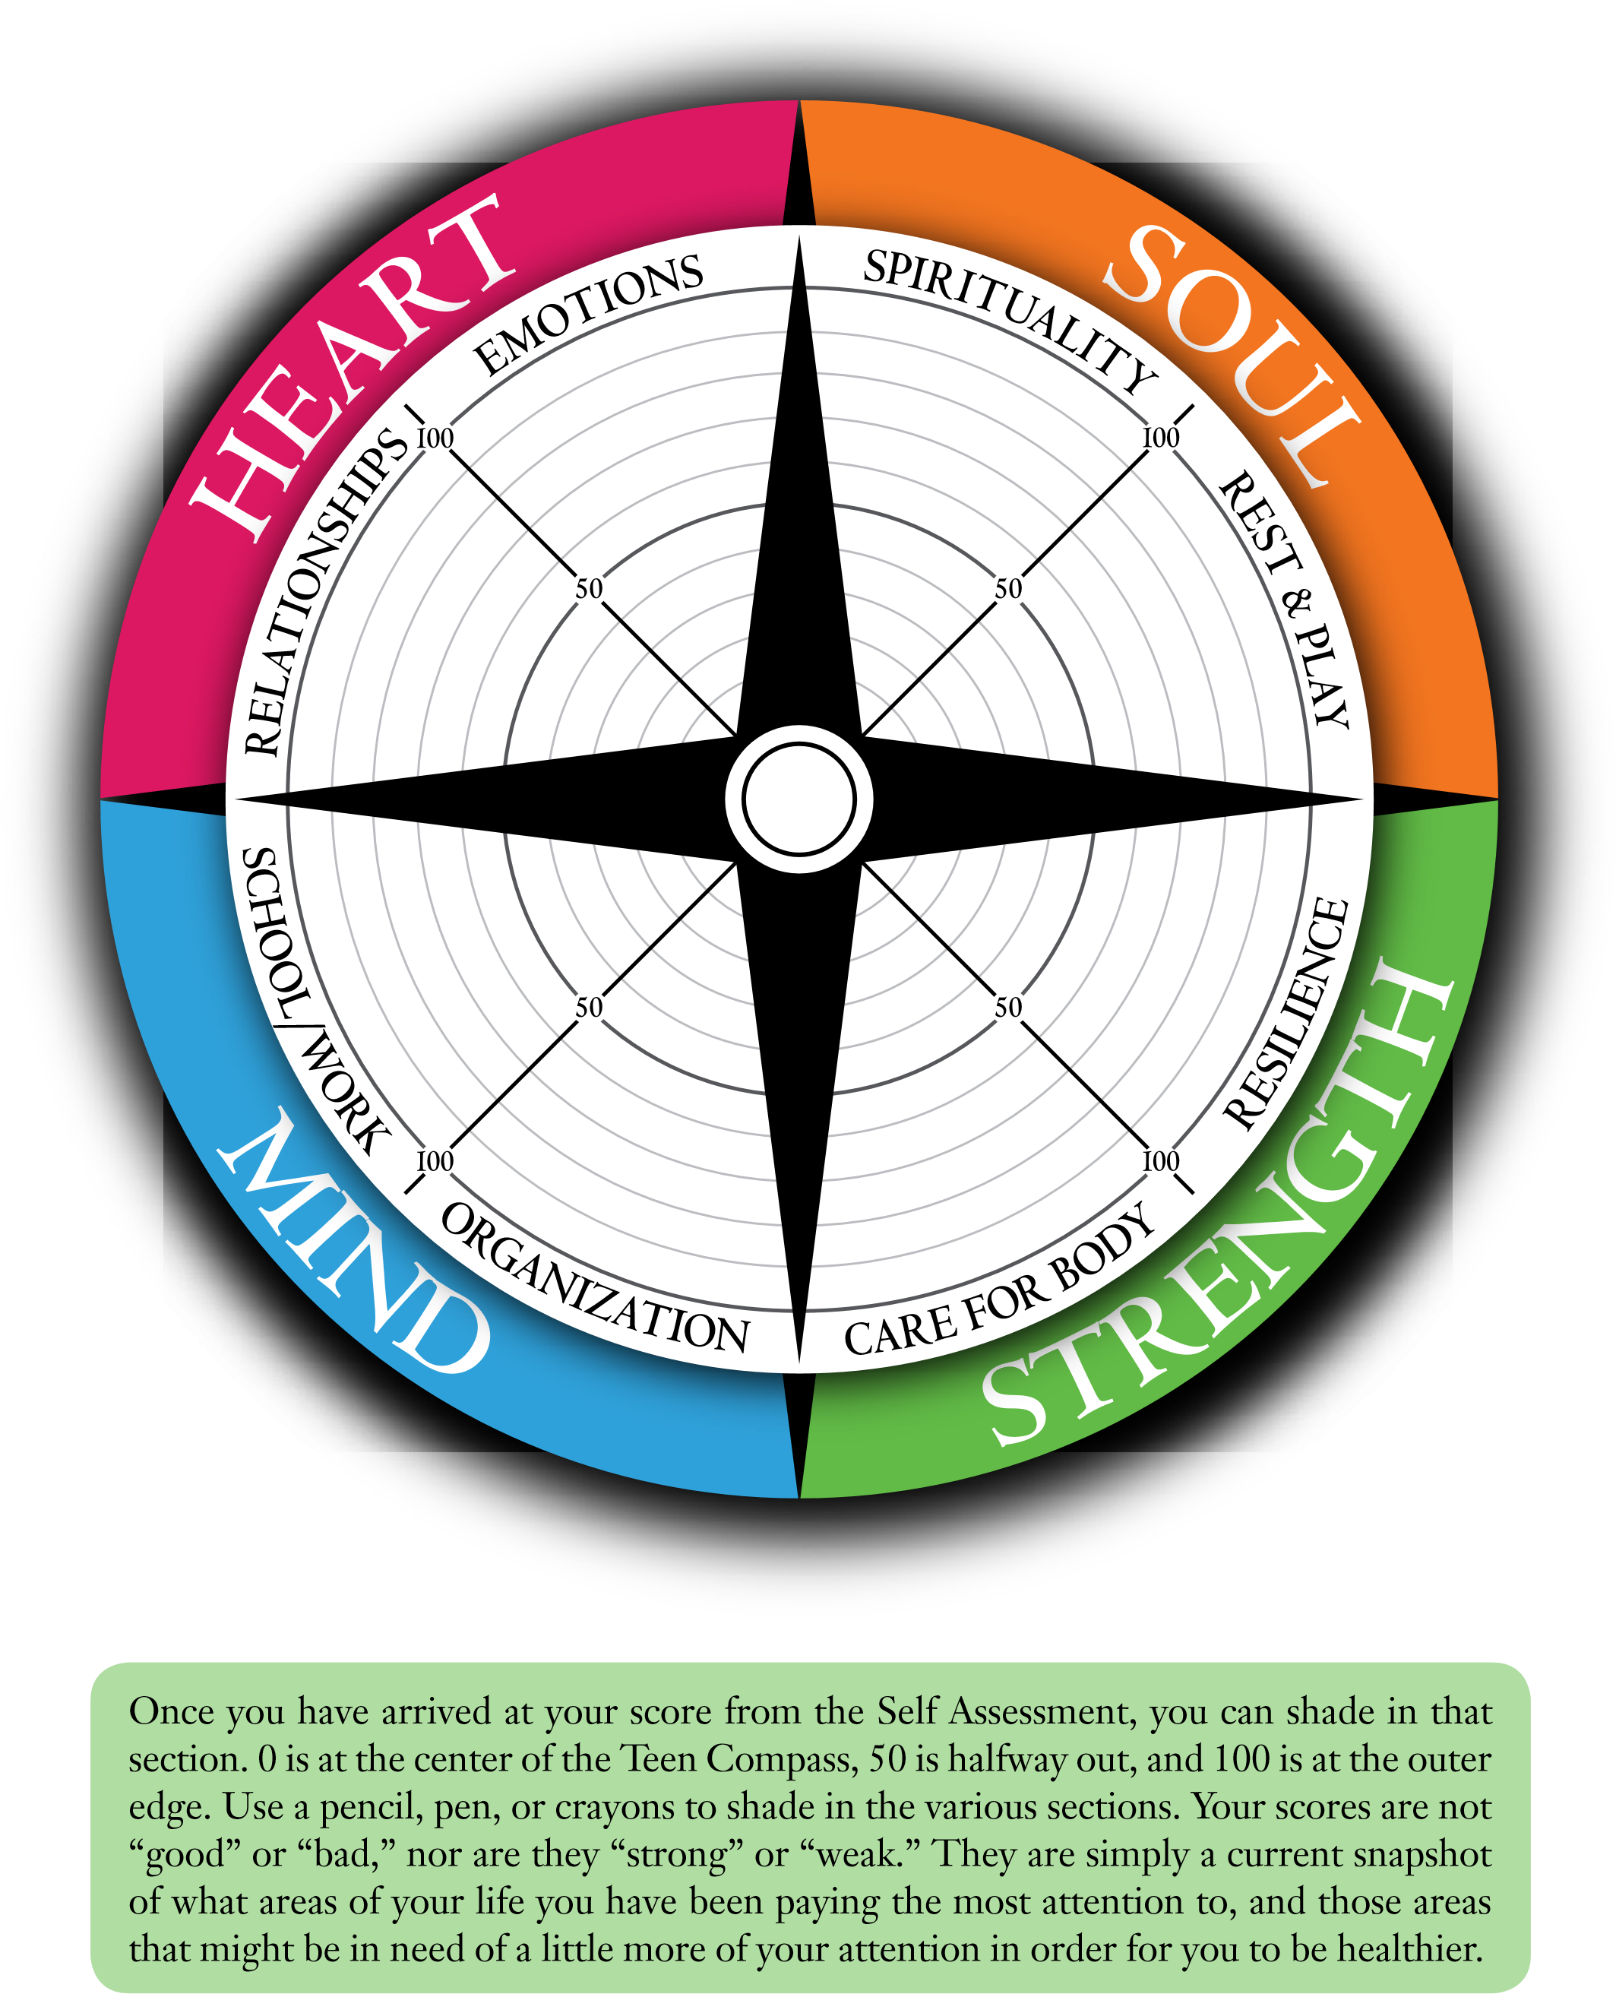
Teen Compass Self-Assessment Results

What areas are you doing well in?

What areas do you need to improve?

List some actions you can take in the next six months to improve your overall health and well-being

Paired Case Study
Wellness Area:

Solutions Suggested:

Determinants to Health Research Task
What is the unemployment rate in Northern Ireland?

What percentage of school leavers achieve 5 GCSE pass grades at A – C?

What percentage of properties are unfit to live in in Belfast?

What percentage of houses are affected by fuel poverty in Belfast?

What is the crime rate in Belfast?

What is the most common crime committed in Belfast?

How many people have died in road traffic collisions in Northern Ireland in the past year?

What is life expectancy in Northern Ireland for males?

What is the life expectancy in Northern Ireland for females?

What percentage of people smoke in Northern Ireland?

What percentage of people drink too much in Northern Ireland?

What percentage of people are obese in Northern Ireland?

What percentage of children are living in child poverty in Northern Ireland?

What is the rate of teenage pregnancy in Northern Ireland?

How many incidences of domestic violence in Northern Ireland in the past year?

How many workplace deaths in Northern Ireland has there been in the past year?

How many workplace injuries has there been in Northern Ireland in the past year?

Poster Promoting one of the Determinants s to health

Things I can do to promote my own health

Clubs I can get involved in

Sports I can get involved in

Volunteering I can get involved in

Study groups I could set up

Choices I need to think more about

Timeline
15 - 20
21 – 25
26 – 30
31 – 35
36 – 40
41 – 45
46 – 50
51 – 55
56 – 60

MindMap consequences of common health issues
Health Issue

Cause:

Who is affected

Consequences to individual

Consequences to community

Consequences to Society

Self-Evaluation of Unit
Class Charter & Target Setting
Leadership Training for Prefects
Sponsored Walk
World’s Largest Lesson
Standardised Testing Week
Health and Well-Being Audit
Work Experience Week
Halloween
Anti-Bullying Project
Determinants of Health
Opportunities to improve my own health and well-being
UNICEF Outright Project
Negative challenges to my own health and well-being
Consequences of common health problems
Target Review

I did well in:

I could do better in:

In the next unit I will:
How has this unit affected your future plans?

Mrs Plunkett could make this unit better by:

